**SCHEME OF WORK FOR ALHA TERM SS2 CHEMISTRY**

WEEKS TOPICS

1. HISTORY OF THE PERIODIC TABLE/THE PERIODIC LAW
2. TRENDS IN THE PROPERTIES OF ELEMENTS
3. OXIDATION AND REDUCTION
4. BALANCING OF REDOX REACTION
5. IDENTIFICATION OF OXIDIZING AND REDUCING AGENTS
6. IONIC THEORY
7. ELECTROLYSIS OF SPECIFIED ELECTROLYTES
8. ELECTROCHEMICAL CELLS
9. STANDARD ELECTRODE POTENTIAL
10. FARADAY’S LAWS OF ELECTROLYSIS AND CALCULATIONS.

**WEEK 1**

**PERIODICITY**

**THE NEED FOR CLASSIFICATION OF ELEMENTS**

Before the beginning of eighteenth century, only a very few elements were known and it was quite easy to study and remember their individual properties. In 1800, only 31 elements were known. This number of elements grew to 63 by 1865. With the discovery of large number of elements it became difficult to study individually the properties of these elements and their compounds. At this stage, the scientists felt the need of some simple methods to facilitate the study of the properties of various elements and their compounds. After numerous attempts the scientists were ultimately successful in arranging the elements in such a way so that similar elements were grouped together and different elements were separated.

The arrangement of elements in such a way that the similar elements fall within same vertical group and the dissimilar elements ate separated, is known as classification of elements.

**MENDELEEV’S PERIODIC TABLE**

Attempts to find regularities among the elements led the Russian Scientist, Dmitri I. Mendeleev to put forward a scheme of classification of elements in 1869. He gave a periodic law known after his name as Mendeleev’s periodic law. This law states that: The properties of elements are a periodic function of their atomic weights.

It means that when the elements are arranged in order of increasing atomic weights, the elements with similar properties recur after regular intervals. On the basis of this periodic law, Mendeleev constructed a periodic table in such a way that the elements were arranged  horizontally in the order of their increasing atomic weights. However, he also kept in mind the similarities in the chemical properties of the elements. The main criterion of the judgment of similarities in the properties· was valency of the elements. Mendeleev observed that some of the elements did not fit in with his scheme of classification if the order of atomic weights was strictly followed. He ignored the order of atomic weights and placed the elements with similar chemical properties together. For example, iodine having atomic weight 127 was placed after tellurium (atomic weight 128), together with fluorine, chlorine and bromine due to similarities in properties.

Mendeleev left certain vacant places in his table which provided a clue for the discovery of new elements. Some of the properties could be predicted with a fair accuracy. For example, both gallium and germanium were not discovered at the time when Mendeleev proposed his periodic table. Mendeleev named these elements as Eka-Aluminium and Eka-Silicon respectively. Later on, when these elements were discovered, Mendeleev’s prediction proved remarkably correct. Some of the properties predicted by Mendeleev for these elements and those found experimentally.

**MODERN PERIODIC LAW**

In 1913, the English Physicist Henry Moseley studied the X-ray spectra of many elements. He observed that a plot of JV (where vis the frequency of the X-rays emitted) against atomic number (Z) gave a straight line and not the plot of JV against atomic weight. He proposed that atomic number  is a more fundamental property of an element than its atomic weight. Therefore, the physical and chemical properties of the elements are determined by their atomic numbers instead of their atomic weights. This observation led to the development of modem periodic law. The modern periodic law states that:

The physical and chemical properties of the elements are the periodic function of their atomic numbers. It means that if the elements are arranged in order of increasing atomic numbers, the elements with similar properties recur after regular intervals.

**PHYSICAL AND CHEMICAL PROPERTIES OF SOME ELEMENTS**

Electronic configuration, physical properties and chemical properties are used to classify elements into various groups. The elements in a vertical column have largely similar properties which show regular gradation with increase in atomic number. The elements in a horizontal row show relatively sharp change in physical and chemical properties.

For example, some physical and chemical properties of alkali metals (Na, K), alkaline earth metals (Mg, Ca) and halogens (F2, Cl2, Br2 and lz) are listed below:

• Sodium and potassium are soft metals. Their hardness – decreases with-increase in atomic number.

• They have low melting points which decreases with increase in atomic number.

• They react with water liberating hydrogen gas and form soluble metal hydroxide

2Na (s) + H2O(l) - 2NaOH (aq) + H2 (g)

2K (s) + H2O (l) - 2KOH (aq) + H2 (g)

**Comparison of the Properties of Eka-aluminium and Eka-silicon  as Predicted by Mendeleev with those Observed Experimentally for Gallium and Germanium**

[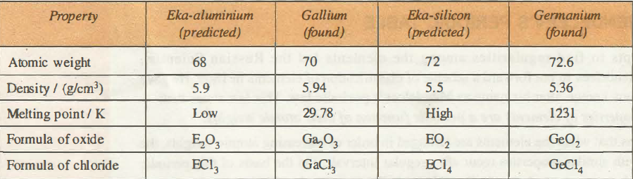](http://www.chemistry-assignment.com/wp-content/uploads/2012/12/057.png)

Reactivity increases with increase in atomic number. The reaction of water with potassium is more vigorous than with sodium.

**Caution:** Reaction of alkali metals with water is very violent.

• Both Na and K have one electron in their outermost shell.

• They exhibit oxidation state of + 1

• They are strong reducing agents.

• Magnesium and Calcium have two electrons in their outermost shells.

• They are harder than alkali metals and have higher melting points.

• They are less reactive with water than alkali metals. Magnesium reacts only with boiling water.

• Mg and Ca have two electrons in the outermost shell.

• They exhibit oxidation state of +2

• Chlorine and bromine are non-metals. They have very low melting and boiling points.

• Chlorine is a gas whereas bromine is a liquid.

• They react with water slowly in the presence of sunlight.

2Cl2 + 2H2O —-7 4HCl + O2

2Br2 + 2H2 O —7 4HBr + O2

Cl2 is more reactive than Br2.

• They have seven electrons in their outermost shell.

• They exhibit oxidation state of -1

• They are strong oxidizing agents.

By studying physical and chemical properties of different elements, the elements have been classified into various groups or families.

For example, alkali metals, alkaline earth metals; halogens, noble gases, etc.

Many new forms of periodic table have been proposed in recent times with modem periodic law as guiding principle, but the general plan of the table remained the same as proposed by Mendeleev. The most commonly known periodic table is the long form of the periodic table. Before discussing the general plan of the long form periodic table, let us look into the basic cause of periodic repetition of properties.

**CAUSE OF SIMILARITIES IN THE PROPERTIES OF ELEMENTS IN THE SAME GROUP**

It has been pointed out that if the elements are arranged in order of increasing atomic numbers, the elements with similar properties are repeated after regular intervals.

The periodical repetition of elements with similar properties after certain regular intervals when the elements are arranged in order of increasing atomic number is called periodicity.

In order to understand the cause of periodicity, let us first answer the question; why do certain elements exhibit similar properties?

From the knowledge of atomic structure it may be recalled that atom has a small positively charged nucleus with electrons distributed around it. The atomic nucleus does not undergo any change during the ordinary chemical reactions. Thus, it may be assumed that the physical and chemical properties of the elements must be related to the arrangement of electrons in their atoms. Since electrons present in the inner shells do not take part in chemical combination, it must be the electrons in the outermost shell which control the properties of the atoms. Thus, if the arrangement of electrons in the outermost shell (valence shell) of the atoms is similar, their properties will also be similar. For example, the electronic configurations of alkali metal as given in Table below show the presence of one electron in their valence shells.

**Electronic Configurations of Some Groups**

[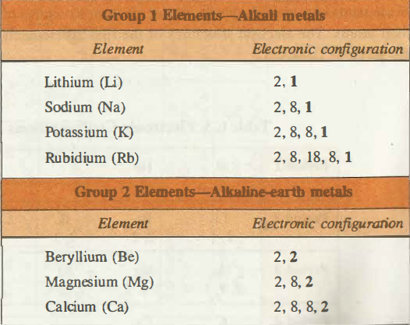](http://www.chemistry-assignment.com/wp-content/uploads/2012/12/058.png)

[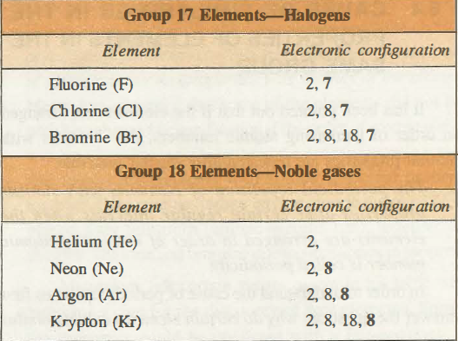](http://www.chemistry-assignment.com/wp-content/uploads/2012/12/059.png)

Similar behaviour of alkali metals is attributed to the similar valence shell configuration of their atoms. For example, all alkali metals react with water and liberate hydrogen gas.

2Li + 2H2 O- 2LiOH + H2

2Na + 2H2O- 2NaOH + H2

2K + 2H2 O-2KOH + H2

Similarly, if we examine the electronic configurations of other elements, we shall find that there is a repetition of the similar valence shell configuration after certain regular intervals with the regular increase of atomic number. Thus, it can be concluded that the periodic repetition of properties is due to the recurrence of similar valence shell configurations after certain regular intervals.

Thus, all the elements in a group have similar valence shell electronic configuration. The similar chemical nature of elements in a group is due to similar electron structures of their atoms. The electron structures of the first 20 elements are given in Table 6.3.

**Electronic Configurations of the First 20 Elements in the Periodic Table**

[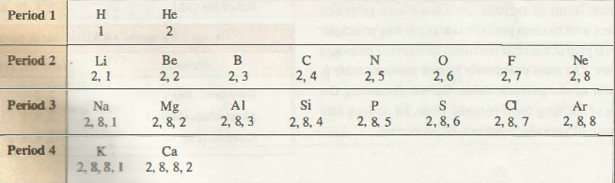](http://www.chemistry-assignment.com/wp-content/uploads/2012/12/060.png)

**ELECTRONIC CONFIGURATION AND THE POSITION OF ELEMENTS IN THE PERIODIC TABLE-The Long Form of Periodic Table**

The long form of the periodic table is an improved form of the periodic table which is based upon modern periodic law. The long form of periodic table is given on page 67. Let us now, study the structural features of the periodic table.

**DESCRIPTION OF PERIODS**

A horizontal row of a periodic table is called a period. A period consists of a series of elements having same valence shell. There are seven periods in all, which are numbered as 1, 2, 3, 4, 5, 6 and 7.

There is a close connection between the electronic configurations of the elements and the long form of the periodic table. As pointed out earlier in Unit 5 that the principal quantum number n defines the main energy level of the electron also called main energy shell. Each period of the periodic table begins with the filling of new energy shell. In fact, the number of the period also represents the highest principal quantum number of the elements present in it. The number of elements in each period is equal to the number of electrons which can be accommodated in the orbitals belonging to that electron shell.

The first period corresponds to the filling of electrons in first energy shell (i.e., n = 1). Now this energy level has only one orbital (i.e., n =1) and, therefore, !t can accommodate two electrons. This means that there can be only two elements in the first period.

The second period starts with the electrons beginning to enter the second energy shell (n = 2). There are only four orbitals (one 2s and three 2p orbitals) to be filled which can accommodate eight electrons. Thus, second period has eight elements in it

**Long Form of Periodic Table**

[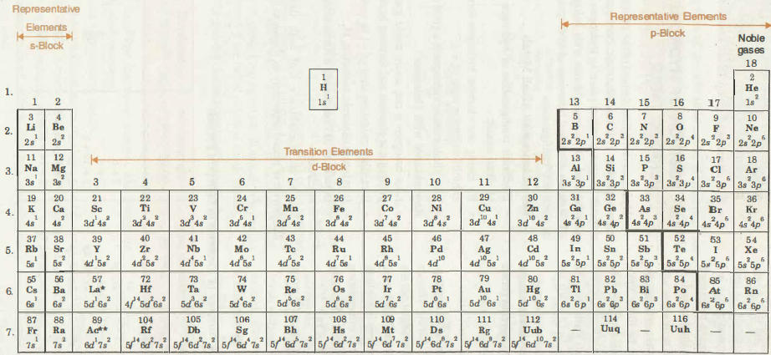](http://www.chemistry-assignment.com/wp-content/uploads/2012/12/061.png)

[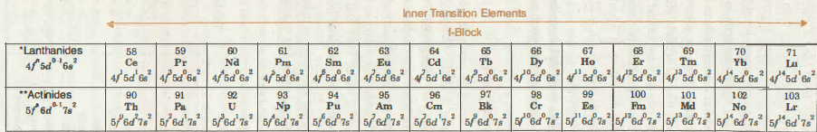](http://www.chemistry-assignment.com/wp-content/uploads/2012/12/062.png)

Fig. 6.1. Long form of periodic table

The third period begins with the electrons entering the third energy shell (n = 3). It may be recalled that out of nine orbitals of this energy level (one s, three p and five d), the five 3d orbitals have higher energy than 4s orbitals. As such only four orbitals (one 3s and three 3p) corresponding ton= 3 are filled before the fourth energy level begins to be formed. Hence. there are only eight elements in the third period.

The fourth period corresponds to n = 4. It starts with the filling of 4s-orbitals. However, after the 4s but before the 4p orbitals, there are five 3d orbitals also to be filled. Thus, in all, nine orbitals (one 4s, five 3d and three 4p) have to be filled and as such there are eighteen elements in fourth period. It may be noted that the filling of 3d-orbitals starts from SC (Z = 21). The elements from SC (Z = 21) to Zn (Z = 30) are called 3d-transition series.

Similarly. we can show that there are 18 elements in the fifth period and 32 elements in the sixth period. Seventh period is still incomplete.

**DESCRIPTION OF GROUP**

A vertical column of the periodic table is called a group. A group consists of a series of elements having similar configuration of the outer energy shell. For example, all the group 1 elements have ns1 valence shell electronic configuration. There are eighteen vertical columns in the long form of the periodic table. According to the recommendation of the International Union of Pure and Applied Chemistry (IUPAC), these groups are numbered from 1 to 18.

It may be noted that the elements belonging to same group are said to constitute a family. For example,

• The elements of group 1 are known as alkali metals.

• The elements of group 2 are known as alkaline earth metals.

• The elements of group 17 are known as halogens.

• The elements of group 18 are known as noble gases.

**POSITION OF HYDROGEN IN THE PERIODIC TABLE**

Hydrogen is the first element of the periodic table having atomic number 1. It has electronic configuration ls1. It is difficult to give a proper place to hydrogen in the periodic table because of its resemblance with halogens as well as alkali metals. The dual behaviour of hydrogen is attributed to its electronic configuration.

**Resemblance with Alkali Metals**

• Electronic configuration of hydrogen resembles that of alkali metals.

• By losing one electron hydrogen forms H+ ion and exhibits oxidation state of + 1.

• Like alkali metals, hydrogen is a good reducing agent. Resemblance with Halogens

• Like halogens it can attain noble gas configuration gaining one electron and forming hydride ion, H-.

• It exhibits oxidation state of -1 in metal hydrides. It exists as diatomic molecule, Hz.

• In most of its compounds it forms bond by sharing of electrons.

Due to its resemblance with both alkali metals and halogens it is placed separately as shown in Fig. 6.1.

Period              Principal         Orbitals being               Electrons to be           Number of

valence                filled up                   accommodated            elements

shell(= n)

First                 n=1                   1s                                2                                  2

Second            n=2                  2s,                                2p 2+6                         8

Third               n=3                  3s,3p                              2+10+6                      8

Fourth                         n=4                  4s,3d.4p                      2+10+6                        18

Fifth                n=5                 5s, 4d,                                     5p 2+ 10+6                  18

Sixth                n=6                  6s. 4f, 5d, 6p               2 + 14 + 10 + 6           32

Seventh           n=7                  7s. 5f, 6d, 7p               2+14+10+6                 32

(incomplete)

**DIVISION OF PERIODIC TABLE INTO s-, p-, d- AND f-BLOCKS ON THE BASIS OF ELECTRONIC CONFIGURATIONS**

The long form of periodic table can be divided into four main blocks. These are s-, p-, d- and f-blocks. The division of elements into blocks is primarily based upon their electronic configuration as shown in Fig. 6.2.

[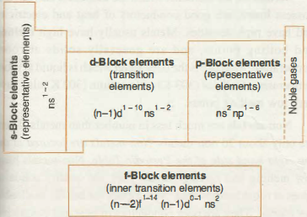](http://www.chemistry-assignment.com/wp-content/uploads/2012/12/063.png)

**Fig. 6.2. Division of periodic table into various blocks.**

**s-BLOCK ELEMENTS**

The elements in which the last electron enters the s-sub- shell of their outermost energy level are called s-block elements. This block is situated at extreme left of the periodic table. It contains elements of groups 1 and 2. Their general configuration is ns1-2, where n represents the outermost shell. the elements of group 1 are called alkali metals whereas the elements of group 2 are called alkaline earth· metals. are:

Some of the general characteristics of s-block elements

(i) They are soft metals. Hardness decreases with increasing atomic number.

(ii) They have low melting and boiling points.

(iii) They have low ionization energies and hence are highly electropositive.

(iv) They are very reactive metals.

(v) They show oxidation states of +1 (in case of alkali metals) or +2 (in case of alkaline earth metals).

(vi) They are good reducing agents.

(vii) The compounds of s-block elements are predominantly ionic.

**p-BLOCK ELEMETS**

The elements in which the last electron enters the p-subshell of their outermost energy level are called p-block elements. The ·general configuration of their outermost shell is ns2 np1-4i. The only exception is helium (l s2). Strictly, helium belongs to the s-block but its positioning in the p-block along with other group 18 elements is justified because it has completely filled valence shell ( 1 s2) and as a result, exhibits properties characteristic of other noble gases. This block is situated at the extreme right of the periodic table and contains elements of groups 13, 14, 15, 16, 17 and 18 of the periodic table. Most of these elements are non-metals, some are metalloids and a few others are heavy elements which exhibit metallic character. The non-metallic character increases as we move from left to right across a period and metallic character increases as we go down the group. Some of the general characteristics of p-block elements are:

(i) They show variable oxidation states.

(ii) They form ionic as well as covalent compounds.

(iii) They have relatively higher values of ionization energy.

(iv) Most of them are non-metals.

(v) Most of them are highly electronegative.

(vi) Most of them form acidic oxides.

**d-BLOCK ELEMENTS**

The elements in which the last electron enters the d-subshell of the penultimate energy level are called d-block elements. Their general valence shell configuration is (n -l)d1-10, ns1-2, where n represents the outermost energy level. d-Block contains three complete rows of ten elements in each. The fourth row is incomplete. The three rows are called first, second and third transition series. They involve the filling of 3d, 4d and 5d orbitals respectively. The d-block contains elements of groups 3 to 12 of the periodic table. The general characteristics of d-block elements are:

(i) They are hard, high melting metals.

(ii) They show variable oxidation states.

(iii) They form coloured complexes.

(iv) They form ionic as well as covalent compounds.

(v) Most of them exhibit paramagnetism.

(vi) Most of them possess catalytic properties.

(vii) They form alloys. For example, brass is an alloy of copper and zinc.

(viii) They are good conductors of heat and electricity.

**f-BLOCK ELEMENTS**

The elements in which the last electron enters the f –sublevel of the anti-penultimate (third to the outermost shell) shell are called f-block elements. Their general configuration is (n – 2)f1-14 (n – 1) d 0-1 , Ns2, where n represents the outermost shell. They consist of two series of elements placed at the bottom of the periodic table. The elements of first series follow lanthanum (57La) and are called lanthanoids. The elements of second series follow actinium (89Ac) and are called actinoids. Actinoid elements are radioactive. Many of them have been made only in nanogram quantities or even less by nuclear reactions. Chemistry of the actinoids is complicated and is not fully studied. The general characteristics of !-block elements are:

(i) They show variable oxidation states.

(ii) They are high melting metals.

(iii) They have high densities.

(iv) They form complexes, most of which are coloured.

( v) Most of the elements of actinoid series are radioactive.

**CLASSIFICATION OF ELEM ENTS AS METALS, NON-METALS AND SEMI-MTALS**

In addition to the classification of elements into s-, p-, d and f-blocks, it is possible to divide them into metals, non-metals and metalloids. More than 78% of the elements are metals. Metals are present on the left side and the centre of the periodic table.

Metals are the elements which are malleable and ductile,  possess luster, are good conductors of heat and electricity and have high densities. Metals usually have high melting and boiling points, and are generally solids at room temperature. Mercury is the only metal which is liquid at room temperature. Gallium (303 K) and caesium (302 K) also have very low melting points.

Non-metals are much less in number than metals. There are only about 20 non-metals. Non-metals are located at the top right hand side of the Periodic Table. Non-metals have low melting and boiling points. They are usually solids or gases at room temperature. Non-metals are neither malleable nor ductile. They are poor conductors of heat and electricity. In a period, the non-metallic character increases as we move from left to right. In a group; the non-metallic character decreases and metallic character increases on going down a group. There is no sharp line dividing metals from non-metals. A zig-zag line separates metals from non-metals as shown in Fig. 6.3. The borderline elements such as silicon, germanium, arsenic, antimony and tellurium exhibit characteristic properties of metals as well as non-metals. These elements are called semi-metals or metalloids.

[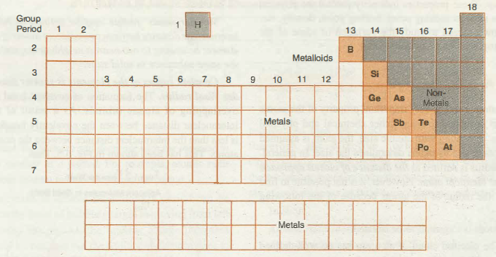](http://www.chemistry-assignment.com/wp-content/uploads/2012/12/064.png)

**Fig. 6.3. Position of metals, non-metals and metalloids in the periodic table.**

**EVALUATION**

1.The periodic table is an arrangement of elements in order of their

a.mass numbers b.relative molecular masses c.atomic numbers d.isotopic masses e.molecular masses.

2.State the period and the group to which the elements aluminium belongs in the periodic table.

3.State the periodic law.

4.Why is it that for chromium,the structure (Ar)4s1 3d5 is more stable than (Ar)4s2 3d4.

5. A, B, C are three elements with atomic numbers, Z- 1, Z, Z + 1 respectively. B is an inert gas.

Answer the following questions:

(i) Predict the group of A and C.

(ii) Which out of the three has positive electron gain energy and why?

(iii) Which of the three has least value of ionization energy?

6. The electronic configurations of some elements are given as:

(a) [Ne] 3s2 3p3          (b) [Ne] 3s2 3p4

(c) [Ne] 3s2 3r             (d) [Ne] 3s2 3p63tf’ 4s1

(i) Which element will be most metallic ?

(ii) Which element will have most negative electron affinity?

(iii) Which element belongs to d-block?

(iv) Which element belongs to group 17?

(v) Out of a, b and c which will have least ionization energy?

 7.Which of the following elements is diatomic?

A. iron B neon C. oxygen D. sodium

8.Calcium and magnesium belong to the same group in the periodic table because both

A. are metals

B. form colourless salts

C. have the same number of valence electrons

D. form cations

9. A solid substances with high melting and boiling points is likely to be a/an

A. covalent compound

B. dative covalent compound

C. electrovalent compound

D. non-metal

10. Which of the following elements is a d-block element?

A. calcium b. iron C. lithium D. silicon

11. If X is a group III element. Its oxide would be represented as

A. X3O2 B. X3O C. X2O3D. XO3

12. Which of the following sets of elements have the similar electronic configuration?

(i) H, He, Be               (ii) Li, Be, B

(iii) He, Ne, Ar            (iv) Li, Na, K

(a) (iii)                         (b) (iii), (iv)

(c) (iv)                         (d) (ii), (iii)

13. Transition metals are:

(a) found between groups 2 and 13

(b) all solids

(c) metals and semi-metals

(d) found between groups 1 and 13.

14. Hydrogen can be placed along with group 17 elements because it

(i) can aquire noble gas configuration by gaining one electron.

(ii) exhibits oxidation state of+ 1.

(iii) has one electron in the outermost shell.

(iv) can exhibit oxidation state of -1.

(a) (ii) and (iii) (b) (i) and (iv)

(c) (i) (d) (iii).

15. number of elements in the 5th period of the periodic table is

(a) 3                 (b) 9

(c) 8                  (d) 18.

16. In the modern periodic table, the period indicates the value of:

(a) atomic number                   (b) atomic mass

(c) principal quantum number

(d) azimuthal quantum number.

17. What is modem periodic law?

18. What is periodicity and what is its cause?

19. What is the total number of groups in. the. long form of periodic table?

20.  An element has atomic number 34. Deduce its period, group and block.

21. Write the general outer electronic configuration of s-, p-, d and /-block elements.

22.  Which groups constitute d-block of the periodic table?

23. In what group of the periodic table is each of the following elements found?

(i) [Ar] 3d10 4s2                     (ii) [Ar] 3d10, 4s2, 4p4.

24.. Which of the following groups consists entirely of metals?

(a) 18               (b) 2

(c) 14               (d) 15.

25. An element with atomic number 20 is placed in which period of the periodic table?

(a) 4                 (b) 3

(c) 2                  (d) 1.

(26) Moderm periodic law was proposed by ……

**WEEK 2**

**PERIODIC TRENDS IN** **PHYSICAL PROPERTIES**

Most of the properties of the elements such as atomic volume, atomic size, ionization enthalpy, electron affinity and electronegativity are directly related to the electronic configuration of the atoms. These properties undergo periodic variation with the change in the atomic number within a period or a group. These properties indirectly control the physical properties such as melting point, boiling point, density, etc. Let us now proceed to study the variation of some of the atomic properties in the periodic table.

**ATOMIC RADIUS**

The atomic size is very important property of the atoms because it is related to many other chemical and physical properties. In dealing with atomic size, the atom is assumed to be a sphere and its radius determines the size. In general, atomic radius is defined as the distance of closest approach to another identical atom. However, it is not possible to find precisely the radius of the atoms because of the following reasons:

1. Atom is too small to be isolated.

2. The electron cloud of an atom has no well-defined boundary.

It is for this reason that atomic size is expressed in terms of different types of radii. Some of these are being discussed below:

**1. COVALENT RADIUS**

The approximate radii of atoms can be determined by measuring the distance between the atoms in a covalent molecule by X-ray diffraction and other spectroscopic techniques. This radius of an atom is referred to as covalent radius. It may be defined as one-half of the distance between the centres of the nuclei of two similar atoms bonded by a single covalent bond.

In case of homonuclear bonds,

r covalent = 2 [Intern clear distance between two bonded atoms]

For example, the intern clear distance between two hydrogen atoms in H2 molecule is 74 pm (Fig. 6.4). Therefore, the covalent radius of hydrogen atom is 37 pm.

[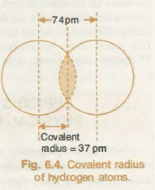](http://www.chemistry-assignment.com/wp-content/uploads/2012/12/065.png)

Similarly internuclear distance between two chlorine atoms in chlorine molecule is 198 pm. Therefore, covalent radius of chlorine is 19812 = 99 pm.

**2 ‘JAN DER WAALS’ RADIUS**

Van der Waals ‘ radius may be defined as half of the internuclear distance between two adjacent atoms of the same element belonging to two nearest neighboring molecules of the same substance in solid state.

Covalent radius of the elements is shorter than its van der Waal radius. The formation of covalent bond involves overlapping of atomic orbitals. As a result of this, the internuclear distance between the covalently bonded atoms is less than the internuclear distance between the non-bonded atoms. This has been shown in Fig below. Thus,

[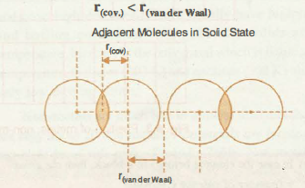](http://www.chemistry-assignment.com/wp-content/uploads/2012/12/066.png)

**Comparison of covalent and van der Waal radii.**

**3. METALLIC OR CRYSTAL RADIUS**

The term is applied for metals only. A metallic lattice is considered to be consisting of Closely packed atoms which are spherical in shape. Metallic radius may be defined as half of the internuclear distance between two adjacent atoms in the metallic lattice. It is measured in angstrom units. Internuclear distances are measured by X-ray studies. The metallic radius of sodium is found to be 186 pm while that of copper is 128 pm.

The metallic radius of an atom is always larger than its covalent radius because metallic bond is weaker than covalent bond. Therefore, two atoms held by covalent bond are closer to each other. For example, the metallic radius of sodium is 186 pm, whereas its covalent radius as determined from its vapours which exist as Na2 molecules is 154 pm. Similarly, metallic radius of potassium is 231 pm whereas covalent radius is 203 pm.

**VARIATION OF ATOMIC RADII IN THE PERIODIC TABLE**

Atomic radii usually depend upon nuclear charge and number of main energy levels of an atom. The periodic trends in atomic radii have been described as follows:

**Table 6.5. Atomic Radii of Elements of Second Period**

[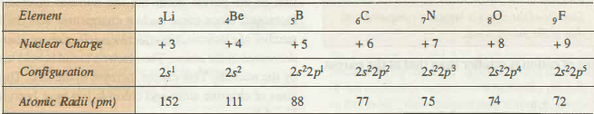](http://www.chemistry-assignment.com/wp-content/uploads/2012/12/067.png)

**(a) Variation in a Period**

In general, the atomic radii decrease with the increase in the atomic number in a period. For example, atomic radii decrease from lithium to fluorine in second period.

The decrease of atomic radii along a period can be explained on the basis of nuclear charge. In moving from left to right across the period, the nuclear charge increases progressively by one unit but the additional electron goes to the same principal shell. As a result, the electron cloud is pulled closer to the nucleus by the increased effective nuclear charge. This causes the decrease of atomic size. The atomic radii of elements of second period are given in Table 6.5.

**(b) Variation in a Group**

In general, the atomic radii increase from top to bottom within a group of the periodic table. For example, atomic radii increase from lithium to cesium among alkali metals and the similar trend is followed by halogens from fluorine to iodine as shown in Table

[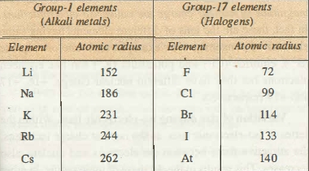](http://www.chemistry-assignment.com/wp-content/uploads/2012/12/068.png)

**Variation of Atomic Radii of Group-1** **and Group-17 elements**

In moving down a group, the nuclear charge increases with increase in atomic number but at the same time, there is a progressive increase in the principal energy levels. The number of electrons in the outermost shell, however, remains the same. Since, the effect of additional energy level is more  pronounced than the effect of increased nuclear charge, therefore, the effective nuclear charge decreases. Consequently, the distance of the outermost electron from the nucleus increases on going down the group. In other words, the atomic size goes on increasing as we move down a group.

In short,

Atomic radii increase down the group.

Atomic radii decrease across the period

**IONIC RADIUS**

Ions are formed when the neutral atoms lose or gain electrons. A positive ion or cation is formed by the loss of one or more electrons by the neutral atom whereas a negative ion or anion is formed by the gain of one or more electrons by the atom. The term ionic radii refers to the size of the ions in the ionic crystals. The ionic radius of an ion may vary from crystal to crystal because of change in surrounding ions.

The equilibrium distance between the nuclei of the two adjacent ions can be determined by X-ray analysis of ionic crystals. Assuming ions to be spheres, the internuclear distance can be taken as the sum of the ionic radii of the adjacent ions (Fig. 6.6). Knowing the ionic radius of one of the ions, the ionic radius of other can be calculated.

[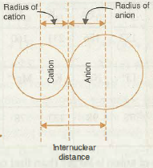](http://www.chemistry-assignment.com/wp-content/uploads/2012/12/069.png)

     Fig. 6.6.  lllustration of ionic radius

**The radius of cation is smaller than that of the parent atom.**

[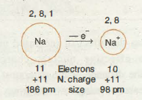](http://www.chemistry-assignment.com/wp-content/uploads/2012/12/070.png)

Fig. 6.7. Relative sizes of Na atom and Na+ion

Cation is formed by the loss of one or more electron from the gaseous atom. Now, in the cation the nuclear charge remains the same as that in the parent atom but the number of electrons becomes less. As a result of this, the nuclear hold on the remaining electrons increases because of the increase in the effective nuclear charge per electron. This causes a decrease in the size.

In many cases the formation of cation also involves the removal of the valence shell completely. For example, formation of Na+ ion from Na atom involves the removal of third shell completely. This also result in the decrease in the size of the ion.

The comparative sizes of certain atoms and their corresponding cations are given in Table 6.7.

**Table 6.7. Atomic and Ionic Radii of Some Elements**

[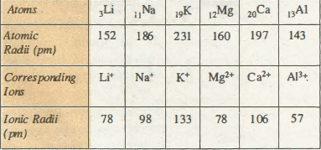](http://www.chemistry-assignment.com/wp-content/uploads/2012/12/071.png)

The radius of anion is larger than that of parent atom. Anion is formed by the gain of one or more electrons by the gaseous atom. In the anion, the nuclear charge is the same as that in the parent atom but the number of electrons has increased. Since same nuclear charge now acts on increased number of electrons, the effective nuclear charge per electron decreases in the anion. The electron cloud is held less tightly by the nucleus. This causes increase in the size. The relative sizes of chlorine atom and chloride ion have been shown in Fig. 6.8.

**Fig. 6.8. Relative sizes of Cl atom and Cl- ion.**

The comparative sizes of some atoms and their corresponding anions are given in Table 6.8.

**Table 6.8. Atomic and Ionic Radii of Some Elements**

**ISO-ELECTRONIC IONS**

The ions having same number of electrons but different magnitude of nuclear charge are called iso-electronic ions. In fact, these are the ions of different elements having same electronic arrangement. For example, each one of sulphide (S2-), chloride (Cl-) and potassium (K+) ion has eighteen electrons but they have different nuclear charge, +16, +17 and + 19 respectively.

**Variation of size among iso-electronic ions.** Within the series of iso-electronic ions, as the nuclear charge increases, the attractive force between the electrons and nucleus also increases. This results in the decrease of ionic radius. In other words, size of the iso-electronic ions decreases with the increase in the magnitude of nuclear charge. For example, N3-, ()2-, F”, Na+, Mg 2+, Al3+ are iso-electronic and have 10 electrons each. The sizes of these ions are in the order:

Mg2+ having the highest nuclear charge (12 units) bas the smallest size whereas N3- ion having the smallest nuclear charge (7 units) has the largest size. Variation of size among these ions has been shown in Table 6.9.

**Table 6.9. Variation of Size Among Iso-electronic Ions**

**SOLVED EXAMPLES**

`**Example 6.3** The following species are isoelectronic with the noble gas neon. Arrange them in order of increasing size: Na+, r-, Q2-, Mg2+, Al3+.

**Solution .** In Na+, p-, 02-, Mg2+, AJ3+, the nuclear charges are 11, 9, 8, 12 and 13 respectively. Among isoelectronic species, greater the nuclear charge smaller is the size. Therefore, the sizes of the above ionic species are in the order:

Al3+ < Mg2+ < Na+ < F- < O2-.

**Example 6.4.** Select from each group the species which has the smallest radius stating appropriate reason.

(i) O,O-, O2-   (ii) K+, srl+ , Ar

(iii) Si, P, CI

**Solution.** (i) The species 0 has the smallest radius because the radius of anion is always larger than the radius of the atom from which it is formed. o- and o:z- are anions of oxygen.

(ii) K+ has the smallest radius. In K+ and AI the outermost shell is third whereas in sc2+ it is fourth. Out of K+ and AI, K+ has smaller size because it has greater nuclear charge.

(iii) Cl has the smallest radius. Si, P and Cl belong to same period. In a period atomic radius decreases with increase in atomic number due to increase in effective nuclear charge.

**Example 6.5.** Name a species that will be isoelectronic with each of the following atoms or ions:

(i) Ne (ii) Cl- (iii) Ca2+ (iv) Rb

**Solution.** (i) Sodium ion, Na+

(ii) Potassium ion, K+

(iii) Sulphide ion, S2- (iv) sr+

**Example 6.6.** Out of Na+ and Na which has smaller size and why?

**Solution.** Na+ has smaller size than Na. Na+ is formed by removal of one electron from Na. Therefore, Na+ has one electron less than Na. However, Na and Na+ have same nuclear charge. Therefore, electrons in Na+ are more tightly held than in Na. Moreover, removal of one electron from Na leads to complete removal of the third shell so that in Na+, the outermost shell is second. Hence, Na+ has smaller size than Na.

**Example 6.7.** Give examples of three cations and three anions which are isoelectronic with argon.

**Solution**       Cations: K+, Ca2+, Sc3+

Anions: CI-,

Ionization Energy

It is a well-known fact that the electrons in an atom are  attracted by the positively charged nucleus. In order to remove electron from an atom, energy has to be supplied to it to

overcome the attractive force. This energy is referred to as ionization energy. Thus, Ionization energy may be defined as the amount of energy required to remove the most loosely bound electron from the isolated gaseous atom in its ground state.

A (g) + Energy (I.E.)                          A+ (g) + e-

Ionization energy is a very important property which gives an idea about the tendency of an atom to form a gaseous positive ion.

Ionization energy is expressed in terms of kilo Joules per mole of atoms (kJ moz-1)

**SUCCESSIVE  IONIZATION  ENERGIES**

Once the first electron has been removed from the gaseous atom, it is possible to remove second and successive electrons from positive ions one after the other. For example,

[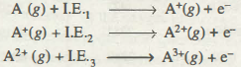](http://www.chemistry-assignment.com/wp-content/uploads/2013/01/1.png)

The amounts of energies required to remove most loosely bound electron from unipositive, dipositive, tripositive  ions of the element in gaseous state are called second, third, fourth  ionization energies respectively.

The second, third, fourth, etc. ionization energies are collectively known as successive ionization energies. It may be noted that:

[](http://www.chemistry-assignment.com/wp-content/uploads/2013/01/11.png)

The variation in the values of successive ionization energies can be explained, in general, as follows:

After the removal of first electron, the atom changes into monopositive ion. In the ion, the number of electrons decreases but the nuclear charge remains the same as in the parent atom. As a result of this, effective nuclear charge per electron increases. The remaining electrons are, therefore, held more tightly by the nucleus. Thus, more energy is required to remove the second electron. Hence, the value of second ionization energy is greater than the first.

Similarly, the removal of second electron results in the formation of divalent positive ion and the attraction between the nucleus and the remaining electrons increases further. This

accounts for the progressive increase in the values of successive ionization energies.

If the removal of first, second or third electron also results in the removal of the valence shell, the next electron (which , belongs to lower energy shell) will require very large amount

of energy for its removal. For example, in sodium, the removal of first electron leads to the removal of third shell completely. Therefore, for sodium, I.E.2 >> LET

[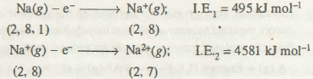](http://www.chemistry-assignment.com/wp-content/uploads/2013/01/12.png)

The first, second and third ionization energies of some elements are given in Table 6.10.

**Table 6.10. I.E.l‘ I.E.2 and I.E.3 Values**

**of Some Elements**

[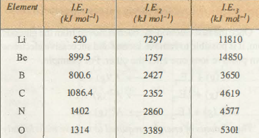](http://www.chemistry-assignment.com/wp-content/uploads/2013/01/13.png)

**FACTORS ON WHICH ION IZATION EN ERGY DEPENDS**

The ionization energy depends upon the following factors:

1 . Size of the atom;

2. Magnitude of nuclear charge;

3. Screening effect of the inner electron;

4. Penetration effect of the electrons; and

5. Electronic configuration.

**1. Size of the Atom.** The attractive force between the electron and the nucleus is inversely proportional to the distance between them. Therefore, as the size of the atom increases, the outermost electrons are less tightly held by the nucleus. As a result, it becomes easier to remove the electron. Therefore, ionization energy decreases with increase in  atomic size.

**2. Magnitude of Nuclear Charge**. The attractive force between the nucleus and the electrons increases with the increase in nuclear charge provided their main energy shell remains the same. This is because, the force of attraction is directly proportional to the product of charges on the nucleus  and that on the electron. Therefore, with the increase in I nuclear charge, it becomes more difficult to remove an electron and, therefore, ionization energy increases.

**3. Screening Effect of the Inner Electrons.** In multi electron atoms, the electrons present in the outermost shell do not experience the complete nuclear charge because of

repulsive interaction of the intervening electrons. Thus, the outermost electrons are shielded or screened from the nucleus by the inner electrons. This is known as screening effect.

If the number of electrons in the inner shells is large, the screening effect will be large. As a result, the attractive interactions between the nucleus and outermost electrons will be less. Consequently, ionization energy will decrease. Thus, if other factors do not change, an increase in the number of inner electrons tends to decrease the ionization energy.

**4. Penetration Effect of the Electrons.** It is a well-known fact that in case of multi-electron atoms, the electrons in the s-orbital have the maximum probability of being found near the nucleus and this probability goes on decreasing in case of p, d and f orbitals. In other words, s-electrons are more penetrating towards the nucleus than p-electrons. The penetration power decreases in a given shell (same value of n) in the order: s > p > d > f

Now, if the penetration of the electron is more, it experiences less shielding effect by the inner electrons and will be held firmly. Consequently, ionization energy will be high. This means· that ionization energy increases with increase in penetration power of the electrons. Thus, for the same shell, it is easier to remove the p-electrons in comparison to the s-electrons.

**5. Electronic Configuration**. It has been noticed that certain electronic configurations are more stable than the other. The atom having a more stable configuration has less tendency to lose the electron and consequently, has high value of ionization energy.. For example:

1. The noble gases have stable configuration (ns2np6). They have highest ionization energies within their respective periods.

1. The elements like N (ls2, 2s2, 2p1, 2py, 2p1) and P ( l s 2 2s 2 2p 6 3 s2 3p 1 3p 1 3p 1) have  configurations in which orbitals belonging to same sub-shell are exactly half-filled. Such  configurations are quite stable and consequently, require more energy for the removal of electron. Hence, their ionization energies are relatively high.

**VARIATION OF ION IZATION ENERGY IN THE PERIODIC TABLE**

Let us now, study the variation of ionization energy across the period and along the group of representative elements on :be basis of above factors.  
**Variation Across the Period**

In general, the value of ionization energy increases with e increase in atomic number across the period. This can be attributed to the fact that moving across the period from left  right,

(i) nuclear charge increases regularly;

(ii) addition of electrons occurs in the same energy level;

(iii) atomic size decreases.

Thus, due to the gradual increase in nuclear charge and simultaneous decrease in atomic size, the attractive force between the nucleus and the electron cloud increases. Consequently  the electrons are more and more tightly bound to the nucleus. This results in the gradual increase in ionization across the period. The ionization energies of the ments of 2nd periods are given in Fig. 6.9.

On carefully examining the values given in Fig. 6.9, wed some exceptions within the period. These can be explained on the basis of other factors governing ionization energy .

(i) There is an increase in ionization energy from Li to Be. This is due to increased nuclear charge and smaller atomic size.

[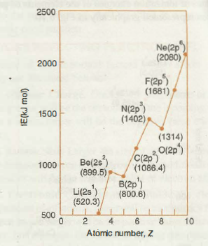](http://www.chemistry-assignment.com/wp-content/uploads/2013/01/14.png)

**Fig. 6.9. Variation of ionization energies**

**among elements of 2nd period.**

(ii) There is a decrease in the value of ionization energy from Be to B inspite of increased nuclear charge. The effect of increased nuclear charge is cancelled by (a) greater penetration of 2s electron as compared to 2p electron: (b) better shielding of 2p electrons by the inner electrons. Thus. 2p electron of boron is relatively less tightly held by its nucleus in comparison to 2s electrons of Be .

(iii) There is a regular increase in ionization energy from B to C to N. It is again due to gradual increase of nuclear charge and decrease of atomic size.

(iv) There is slight decrease in ionization energy from N to O. It is attributed to the relatively stable configuration of the nitrogen due to a half filled 2p-orbital. In the nitrogen atom three 2p-electrons are present in different atomic orbitals (Hund’s rule) whereas in the oxygen atom, two of the four 2p-electrons are present in the same 2p-orbital resulting in an increased electron-electron repulsion. Therefore, it is easier to remove one of the 2p-electron from oxygen than it is, to remove one of the 2p-electrons from nitrogen.

(v) There is an expected increase in ionization energy from O to F to Ne.

**Variation in a Group**

The values of ionization energies of elements decrease regularly with the increase in atomic number within a group.

The values of ionization energies of the elements of group 1 have been represented graphically in [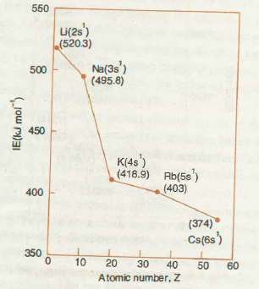](http://www.chemistry-assignment.com/wp-content/uploads/2013/01/15.png)

**Variation of ionization energy among elements of group 1.**

The decrease in the value of ionization energy within the group can be explained on the basis of net effect of the following factors:

As we move down the group there -is:

(i) A gradual increase in the atomic size due to progressive addition of new energy shells;

(ii) Increase in the shielding effect on the outermost electron due to in’2rease in the   number of inner electrons.

The nuclear charge also increases but the effect of increased nuclear charge is cancelled by the increase in atomic size and the shielding effect. Consequently, the nuclear hold on the valence electron decreases gradually and ionization energy also decreases. The variation of first ionization energy as a function of atomic number for elements with atomic number up to 60 have been shown in Fig. 6. 1 1 . The maxima in the curve represents noble gases which means that the

ionization energies of noble gases are highest- within their periods. The minima in the curve represent alkali metals which implies that ionization energies of alkali metals are the lowest

within their respective periods.

[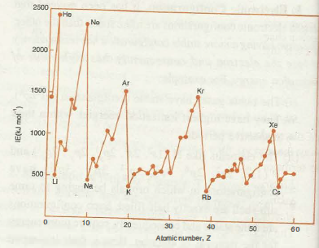](http://www.chemistry-assignment.com/wp-content/uploads/2013/01/16.png)

**Fig. 6.11. Ionization energies of elements up to Z = 60.**

**SOLVED EXAMPLES**

**Example 6.8**  From each set, choose the atom which has the largest ionization energy and explain your answer

(i) F, 0, N.       (ii) Mg, P, Ar.

(iii) B, Al, Ga.

**Solution .** (i) F has the highest ionization energy among F, 0 and N because it has smallest size and highest nuclear charge. In general, ionization energy increases as we go from left to right in a period.

(ii) Ar (a noble gas) has the highest ionization energy among the elements Mg, P and Ar because it has stable electronic configuration and maximum nuclear charge.

(iii) B, AI and Ga belong to group- 13. Among these elements B has the largest ionization energy because on moving down a group, from top to bottom, ionization energy decreases. B is the first element of group 13.

**Example 6.9.** Out of Na+ and Ne which has higher ionization energy ? Explain why.

**Solution.** Na+ has higher ionization energy than Ne. Na+ and Ne are isoelectronic species. However, the nuclear charge in Na+ is more than in Ne. Hence, the electrons are more tightly held in Na+ and it has higher ionization energy.

**Example 6. 10.** How do you explain that 31 Ga has slightly higher ionization energy than 13Al, although it occupies lower position in the group ?

**Solution.**      13AJ : 1s2, 2s2, 2p6, 3s2, 3pl

13Ga : ls2, 2?, 2p6, 3s2, 3p6, 3d10, 4s2, 4p1

In Ga, the 10 electrons present in 3d-sub-shell do not shield the outer electrons from the nucleus effectively. As a result, effective 1uclear charge in Ga increases. This explains why ionization energy of Ga is slightly more than that of 13Al.

Electron Affinity, Eea

We have already learnt that ionization energy is a measure of the tendency of the atom to form cation. In the similar way, the tendency of a gaseous atom to form anion is expressed in terms of electron affinity.

Electron affinity may be defined as the energy change taking place when an isolated gaseous atom accepts an electron to form a monovalent gaseous anion.

The values of electron affinity are expressed in kilo joules per mole of atoms. For example, electron affinity of chlorine is – 348 kJ mol-1, i.e.,

 Cl(g) + e- à    CI- (g) Eea = – 348 kJ mot-1

Depending on the element, the process of adding an electron can be either exothermic or endothermic.

The magnitude of electron affinity measures the tightness with which the atom can hold the additional electron. The large negative value of electron affinity reflects the greater tendency of an atom to accept the electron. For example, the elements of group-17 (the halogens) have  very high negative electron affinities because they can attain stable noble gas electronic configuration by gaining an electron. Thus, halogens have great tendency to accept an electron. On the other hand, the elements of group-18 (the noble gases) have large positive electron affinities because the additional electron goes to the next principal shell resulting in a very unstable electronic configuration.

**FACTORS AFFECTING ELECTRON AFFINITY**

Some of the important factors which affect electron affinity are discussed below:

**1. Nuclear Charge.** Greater the magnitude of nuclear charge greater will be the attraction for the incoming electron and as a result, larger will be the negative value of electron affinity.

**2. Atomic Size.** Larger the size of an atom is, more will be the distance between the nucleus and the additional electron and smaller will be the negative value of electron affinity.

**3. Electronic Configuration**. Stable the electronic configuration of an atom is, lesser will be its tendency to accept the electron and larger will be the positive value of its electron affinity. For example, the elements having completely filled sub-levels of the valence shell have relatively stable configurations and consequently, possess large positive values of electron affinity.

**VARIATION OF ELECTRON AFFINITY IN THE PERIODIC TABLE**

Since experimental determination of electron affinity is not as easy as that of ionization energy, the sufficient data regarding electron affinities is not available. Consequently, the varying trends of electron affinities are not well-defined. The electron affinities of some elements are given in Table 6. 1 1 .

**Table 6.11. Electron Affinities of Some Elements (kJ moi-1)**

[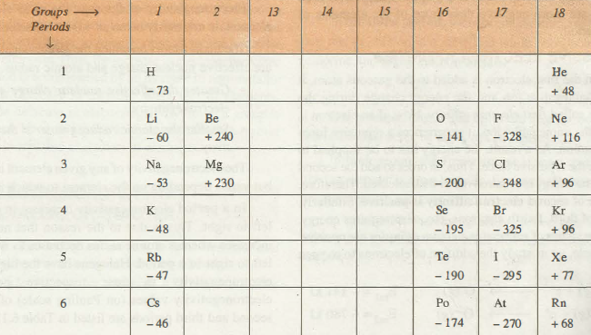](http://www.chemistry-assignment.com/wp-content/uploads/2013/01/17.png)

**Variation in a Period**

On moving across the period, the atomic size decreases and nuclear charge increases. Both these factors result into greater attraction for the incoming electron, therefore, electron

affinities tend to become more negative as we go from left to right across a period. However, some irregularities are observed among the elements of group 2, group 1 5 and group 18. The electronic configurations of these elements are relatively stable and hence, these elements have positive or very low negative electron gain enthalpies.

**Variation Down a Group**

On moving down a group, the atomic size as well as nuclear charge increases. But the effect of increase in atomic size is much more pronounced than that of nuclear charge and thus, the additional electron feels less attraction. Consequently, electron affinity becomes less negative on going down the group. Let us now examine the values of electron affinity for halogens as shown in Table 6. 1 1 .

It may be noted that the electron affinity becomes less negative as we go from chlorine to bromine to iodine. However, as we move from fluorine to chlorine the electron affinity becomes more negative whereas reverse was expected. This is because when an electron is added· to fluorine atom, it goes to the relatively compact second energy level. As a result, it experiences significant repulsion from the other electrons present in this shell. On the other hand, in chlorine atom, the added electron goes to the third energy shell which is relatively larger. Hence, it experiences Jess electron-electron repulsion. Therefore, electron affinity of fluorine is less negative as compared with chlorine. The unexpected trend is observed in case of many other elements of third period as their electron affinities are more negative than those of the elements of second period.

**SUCCESSIVE ELECTRON AFFINITIES**

When the first electron is added to the gaseous atom, it forms a uninegative ion and the energy change during the process is called .first electron affinity. Now, if an electron is added to the uninegative ion, it experiences a repulsive force from the anion. As a result, the energy has to be supplied to overcome the repulsive force. Thus, in order to add the second electron, the energy is required rather than released. Therefore, the value of second electron affinity is positive. Similarly, addition of third, fourth electrons, etc., also requires energy. Hence, the values of successive electron affinities are positive. For example, let us study the addition of electrons to oxygen atom

[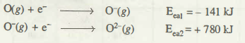](http://www.chemistry-assignment.com/wp-content/uploads/2013/01/18.png)

**SOLVED EXAMPLE**

**Example 6.11** . Which of the following will have the most negative electron affinity and which the least negative?

P, S, Cl, F.

Explain your answer.

**Solution.** Electron affinity generally becomes more negative across a period as we move from left to right. Therefore, among P, S and Cl the order of negative electron affinity is Cl > S > P. Within a group, electron affinity becomes less negative down a group. However, adding an electron to the 2p-orbital leads to greater repulsion than adding an electron to the larger 3p-orbital. Therefore, electron affinity of Cl is more negative than that of F. Hence, the element with most negative electron affinity is Cl the one with the least negative electron affinity is P.

**Electronegativity**

Electronegativity

Electronegativity may be defined as the tendency of an atom in a molecule to attract towards itself the shared pair of electrons.

It may be mentioned here that unlike ionization energy and electron affinity, electronegativity is not a measurable quantity. However, in order to compare the electronegativity values of different elements a number of numerical scales of electronegativity of elements have been proposed. The most common and widely use scale of electronegativity is the

**Pauling scale.**

Pauling’s scale of electronegativity is based on excess bond energies. Electronegativity of fluorine, the most electronegative element, is arbitrarily taken as 4.0 in this scale.

The main factors on which the electronegativity depends are effective nuclear charge and atomic radius.

• Greater the effective nuclear charge greater is the electronegativity.

• Smaller the atomic radius greater is the electronegativity.

The electronegativity of any given element is not const3nt but varies depending on the element to which it is bound.

In a period electronegativity increases in moving from left to right. This is due to the reason that nuclear charge increases whereas atomic radius decreases as we move from left to right in a period. Halogens have the highest value of electronegativity in their respective periods. The electronegativity values (on Pauling scale) of elements of second and third periods are listed in Table 6.12.

**Table 6.12. Electronegativity Values of Elements of Second and Third Periods**

|  |  |
| --- | --- |
| Elements of Second Period                  Li                Be  Electronegativity                                   1.0             1.5  Elements of Third Period                     Na             Mg  Electronegativity                                  0.9             1.2 | B           C         N         O           F  2.0          2.5     3.0         3.5      4.0  Al             Si      p           s          CI  1.5         1.8       2.1        2.5      3.0 |

In a group electronegativity decreases on moving down the group. This is due to the effect of increased atomic radius. for example, among halogens fluorine has the highest etectronegativity. In fact, fluorine has the highest value of etectronegativity among all the elements.

The electronegativity values (on Pauling scale) of group and group 17 elements are given in Table 6.13.

**Table 6.13. Electronegativity Values of Group-1 and Group-17 Elements**

[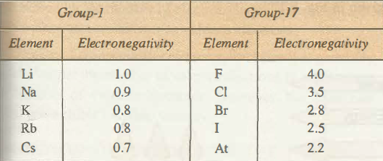](http://www.chemistry-assignment.com/wp-content/uploads/2013/01/19.png)

**Relationship between Electronegativity and Non-metallic or Metallic) Character of an Element**

Non-metallic elements have strong tendency to gain electrons. Therefore, electronegativity is directly related to he non-metallic character of elements. We can also say that the electronegativlty is inversely related to the metallic character of elements. Thus, the increase in electronegativities .across a period is accompanied by an increase in non-metallic character (or decrease in metallic character) of elements. Similarly, the decrease in electronegativity down a group is accompanied by a decrease in non-metallic character or increase in metallic character) of elements.

Electropositivity or Metallic Character

Tendency of atoms of an element to lose electrons and form positive ion is known as electropositivity.

A more electropositive element has more metallic character.

Whether an element behaves as a metal or a non-metal is directly related to its ionization energy. The elements having low values of ionization energies are metals whereas e1ements having high values of ionization energies are non-metals. The border line elements behave as metalloids.

**Variation of Metallic Character Across a Period**

Metallic character decreases across a period from left to right. On the other hand non-metallic character increases with increase in atomic number across a period. For example, let us consider elements of second and third periods.

[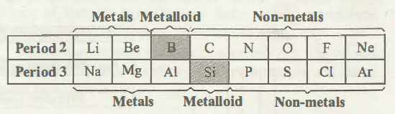](http://www.chemistry-assignment.com/wp-content/uploads/2013/01/110.png)

In the second period, lithium and beryllium are metals, boron is a metalloid while carbon, nitrogen, oxygen, fluorine and neon are non-metals.

In the third period, sodium, magnesium and aluminium are metals, silicon is a metalloid while phosphorus, sulphur chlorine and argon are non-metals.

**Variation of Metallic Character along a Group**

On going along a group from top to bottom, the metallic character of elements increases.

In each group, the first element is least metallic while the last element is most metallic. For example, let us consider the elements of groups 14 and 15.

In group 14, the first element carbon is a non-metal, silicon and germanium are metalloids while tin and lead are metals.

[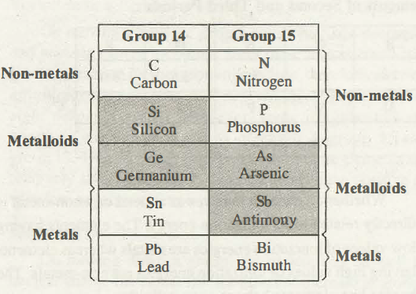](http://www.chemistry-assignment.com/wp-content/uploads/2013/01/111.png)

In group 15, the first two elements, nitrogen and phosphorus, are non-metals while arsenic and antimony are metalloids and bismuth is a metal.

It may be mentioned here that metals generally form cations by losing electrons from the outermost shell while non-metals generally form anions by accepting one or more electrons. For example, alkali metals form M+ ions by losing

**SOLVED EXAMPLES**

**Example 6.12** Arrange the following elements in the increasing order of metallic character:

8, At, Mg, K

**Solution**. Metallic character increases on moving down the group and decreases on going across a period from left to right. Hence, the· order of increasing metallic character is B <Al < Mg < K. one electron while alkaline earth metals form M2+ ions by losing two electrons from the outermost shell. The nonmetallic elements of group 17 form anions (X-) by accepting one electron.

**The periodic trends of various physical properties are given in Fig. 6.12.**

[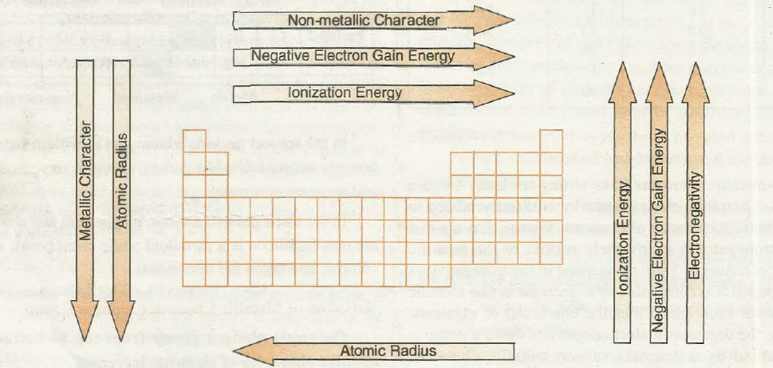](http://www.chemistry-assignment.com/wp-content/uploads/2013/01/112.png)

**Fig. 6.12. The general periodic trends of various physical properties in the periodic table.**

**Example 6.13** Arrange the following elements in the increasing order of non-metallic character:

B, C, Si , N, F

**Solution .**  Non-metallic character increases across a period from left to right and decreases on moving down the group from top to bottom. Hence, the order of increasing non-metallic character is

Si < B < C < N < F.

**Example 6.14** Among the elements B, AI, C and Si

( i) Which has the highest first ionization energy?

(ii) Which has the most negative electron gain energy?

(iii) Which has the largest atomic radius?

(iv) Which has the most metallic character?

**Solution** . (i) Carbon (C) has the highest first ionization energy.

(ii) Carbon (C) has the most negative electron gain energy.

(iii) Aluminium (AI) has the largest atomic radius.

(iv) Aluminium (AI) has the most metallic character.

Valency

The valency of an element may be defined as the combining capacity of element.

The valency of an element may be expressed in terms of the number of electrons that an atom of the element makes available for bonding. The valency of an element is determined by the number of electrons in the outermost shell. These electrons are known as valence electrons.

In case of representative elements, the valency is generally  equal to either the number of valence electrons or eight minus the number of valence electrons. However,· the transition elements, exhibit variable valency.

**VARIATION OF-VALENCY IN THE PERIODIC ABLE**

**variation in a Period**

The number of valency electrons increases from 1 to 8 on moving across a period, the valency of the elements with respect to hydrogen and chlorine increases from 1 to 4 and then decreases from 4 to zero. Table 6.14 shows the valencies of the elements of 2nd and 3rd periods. The valencies of the elements have been shown in brackets.

**Variation in a Group**

On moving down a group, the number of valence electrons remains .same and, therefore, all the elements in a group exhibit same valency. For example, all the elements of group 1 have valency equal to 1 and those of group 2 have valency equal to 2.

**Table 6.14. Variation of Valencies and Type of Bonding Among Elements of Second and Third Periods**

[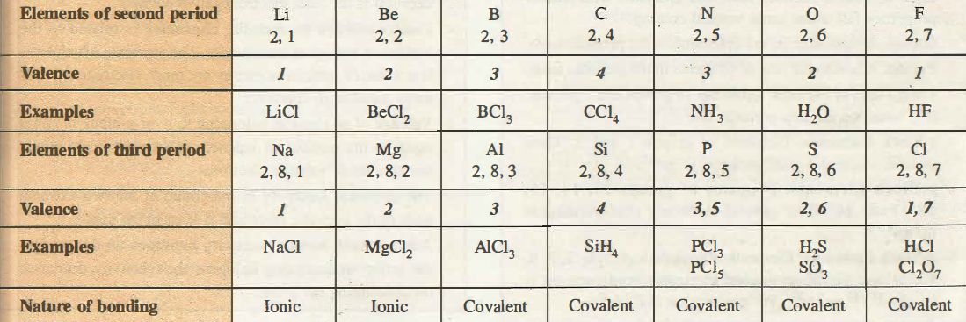](http://www.chemistry-assignment.com/wp-content/uploads/2013/01/113.png)

**SOLVED EXAMPLE**

**Example 6.15**  Predict the formulae of the stable binary compounds that would be formed by the following pairs of elements:

(i) silicon and oxygen              (ii) aluminium and bromine

(iii) calcium and iodine

**Solution.** (i) Silicon belongs to group 14. Its valency is 4. The valency of oxygen is 2. Thus, the binary compound between silicon and oxygen would have formula Si02

(ii) Aluminium belongs to group 13. Its valency is 3. The valency of bromine is 1. Thus, the binary compound between  aluminium and bromine would have formula AlBr 3

(iii) Calcium belongs to group 2. Its valency is 2. The valency of iodine is 1. Thus, the compound between calcium and iodine would have formula CaI 2

Valency

The valency of an element may be defined as the combining capacity of element.

The valency of an element may be expressed in terms of the number of electrons that an atom of the element makes available for bonding. The valency of an element is determined by the number of electrons in the outermost shell. These electrons are known as valence electrons.

In case of representative elements, the valency is generally  equal to either the number of valence electrons or eight minus the number of valence electrons. However,· the transition elements, exhibit variable valency.

**VARIATION OF-VALENCY IN THE PERIODIC ABLE**

**variation in a Period**

The number of valency electrons increases from 1 to 8 on moving across a period, the valency of the elements with respect to hydrogen and chlorine increases from 1 to 4 and then decreases from 4 to zero. Table 6.14 shows the valencies of the elements of 2nd and 3rd periods. The valencies of the elements have been shown in brackets.

**Variation in a Group**

On moving down a group, the number of valence electrons remains .same and, therefore, all the elements in a group exhibit same valency. For example, all the elements of group 1 have valency equal to 1 and those of group 2 have valency equal to 2.

**Table 6.14. Variation of Valencies and Type of Bonding Among Elements of Second and Third Periods**

[](http://www.chemistry-assignment.com/wp-content/uploads/2013/01/113.png)

**SOLVED EXAMPLE**

**Example 6.15**  Predict the formulae of the stable binary compounds that would be formed by the following pairs of elements:

(i) silicon and oxygen              (ii) aluminium and bromine

(iii) calcium and iodine

**Solution.** (i) Silicon belongs to group 14. Its valency is 4. The valency of oxygen is 2. Thus, the binary compound between silicon and oxygen would have formula Si02

(ii) Aluminium belongs to group 13. Its valency is 3. The valency of bromine is 1. Thus, the binary compound between  aluminium and bromine would have formula AlBr 3

(iii) Calcium belongs to group 2. Its valency is 2. The valency of iodine is 1. Thus, the compound between calcium and iodine would have formula CaI 2

Periodic Trends and Chemical Reactivity

We have already studied the periodic trends in the various fundamental properties such as atomic and ionic radii, ionization energy, electron affinity, electronegativity and valence. The periodic trends in these properties can be explained on the basis of electronic configuration of the elements. The chemical reactivity of elements can be related to the fundamental properties of elements. As already discussed the ionization energy is least for the element at the extreme left of the period and the electron affinity is most negative for the element at the extreme right of the period (For group-17 elements). The elements of group-18 have positive electron affinity due to their stable electronic configurations. As a result, the chemical reactivity is maximum at the two extremes and lowest in the centre. The extreme reactivity of group-1 elements is due to the ease with which these elements can lose an electron leading. to the formation of corresponding cation. On the other hand, the reactivity of halogens is due to the ease with which these elements can gain an electron to form the corresponding anion. Thus, elements at the extreme left exhibit strong reducing behaviour whereas the elements at the extreme right exhibitstrong oxidizing behaviour.

Since ionization energy of alkali metals decreases on moving down the group their reactivity increases from lithium to caesium. For example, lithium reacts with water slowly, sodium reacts vigorously whereas potassium reacts almost violently. Reaction of caesium with water is explosive

2M + 2H2O                2MOH + H2

(M = Li, Na or K)

On the other hand among halogens, the reactivity decreases on going down the group because tendency to gain electron becomes less on descending the group.

Noble gases are almost inert due to their stable electronic configuration.

**EVALUATION**

1. The correct order of size among Cl, Cl+ and CI- is

(a) CI+ < CI- < Cl (b) Cl+ > CI- > Cl

(c) Cl+ < Cl < CI- (d) CI- < Cl < CJ+.

2. Considering the elements B, Al, Mg, and K, the correct order of their metallic character is

(a) B > Al > Mg > K               (b) Al > Mg > B > K

(c) Mg > Al > K > B                (d) K > Mg > Al > B.

3. Which of the following represents the correct order of ionic radii?

(a) s2- > Cl- > K+ > Ca2+      (b) Ca2+ > K+ > CI- > s2-

(c) CI- > S2- > K+ > Ca2+      (d) S2- > Ca2+ > K+ > CI-.

.

4. The first ionization energies of Na, Mg, Al and Si are in the order

(a) Na < Mg > Al < Si             (b) Na > Mg > Al > Si

(c) Na < Mg < Al > Si              (d) Na > Mg > AI < Si.

5. Keeping in view, the periodic law and periodic table, suggest which of the following elements should have maximum electronegative character?

(a) Oxygen      (b) Nitrogen

(c) Fluorine      (d) Astatine.

6. Which of the following structures is associated with the biggest jump between the second and the third ionization energies?

(a) 1s22s22p6              (b) 1s22s22p63 s1

(c) ls22s22p63s2         (d) 1s22s22p1.

 7. The statement that is not correct for periodic classification of elements is

 (a)    the properties of elements are a periodic function of their atomic numbers.

(b)   non-metallic elements are less in number than metallic elements.

(c)    the first ionization energies of elements along a period do not vary in a regular manner   with increase in atomic number.

(d)   for transition elements, the d-subshells are filled with electrons monotonically with increase in atomic number.

8. Which one of the following statements is incorrect in relation to ionization energy?

(a)    Ionization energy increases for each successive electron.

(b)   The greatest increase in ionization energy is experienced on removal of electron from core noble gas configuration.

(c)    End of valence electrons is marked by a big jump in ionization energy.

(d)   Removal of electron from orbitals bearing lower n value is easier than from orbital having higher n value.

 9. The incorrect statement among the following is

(a) The first ionization energy of Al is less than the first ionization energy of Mg

(b) The second ionization energy of Mg is greater than the second ionization energy of Na

(c) The first ionization energy of Na is less than the first ionization energy of Mg

(d) The third ionization energy of Mg is greater than the third ionization energy of AL

10.  Which of the following ions has the highest value of ionic radius?

(a) Li+ (b) BJ+

(c) oz- (d) p-

11.  Which one of the following sets of ions represents the collection of isoelectronic species?

(a) K+, Ca2+, Sc3+, Cl-          (b) Na+, Ca2+, Sc3+, p-

(c) K+, Cl-, Mg2+, Sc3+         (d) Na+, Mg2+, Al3+, Cl-

(Atomic numbers: F= 9, Cl = 17, Na = 11, Mg = 12, Al = 13,

K = 19, Ca = 20, Sc = 21).

**II. Fill in the blanks.**

12 . Complete the following sentences by supplying appropriate words.

(i) The most electropositive element in second period is …… whereas the most electronegative element is …….

(ii) The ionization energy of nitrogen is …… than that of oxygen.

(iii) There are …… periods in long form of periodic table and …… groups.

(v) The d-block elements are known as …… metals.

(vi) Ca2+ has a smaller ionic radius than K+ because it has …… .

(vii) Among halogens, the most negative electron affinity is of

(viii) The element with highest value of first ionization energy is …… .

(ix) Metallic radius is …… than the covalent radius.

(x) Moderm periodic law was proposed by ……

(xi) Metallic character …… from top to bottom in a group.

(xii) Amongst the elements Na, Mg and Al the highest value of second ionization energy is of …… .

13. Out of metallic radius and covalent radius of an element, which is larger and why?

14. Why van der Waals’ radius of an element is always larger than the covalent radius?

15. Out of the following ions which has the smallest ionic size?

Li+, Na+, K+

16. Arrange the following ions in the increasing order of their sizes.

CI-, P3-, s2-, F -

17. Arrange the following sets of ions in the decreasing order of their sizes

(i) Al3-, Mg2+, Na+,O2-, F(

(ii) Na+, Mg2+, K+.

18. Out of I and I+ which has larger size and why?

19. Which element has the highest ionization energy?

20. Among the alkali metals which element has the highest ionization energy?

21. Arrange each of the following sets of elements in the increasing order of their ionization energies:

(i) 0, N, S                    (ii) C, N, 0

(iii) Li, Be, Na             (iv) Ne, He, Ar.

22. Out of Na (Z = 11) and Mg (Z = 12), which has higher second ionization energy and why?

23. Explain why

(i) Be has higher ionization energy than B

(ii) 0 has lower ionization energy than N and F?

24. Why halogens have highest negative electron affinities in their respective periods?

25. Why noble gases have largest positive electron affinity in their respective periods?

26.  Comment on the statement that “all elements having high ionization energies also have high negative electron affinities.”

27. Out of oxygen and sulphur, which has greater negative electron affinity and why?

28. Consider the electronic configurations of the elements X, Y and Z and answer.

X : ls2, 2s2, 2px1, 2py1

Y : ls2 2 s2 2p 2 2p 1 2p 1

Z: 1s2, 2s2, 2px1, 2py1, 2pz1

(i) Which element has highest negative electron affinity?

(ii) Which element has lowest negative electron affinity?

 29. In each of the following sets, arrange the elements in the increasing order of their negative electron affinities:

(i)C,N,O          (ii) 0, N, S

(iii) S, Cl, Ar    (iv) F, Cl, Br.

 30. What is the trend of metallic character on going down from top to bottom in a group?

31. Define electronegativity. How does it vary along a period and along a group?

32. What is the basic difference between the terms electron affinity and electronegativity?

33. Why second ionization energy is always higher than first ionization energy?

 34. A, B, C are three elements with atomic numbers, Z- 1, Z, Z + 1 respectively. B is an inert gas.

Answer the following questions:

(i) Predict the group of A and C.

(ii) Which out of the three has positive electron gain energy and why?

(iii) Which of the three has least value of ionization energy?

35. The electronic configurations of some elements are given as:

(a) [Ne] 3s2 3p3          (b) [Ne] 3s2 3p4

(c) [Ne] 3s2 3r             (d) [Ne] 3s2 3p63tf’ 4s1

(i) Which element will be most metallic ?

(ii) Which element will have most negative electron affinity?

(iii) Which element belongs to d-block?

(iv) Which element belongs to group 17?

(v) Out of a, b and c which will have least ionization energy?

36. Account for the following:

(i) Be has slightly higher value of ionization energy than that of boron (B).

(ii) The ionization energy of Na+ is more than that of Ne although they have same configuration.

(iii) Electron affinity of Cl is more negative than that of F. Among the elements of second period Li to Ne pick out the element

(i) with the highest ionization energy

(ii) with highest negative electron affinity

(iii) with largest covalent radius

(iv) that is most reactive non-metal

(v) that is most reactive metal.

37. The first (IE1) and the second (IE2) ionization energies (in kJ moJ-1) and the electron affinity (in kJ mol-1) of a few elements are a given as follows:

[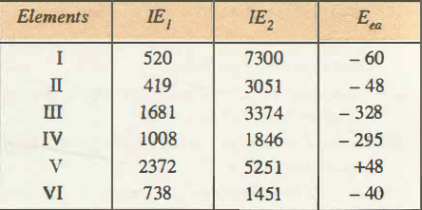](http://www.chemistry-assignment.com/wp-content/uploads/2013/01/114.png)

Which of the above element is likely to be:

(i) the least reactive element.

(ii) the most reactive metal.

(iii) the most reactive non-metal.

(iv) the least reactive non-metal.

(v) the metal which can form a stable binary halide of the formulae .

**WEEK 3**

**Concept of Oxidation and Reduction**

→ Classical Concept of Oxidation and Reduction

In our daily life we come across processes like rusting of iron articles, fading of the colour of the clothes, burning of the combustible substances such as cooking gas, wood, coal, etc. All these processes fall in the category of redox reactions. A large number’ of industrial processes like, electroplating, extraction of metals like aluminium and sodium, bleaching of wood pulp, manufacture of caustic soda, etc., are also based upon the redox reactions: Redox reactions also form the basis of electrochemical and electrolytic cells. In the present unit we shall understand the meaning of oxidation, reduction, oxidising agents and reducing agents.

**CLASSICAL CONCEPT OF OXIDATION AND REDUCTION**

According to classical concept following definitions were proposed to explain the process of oxidation and reduction.

Oxidation: It is a process of chemical addition of oxygen or any electronegative radical or removal of hydrogen or any electropositive radical.

Reduction: It is a process of chemical addition of hydrogen or any electropositive radical or removal of oxygen or any electronegative radical.

Some examples of oxidation and reduction reactions are given below:

(i)                 Peaction of PbO and carbon

[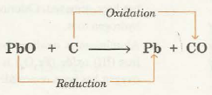](http://www.chemistry-assignment.com/wp-content/uploads/2013/02/1131.png)

Here, oxygen is being removed from lead oxide (PbO) and is being added to carbon (C). Thus, PbO is reduced while C is oxidised.

(ii) Reaction of H2S and Cl2

[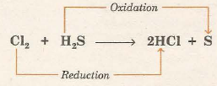](http://www.chemistry-assignment.com/wp-content/uploads/2013/02/1132.png)

Here, hydrogen is being removed from hydrogen sulphide (H2S) and is being added to chlorine (C2S). Thus, H2S is oxidised and Cl2 is reduced.

(iii) Reaction between Mg and F2

[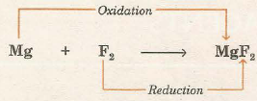](http://www.chemistry-assignment.com/wp-content/uploads/2013/02/1133.png)

Here, electronegative radicals fluoride ion (p) is added to magnesium while electropositive radical Mg2+ is added to fluorine. Hence, Mg is oxidised and F2 is reduced.

Looking at all the reactions given above we observe that oxidation and reduction occurs simultaneously, hence the word “redox” was coined for this class of chemical reactions.

**OXIDATION-REDUCTION IN TERMS OF ELECTRON TRANSFER**

In order to understand electronic concept of oxidation and reduction let us study the reaction of magnesium with oxygen. When magnesium is burnt in oxygen it gets oxidised to magnesium oxide (MgO). In the formation of magnesium oxide, two electrons from magnesium atom are transferred to oxygen atom.

[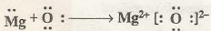](http://www.chemistry-assignment.com/wp-content/uploads/2013/02/1135.png)

The process of transference of electrons is described as redox process. Let us define oxidation and reduction in terms of electrons.

Oxidation is a process in which an atom or a group of atoms taking part in chemical reaction loses one or more electrons. The loss of electrons results in the increase of positive charge or decrease of negative charge of the species.

For example,

[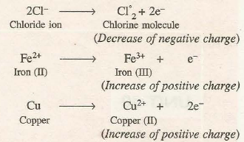](http://www.chemistry-assignment.com/wp-content/uploads/2013/02/1136.png)

The species which undergo the loss of electrons during the reactions are called reducing agents or reductants. Cl-, Fe2+ and Cu are reducing agents in the above examples.

Reduction is a process in which an atom or a group of atoms taking part in chemical reaction gains ·one or more electrons. The gain of electrons results in the decrease of positive charge or increase of negative charge of the species. For example,

[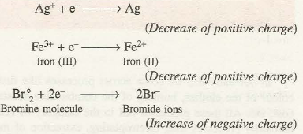](http://www.chemistry-assignment.com/wp-content/uploads/2013/02/1137.png)

The species which undergo gain of electrons during the reactions are called oxidising agents or oxidants. In the above examples, Ag+, Fe3+ ions, Br2 molecule are oxidising agents.

**SIMULTANEOUS OCCURRENCE OF OXIDATION AND REDUCTION**

Since oxidation involves loss of electrons and reduction involves gain of electrons, it is evident that if one substance loses electrons, another substance at the same time must gain electrons because electrons cannot be the products in any chemical change. This means that in any process, oxidation can occur only if reduction is also taking place side by side and vice versa. Thus, neither oxidation, nor reduction can occur alone. Both the processes are complementary like give and take and proceed simultaneously. That is why chemical reactions involving reduction-oxidation are called redox reactions. In fact, during the redox reaction there is a transference of electrons from the reducing agent to the oxidising agent as shown below:

[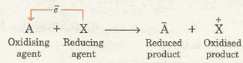](http://www.chemistry-assignment.com/wp-content/uploads/2013/02/1138.png)

For example, consider a reaction between zinc and copper ions

[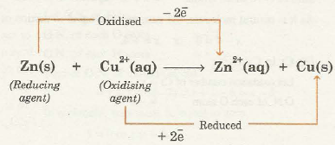](http://www.chemistry-assignment.com/wp-content/uploads/2013/02/1139.png)

In this reaction zinc atoms lose electrons and are oxidised to zinc ions (Zn2+) whereas cupric ions (Cu2+) gain electrons and are reduced to copper atoms. Thus, cupric ions act as oxidising agent and zinc atoms act as reducing agent. In fact the oxidising agent gets reduced while reducing agent gets oxidised during the redox reactions.

**Oxidation Number or Oxidation State**

In many covalent reactions such as reaction between H2 and Cl2:

H2(g) + Cl2(g) à 2HCl(g)

the loss and gain of electrons could not be easily explained. In order to explain transference of electrons in either of the species in a more convenient way, the concept of oxidation number has been introduced.

Oxidation number (O.N.) of the element is defined as the residual charge which its atom has or appears to June when all other atoms from the molecule are assumed to be removed as ions by counting the shared electrons with more electronegative atom.

For example, in hydrogen chloride molecule, chlorine is more electronegative than hydrogen. Therefore, the shared pair is counted towards chlorine atom as shown below:

As a result of this, chlorine gets one extra electron and acquires a unit negative charge. Hence, oxidation number of chlorine is -1. On the other hand, hydrogen atom without electron has a unit positive charge. Hence, oxidation number of hydrogen in hydrogen chloride is + 1.

It may be noted that electrons shared between two similar atoms are divided equally between the sharing atoms. Hence in molecules like H2, Cl2, Br2 the oxidation number of element is zero.

**RULES FOR ASSIGNING OXIDATION NUMBER TO AN ATOM**

These rules have been formulated on the basis of the assumption that electrons in a covalent bond belong entirely to the more electronegative atom.

1. The oxidation number of the element in the free or elementary state is always zero irrespective of its allotropic form.

For example,

Oxidation number of helium in           He = 0

Oxidation number of chlorine in         Cl2 = 0

Oxidation number of sulphur in          S8 = 0

Oxidation number of phosphorus in   P4 = 0

2. The oxidation number of the element in monoatomic ion is equal to the charge on the ion. For example, in K+CI-, the oxidation number of K is + 1 while that of Cl is -1. In the similar way, oxidation number of all the alkali metals is + 1 while those of alkaline earth metals is +2 in their compounds.

3. The oxidation number of fluorine is always -1 in all its compounds. Other halogens (Cl, Brand I) also have an oxidation number of -1, when they occur as halide ions in their compounds. However, in oxoacids and oxoanions they have positive oxidation numbers.

4. Hydrogen is assigned oxidation number + 1 in all its compounds except in metal hydrides. In metal hydrides like NaH, MgH2 , CaH2, LiH, etc., the oxidation number of hydrogen is -1.

5. Oxygen is assigned oxidation number -2 in most of its compounds, however, in peroxides (which contain 0-0 linkage) like H2O 2, BaO2, Na2O2, etc., its oxidation number is -1. Similarly, the exception also occurs in compounds of fluorine and oxygen like OF2 (F-0-F) and 0 2F2 (F-0- 0 – F) in which the oxidation number of oxygen is +2 and+ 1 respectively.

6. In accordance with principle of conservation of charge, the algebraic sum of the oxidation numbers of all the atoms in molecule is zero. But in case of polyatomic ion the sum of oxidation numbers of all its atoms is equal to the charge on the ion.

7. In binary compounds of metal and non-metal, the metal atom has positive oxidation number while the non-metal atom has negative oxidation number. For example, O.N. of Kin KI is +1 but O.N. of l is – l.

8. In binary compounds of non-metals, the more electronegative atom has negative oxidation number, but less electronegative atom has positive oxidation number. For example, O.N. of Cl in CIF3 is positive (+3) while that in ICl is negative (-1).

By the application of above .rules, we can find the oxidation number of the desired element in a molecule or in an ion. It may be noted that if a molecule contains two or more atoms of same element, then oxidation number calculated by these rules is average oxidation number.

Let us apply the above rules to calculate the oxidation number of some elements.

**Oxidation and Reduction in Terms of Oxidation Number**

After having discussed the concept of oxidation number, let us now define oxidation and reduction in terms of oxidation number. Oxidation is defined as a chemical process in which oxidation number of the element increases. On the other hand, reduction is defined as the chemical process in which oxidation number of the element decreases. For example, let us consider the reaction between hydrogen sulphide and bromine to give hydrogen bromide and sulphur.

[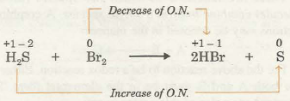](http://www.chemistry-assignment.com/wp-content/uploads/2013/02/1140.png)

In the above example, the oxidation number of bromine decreases from 0 to -1, thus, it is reduced. The oxidation number of S increases from – 2 to 0. Hence, ~S is oxidised.

Let us now define oxidising and reducing agents in the light of the concept of oxidation number:

Oxidising agent is a substance which undergoes decrease in the oxidation number of one or more of its elements.

Reducing agent is a substance which undergoes increase in the oxidation number of one or more of its elements. In the above example, H2S is reducing agent while Br2 is oxidising agent.

**OXIDATION HALF AND REDUCTION HALF REACTIONS**

Every redox reaction can be split up into two half reactions. The part of the redox reaction which represents loss of electrons or increase in oxidation number, is called oxidation half reaction while the other part which represents gain of electrons or decrease in oxidation number, is called reduction half reaction. Some examples are given below:

(i)                 The reaction: Zn + Cu2+ àZn2+ + Cu, can be split up into two half equations as

[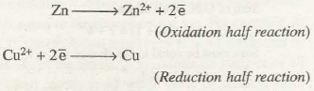](http://www.chemistry-assignment.com/wp-content/uploads/2013/02/1142.png)

(i)                 The reaction: Sn2+ + 2Hg2+ à Sn4+ + Hg2 can be split up into half reactions as

[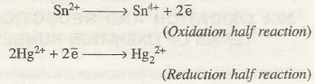](http://www.chemistry-assignment.com/wp-content/uploads/2013/02/1143.png)

OXIDATION NUMBER AND IUPAC NOMENCLATURE

"Oxidation state" is defined as the charge an atom might be imagined to have when electrons are counted according to an agreed-upon set of rules:

1. the oxidation state of a [free element](https://en.wikipedia.org/wiki/Free_element) (uncombined element) is zero
2. for a simple [(monatomic) ion](https://en.wikipedia.org/wiki/Monatomic_ion), the oxidation state is equal to the net charge on the ion
3. hydrogen has an oxidation state of +1 and oxygen has an oxidation state of −2 when they are present in most compounds. Exceptions to this are that hydrogen has an oxidation state of −1 in [hydrides](https://en.wikipedia.org/wiki/Hydride) of active metals, e.g. [LiH](https://en.wikipedia.org/wiki/Lithium_hydride), and oxygen has an oxidation state of −1 in [peroxides](https://en.wikipedia.org/wiki/Peroxide), e.g. [H  
   2O  
   2](https://en.wikipedia.org/wiki/Hydrogen_peroxide).
4. the algebraic sum of oxidation states of all atoms in a neutral molecule must be zero, while in ions the algebraic sum of the oxidation states of the constituent atoms must be equal to the charge on the ion.

## Determining the oxidation state or number

There are two different methods for determining the oxidation state of elements in chemical compounds. First (and widely taught) a method based on the rules in the IUPAC definition (see above). Second, a method based on the relative electronegativity of the elements in the compound, where the more electronegative element is assumed to take the negative charge.

### Simple examples using IUPAC definition

* Any pure element—even if it forms [diatomic molecules](https://en.wikipedia.org/wiki/Diatomic_molecule) like [chlorine](https://en.wikipedia.org/wiki/Chlorine) (Cl  
  2)—has an oxidation state of zero. Examples of this are [Cu](https://en.wikipedia.org/wiki/Copper) or [O  
  2](https://en.wikipedia.org/wiki/Oxygen).
* For monatomic [ions](https://en.wikipedia.org/wiki/Ion), the oxidation state is the same as the charge of the ion. For example, the [sulfide](https://en.wikipedia.org/wiki/Sulfide) anion (S2−  
  ) has an oxidation state of −2, whereas the [lithium](https://en.wikipedia.org/wiki/Lithium) cation (Li+  
  ) has an oxidation state of +1.
* The sum of oxidation states for all atoms in a [molecule](https://en.wikipedia.org/wiki/Molecule) or [polyatomic ion](https://en.wikipedia.org/wiki/Polyatomic_ion) is equal to the charge of the molecule or ion. Thus, the oxidation state of one element can be calculated from the oxidation states of the other elements.

1. An application of this rule is that the sum of the oxidation states of all atoms in a neutral molecule must be zero. Consider a neutral molecule of [carbon dioxide](https://en.wikipedia.org/wiki/Carbon_dioxide), CO  
   2. Oxygen is assumed to have its usual oxidation state of −2, and so the sum of the oxidation states of all the atoms can be expressed as *x* + 2(−2) = 0, or *x* − 4 = 0, where *x* is the unknown oxidation state of carbon. Thus, it can be seen that the oxidation state of carbon in the molecule is +4.
2. In polyatomic ions, the sum of the oxidation states of the constituent atoms must be equal to the charge on the ion. As an example, consider the [sulfate](https://en.wikipedia.org/wiki/Sulfate) anion, which has the formula SO2−  
   4. As indicated by the formula, the total charge of this ion is −2. Because all four oxygen atoms are assumed to have their usual oxidation state of −2, and the sum of the oxidation states of all the atoms is equal to the charge of the ion, the sum of the oxidation states can be represented as *y* + 4(−2) = −2, or *y* − 8 = −2, where *y* is the unknown oxidation state of [sulfur](https://en.wikipedia.org/wiki/Sulfur). Thus, it can be computed that *y* = +6.

These facts, combined with some elements almost always having certain oxidation states (due to their very high [electropositivity](https://en.wikipedia.org/wiki/Electropositivity) or [electronegativity](https://en.wikipedia.org/wiki/Electronegativity)), allows one to compute the oxidation states for the remaining atoms (such as [transition metals](https://en.wikipedia.org/wiki/Transition_metal)) in simple compounds.

**Example for a complex salt**: In Cr(OH)  
3, oxygen has an oxidation state of −2 (no fluorine or O−O bonds present), and hydrogen has a state of +1 (bonded to oxygen). So, each of the three [hydroxide](https://en.wikipedia.org/wiki/Hydroxide) groups has an overall oxidation state of −2 + 1 = −1. As the compound is neutral, [chromium](https://en.wikipedia.org/wiki/Chromium) has an oxidation state of +3.

**EVALUATION**

**1.** What is the value of X in the following equation?

2H2S + SO2→ 2H2O + XS

A. 6 B. 4 C.3 D. 2

2.The oxidation number of phosphorus in H4P2O7 is

a. +1 b.+2c. +5 d.+3 e.+4

3.Oxidation is a process involving

a. gain of electrons b. loss of electrons c. gain of hydrogen d .loss of oxygen e.ion exchange

4.Define the terms oxidation and reduction

5.In the reaction Fe2O3(S)+3CO(g)-2Fe(s)+3CO2(g)

Which of the substances is

i.reduced and

ii .oxidized?

6.Name this compound H4P2O7

**WEEK 4**

**BALANCING OF REDOX REACTIONS**

**Balancing by Ion Electron or Half Reaction Method**

We are familiar with the balancing of chemical equations by inspection method. However, inspection method may not be useful for balancing the redox equations because in these equations, we have to keep in mind the conservation of charge as well as conservation of mass. The redox equations, are therefore, are balanced by using the concept of half equations and following certain set of rules. One of the methods used for balancing redox reactions is called ion-electron method.

**BALANCING BY ION ELECTRON OR HALF REACTION METHOD**

We know that during redox reactions there is a change in oxidation number of the elements due to the transference of electrons. The basic principle involved in balancing the redox equation is that the number of electrons lost during oxidation is equal to the number of electrons gained during reduction.

**STEPS INVOLVED IN BALANCING REDOX EQUATIONS**

The various steps involved in the balancing of redox equations ion-electron method are as follows:

1. Indicate the oxidation number of each atom involved in the reaction. Identify the elements which undergo a change in the oxidation number.

2. Divide the skeleton redox equation into two half reactions; oxidation half and reduction half. In each half reaction balance the atoms which undergo the change in oxidation number.

3. In order to make up for the difference in O.N. add electrons to left hand side or right hand side of the arrow in each half reaction.

4. Balance oxygen atoms by addition of proper number of H2O molecules to the side which is falling short of 0 atoms in each half reaction.

5. This step is meant for only ionic equations. It involves the balancing of H atoms in each half reaction as follows:

(i) For acidic medium Add proper number of H+ ions to the side falling short of H atoms.

( ii) For basic medium. Add proper number of H2O molecules to the side falling short of H atoms and equal number of OH- ions to the other side.

6. Equalise the number of electrons lost and gained by multiplying the half reactions with suitable integer and add them to get the final equation. The application of various steps described above has been illustrated as follows by balancing the redox equation representing the reaction between iodine and nitric acid.

HNO3 + I2 à HIO3 + NO2 + H2O

**Step 1.** Indication of oxidation numbers of each atom

[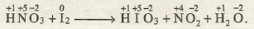](http://www.chemistry-assignment.com/wp-content/uploads/2013/02/1161.png)

Thus, only nitrogen and iodine undergo change in oxidation number.

**Step 2.** Division into two half reactions and balancing the atoms undergoing change in O.N.

[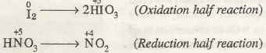](http://www.chemistry-assignment.com/wp-content/uploads/2013/02/1162.png)

**Step 3.** Addition of electrons to make up the difference in O.N.

[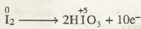](http://www.chemistry-assignment.com/wp-content/uploads/2013/02/1163.png)

(Each I atom loses 5e- therefore, two iodine atoms would lose 10e-)

[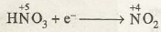](http://www.chemistry-assignment.com/wp-content/uploads/2013/02/1164.png)

(Each N atom gains 1 electron).

**Step 4.** Balancing of 0 by adding proper number of H2O molecule to the side falling short of 0 atoms.

[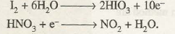](http://www.chemistry-assignment.com/wp-content/uploads/2013/02/1165.png)

**Step 5.** Not required because the equation is not ionic.

**Step 6.** To equalise the electrons multiply reduction half reaction by 10 and add the two.

[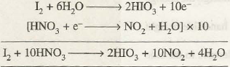](http://www.chemistry-assignment.com/wp-content/uploads/2013/02/1166.png)

Let us now proceed to balance the ionic equations in acidic and basic mediums.

Consider the chemical reaction between zinc and copper(II) tetraoxosulphate(V) solution.

Zn(s) + CuSO4(aq) à ZnSO(aq) + Cu(s)

Writing ionic form of each species we have

Zn(s) + Cu2+(aq) + SO4(aq) à Zn2+(aq) + SO4(aq) + Cu(s)

Now, it is evident that Cu atoms and Zn2+ ions undergo oxidation and reduction respectively and are active ions. SO4  lion, on the other hand, do not participate in the reaction and remain as such. They are inactive towards the reaction and are called spectator ions. In the similar way K+ ions are spectator ions in the following reaction.

# Balancing Redox Reactions: Examples

Oxidation-Reduction or "redox" reactions occur when elements in a chemical reaction gain or lose electrons, causing an increase or decrease in oxidation numbers. The Half Equation Method is used to balance these reactions.

In a redox reaction, one or more element becomes oxidized, and one or more element becomes reduced. Oxidation is the loss of electrons whereas reduction is the gain of electrons. An easy way to remember this is to think of the charges: an element's charge is reduced if it gains electrons (an acronym to remember the difference is LEO = Lose Electron Oxidation & GER = Gain Electron Reduction). Redox reactions usually occur in one of two environments: acidic or basic. In order to balance redox equations, understanding [oxidation states](https://chem.libretexts.org/Core/Analytical_Chemistry/Electrochemistry/Redox_Chemistry/Oxidation_State) is necessary.

Some points to remember when balancing redox reactions:

* The equation is separated into two half-equations, one for oxidation, and one for reduction.
* The equation is balanced by adjusting coefficients and adding H2O, H+, and e- in this order:  
      1) Balance the atoms in the equation, apart from O and H.  
      2) To balance the Oxygen atoms, add the appropriate number of water (H2O) molecules to the other side.  
      3) To balance the Hydrogen atoms (including those added in step 2), add H+ ions.  
      4) Add up the charges on each side. They must be made equal by adding enough electrons (e-) to the more positive side.
* The e- on each side must be made equal; if they are not equal, they must be multiplied by appropriate integers to be made the same.
* The half-equations are added together, cancelling out the electrons to form one balanced equation. Cancel out as much as possible.
* (If the equation is being balanced in a basic solution, the appropriate number of OH- must be added to turn the remaining H+ into water molecules)
* The equation can now be checked to make sure it is balanced.

Next, these steps will be shown in another example:

|  |
| --- |
| **Example 1a: In Acidic Aqueous Solution** |
| For example looking at the following reaction in an acidic solution  *MnO*−4(*aq*)+*I*−(*aq*)→*Mn*2+(*aq*)+*I*2(*s*)  The first step is to identify which element(s) is being oxidized and which element(s) is being reduced. Manganese(Mn) goes from a charge of +7 to a charge of +2. Since it gains five electrons, it is reduced. Because it is reduced, it is considered the **oxidizing agent** of the reaction.  Iodine (I) goes from a charge of -1 to 0. Thus it loses electrons, and is oxidized. Iodine (I) is therefore considered to be the **reducing agent** of this reaction.  The next step is to break the equation down into two half equations, one each for the reduction and oxidation reactions. At a later stage, the equations will be recombined into a balanced overall equation.  The first half reaction is for the reduction: MnO4- (aq) → Mn2+(aq)  The other describes the oxidation:  *I*−(*aq*)→*I*2(*s*)  The overall equation is balanced as follows. For the reduction half, oxygen is the only element that requires balancing, which is accomplished by adding H2O to the product side. Since there are four oxygen atoms in MnO4-(aq), four water molecules must be added so that the oxygen of the MnO4-(aq) balances with the oxygen in the H2O. However, the added water introduces hydrogen into the reaction, which must be balanced as well. Under acidic conditions, this is accomplished by adding hydrogen ions to the reactant side. Electrons must also be added to balance the charges. Because on the left there is a charge of +7 and on the right a charge of +2, five electrons must be added to the +7 side:  MnO4- (aq) + 8H+ (aq) + 5e- → Mn2+(aq) +4H2O (l)  The reduction half reaction is now sufficiently balanced.  The only element in the oxidation half reaction is iodine. This is easily balanced by doubling the iodide ions on the reactant side and adding electrons to the product side to balance the negative charge:  2I-(aq) → I2(s) + 2e-  (Note that the electrons were also multiplied because another iodide, with another negative charge, was added. Also,  a general rule of thumb is that the electrons should appear on opposite sides in each half reaction so they will cancel out when the reactions are combined.)  Now that both parts of the reaction are balanced, it is time to reform the overall reaction equation. Consider the electrons in each reaction. There are currently five electrons on the left in the reduction half reaction, and two on the right in the oxidation half reaction. The least common multiple of five and two is ten, so the reduction reaction is multiplied by two and the oxidation reaction is multiplied by five:  2MnO4-(aq) + 16H+(aq) + 10e-\(\rightarrow\) 2Mn2+(aq) + 8H2O (l)  10I-(aq) → 5I2(s) + 10e-.  The two reactions are added together, and common terms on either side of the reaction arrow are eliminated (in this case, only the electrons) to add the two parts together and cancel out anything that is on both sides, in this case, only the electrons can be cancelled out:  2MnO4-(aq) + 16H+(aq) + 10e-→ 2Mn2+(aq) + 8H2O (l)  10I-(aq) → 5I2(s) + 10e-  _________________________________________________  **10I-(aq) + 2MnO4-(aq) + 16H+(aq) → 5I2(s) + 2Mn2+(aq) + 8H2O (l)**  This is the balanced reaction equation in acidic solution. |

|  |
| --- |
| **Example 1b: In Basic Aqueous Solution** |
| The balancing procedure in basic solution differs slightly because OH- ions must be used instead of H+ ions when balancing hydrogen atoms. To give the previous reaction under basic conditions, sixteen OH- ions can be added to both sides. on the left the OH- and the H+ ions will react to form water, which will cancel out with some of the H2O on the right.  10I-(aq) + 2MnO4-(aq) + 16H+(aq) + 16OH- (aq) → 5I2(s) + 2Mn2+(aq) + 8H2O (l) + 16OH- (aq)  On the left sidethe OH-and the H+ions will react to form water, which will cancel out with some of the H2O on the right:  10I-(aq) + 2MnO4-(aq) + 16H2O (l) → 5I2(s) + 2Mn2+(aq) + 8H2O (l) + 16OH- (aq)  Eight water molecules can be canceled, leaving eight on the reactant side:  **10I-(aq) + 2MnO4-(aq) + 8H2O (l) → 5I2(s) + 2Mn2+(aq) + 16OH-(aq)**  This is the balanced reaction in basic solution. |

|  |
| --- |
| **Example 2** |
| To balance a redox reaction, first take an equation and separate into two half reaction equations specifically oxidation and reduction, and balance them. Balance the following in an acidic solution.  SO32-(aq) + MnO4- (aq) → SO42- (aq) + Mn2+ (aq)    **Step 1: Split into two half reaction equations: Oxidation and Reduction**  Oxidation: **SO32- (aq)** → **SO42- (aq)**  [ oxidation because oxidation state of sulfur increase from +4 to +6]  Reduction: **MnO4+ (aq)** → **Mn2+ (aq)** [ Reduction because oxidation state of Mn decreases from +7 to +2]    **Step 2: Balance each of the half equations in this order:**   * **Atoms other than H and O** * **O atoms by adding H2Os with proper coefficient** * **H atoms by adding H+ with proper coefficient**   The Sulfur atoms and Mn atoms are already balanced,    Balancing O atoms  Oxidation: **SO32- (aq) + H2O (l)** → **SO4- (aq)**  Reduction: **MnO4- (aq)** → **Mn2+ (aq) + 4H2O (l)**  Then balance out H atoms on each side  Oxidation: **SO32- (aq) + 4H2O (l)** → **SO42- (aq) + 2H+ (aq)**  Reduction: **MnO4- (aq) + 8H+ (aq)** → **Mn2+ (aq) + 4H2O (l)**    **Step 3: Balance the charges of the half reactions by adding electrons**  Oxidation: **SO32- (aq) + H2O (l)** → **SO4- (aq) + 2H+  (aq) + 2e-**  Reduction: **MnO4- (aq) + 8H+ + 5e-** → **Mn2+ (aq) + 4H2O (l)**    **Step 4: Obtain the overall redox equation by combining the half reaction, but multiply entire equation by number of electrons in oxidation with reduction equation, and number of electrons in reduction with oxidation equation.**    Oxidation:[ **SO32- (aq) + H2O (l)** → **SO4- (aq) + 2H+  (aq) + 2e-**] x 5  Reduction: [ **MnO4- (aq) + 8H+ + 5e-**→ **Mn2+ (aq) + 4H2O (l)** ] x 2    Overall Reaction:  Oxidation: **5 SO32- (aq) + 5H2O (l)** → **5SO42- (aq) + 10H+ (aq) + 10e-**  +  Reduction: **2 MnO4- (aq) + 16H+ (aq) +10e-** → **2 Mn2+ (aq) + 8H2O (l)**  **5 SO32- (aq) + 5H2O (l) + 2 MnO4- (aq) + 16H+ (aq) +10e-** → **5SO42- (aq) + 10H+ (aq) + 10e- +2 Mn2+ (aq) + 8H2O (l)**    **Step 5: Simplify and cancel out similar terms on both sides, like the 10e- and waters.**  **5 SO32- (aq) + 2 MnO4- (aq) + 6H+ (aq)** → **5SO42- (aq) + 2Mn2+ (aq) + 3H2O (l)** |
| **Example 3** |
| MnO4-(aq) + SO32-(aq) --> MnO2(s) + SO42-(aq)  First, they are separated into the half-equations:  MnO4-(aq) --> MnO2(s) (the reduction, because oxygen is LOST) and  SO32-(aq) --> SO42-(aq) (the oxidation, because oxygen is GAINED)  Now, to balance the oxygen atoms, we must add two water molecules to the right side of the first equation, and one water molecule to the left side of the second equation:  MnO4-(aq) --> MnO2(s) + 2H2O(l)  H2O(l) + SO32-(aq) --> SO42-(aq)  To balance the hydrogen atoms (those the original equation as well as those added in the last step), we must add four H+ ions to the left side of the first equation, and two H+ ions to the right side of the second equation.  4H+ + MnO4-(aq) --> MnO2(s) + 2H2O(l)  H2O(l) + SO32-(aq) --> SO42-(aq) + 2H+  Now we must balance the charges. In the first equation, the charge is +3 on the left and 0 on the right, so we must add three electrons to the left side to make the charges the same. In the second equation, the charge is -2 on the left and 0 on the right, so we must add two electrons to the right.  3e- + 4H+ + MnO4-(aq) --> MnO2(s) + 2H2O(l)  H2O(l) + SO32-(aq) --> SO42-(aq) + 2H+ + 2e-  Now we must make the electrons equal eachother, so we multiply each equation by the appropriate number to get the common multiple (in this case, by 2 for the first equation, and by 3 for the second).  2(3e- + 4H+ + MnO4-(aq) --> MnO2(s) + 2H2O(l))  3(H2O(l) + SO32-(aq) --> SO42-(aq) + 2H+ + 2e-)  With the result:  6e- + 8H+ + 2MnO4-(aq) --> 2MnO2(s) + 4H2O(l)  3H2O(l) + 3SO32-(aq) --> 3SO42-(aq) + 6H+ + 6e-  Now we cancel and add the equations together. We can cancel the 6e- because they are on both sides. We can get rid of the 6H+ on both sides as well, turning the 8H+ in the first equation to 2H+. The same method gets rid of the 3H2O(l) on the bottom, leaving us with just one H2O(l) on the top. In the end, the overall reaction should have no electrons remaining. Now we can write one balanced equation:  2MnO4-(aq) + 2H+ + 3SO32-(aq) --> H2O(l) + 2MnO2(s) + 3SO42-(aq)  The equation is now balanced in an acidic environment. If necessary, we can balance in a basic environment by adding OH- to turn the H+ into water molecules as follows:   2MnO4-(aq) + H2O + 3SO32-(aq) --> H2O(l) + 2MnO2(s) + 3SO42-(aq) + 2OH-  The equation is now balanced in a basic environment. |

|  |
| --- |
| **Example 4** |
| **Fe(OH)3 + OCl-**→**FeO42-+ Cl-** in acidic solution  Step 1:  Reduction: **OCl-**→**Cl-**  Oxidation:  **Fe(OH)3**→**FeO42-**  Step 2/3:  Reduction:  **2H++  OCl- + 2e-**→**Cl- + H2O**  Oxidation:  **Fe(OH)3 + H2O**→**FeO42- + 3e- + 5H+**  Step 4:  Overall Equation:  **[ 2H++  OCl- + 2e-**→**Cl- + H2O ] x 3**  **[ Fe(OH)3 + H2O**→**FeO42- + 3e- + 5H+] x 2**  =  **6H++ 3OCl- + 6e-**→**3Cl- +3 H2O**  **+**  **2Fe(OH)3 +2 H2O**→**2FeO42- + 6e- + 10H+**  **6H++ 3OCl- + 2e-+ 2Fe(OH)3 +2 H2O**→**3Cl- +3 H2O + 2FeO42- + 6e- + 10H+**    Step 5:  Simplify:  **3OCl- + 2Fe(OH)3**→**3Cl- + H2O + 2FeO42- + 4H+**  **Example 2: VO43-+ Fe2+**→**VO2++ Fe3+**in acidic solution  Step 1:  Oxidation:    **Fe2+**→**Fe3+**  Reduction:   **VO43-**→**VO2+**    Step 2/3:  Oxidation: **Fe2+**→**Fe3+ + e-**  Reduction: **6H+ + VO43-+ e-**→**VO2+ + 3H2O**  Step 4:  Overall Reaction:  **Fe2+**→**Fe3+ + e-**  **+**  **6H+ + VO43-+ e-**→**VO2+ + 3H2O**  **____________________________**    **Fe2++ 6H+ + VO43-+ e-**→**Fe3+ + e- + VO2+ + 3H2O**  Step 5:  Simplify:  **Fe2++ 6H+ + VO43-**→**Fe3+  + VO2+ + 3H2O** |

### Practice Problems

Balance the following equations in both acidic and basic environments:

1) Cr2O72-(aq) + C2H5OH(l) --> Cn3+(aq) + CO2(g)

2) Fe2+(aq) + MnO4-(aq) --> Fe3+(aq) + Mn2+(aq)

**Solutions:**

1. (Acidic Answer: 2Cr2O7-(aq) + 16H+(aq) + C2H5OH(l) --> 4Cr3+(aq) + 2CO2(g) + 11H2O(l))

    (Basic Answer: 2Cr2O7-(aq) + 5H2O(l) + C2H5OH(l) --> 4Cr3+(aq) + 2CO2(g) + 16OH-(aq))

2. (Acidic Answer: MnO4-(aq) + 5Fe2+(aq) + 8H+(aq) --> Mn2+(aq) + 5Fe3+(aq) + 4H2O(l))

    (Basic Answer: MnO4-(aq) + 5Fe2+(aq) + 4H2O(l) --> Mn2+(aq) + 5Fe3+(aq) + 8OH-(aq))

In a redox reaction, also known as an oxidation-reduction reaction, it is a must for oxidation and reduction to occur simultaneously. In the oxidation half of the reaction, an element gains electrons. A species loses electrons in the reduction half of the reaction. These reactions can take place in either acidic or basic solutions.

|  |
| --- |
| **Example 1: Balance in Acid Solution** |
| Problem : *MnO*−4+*I*−→*I*2+*Mn*2+  Steps to balance :  1) Separate the half-reactions that undergo oxidation and reduction.  **Oxidation:** *I*−→*I*2  This is the oxidation half because the oxidation state changes from -1 on the left side to 0 on the right side. This indicates a gain in electrons.  **Reduction:** *MnO*−4→*Mn*2+  This is the reduction half because the oxidation state changes from +7 on the left side to +2 on the right side. This indicates a reduction in electrons.  2) In order to balance this half reaction we must start by balancing all atoms other than any Hydrogen or Oxygen atoms.  **Oxidation**: 2*I*−→*I*2  In order to balance the oxidation half of the reaction you must first add a 2 in front of the I on the left hand side so there is an equal number of atoms on both sides.  **Reduction**: *MnO*−4→*Mn*2+  For the reduction half of the reaction, you can notice that all atoms other than Hydrogen and Oxygen are already balanced because there is one manganese atom on both sides of the half reaction.  3) Balance Oxygen atoms by adding H2O to the side of the equation that needs Oxygen. Once you have completed this step add H+ to the side of the equation that lacks H atoms necessary to be balanced.  **Oxidation:** 2*I*−→*I*2  Because there are no Oxygen or Hydrogen atoms in this half of the reaction, it is not required to perform any kind of balancing.  **Reduction**: *MnO*−4→*Mn*2++4*H*2*O*  The first step in balancing this reaction using step 3 is to add4  H2O atoms in order to balance the Oxygen atoms with the 4 on the other side of MnO4-  **Reduction**: *MnO*−4+8*H*+→*Mn*2++4*H*2*O*  Now that the Oxygen atoms have been balanced you can see that there are 8 H atoms on the right hand side of the equation and none on the left. Therefore, you must add 8 H+ atoms to the left hand side of the equation to make it balanced.  4) Now that the two half reactions have been balanced correctly one must balance the charges in each half reaction so that both the reduction and oxidation halves of the reaction consume the same number of electrons.  **Oxidation**: 2*I*−→*I*2+2*e*−  Because of the fact that there are two I's on the left hand side of the equation which a charge of -1 we can state that the left hand side has an overall charge of -2. The I on the left side of the equation has an overall charge of 0. Therefore to balance the charges of this reaction we must add 2 electrons to the right side of the equation so that both sides of the equation have equal charges of -2.  **Reduction**: 5*e*−+8*H*++*MnO*−4→*Mn*2++4*H*2*O*  Looking at the left hand side of the equation you can notice that there are 8 Hydrogen atoms with a +1 charge. There is also a MnO4-  ion that has a charge of -1. When we add these two charges up we can calculate that the left hand side of the equation has an overall charge of +7. The right hand side has an Mn atom with a charge of +2 and then 4 water molecules that have charges of 0. Therefore, the overall charge of the right side is +2. We must add 5 electrons to the left side of the equation to make sure that both sides of the equation have equal charges of +2.  5) Multiply both sides of both reactions by the least common multiple that will allow the half-reactions to have the same number of electrons and cancel each other out.  **Oxidation**: 10*I*−→5*I*2+10*e*−  We multiply this half reaction by 5 to come up with the following result above.  Reduction: 10*e*−+16*H*++2*MnO*−4→2*Mn*2++8*H*2*O*  We multiply the reduction half of the reaction by 2 and arrive at the answer above.  By multiplying the oxidation half by 5 and the reduction half by 2 we are able to observe that both half-reactions have 10 electrons and are therefore are able to cancel each other out.  6) Add the two half reactions in order to obtain the overall equation by canceling out the electrons and any H2O and H+ ions that exist on both sides of the equation.  **Overall**: 10*I*−+16*H*++2*MnO*−4→5*I*2+2*Mn*2++8*H*2*O*  In this problem, there is not anything that exists on both halves of the equation that can be cancelled out other than the electrons. Finally, double check your work to make sure that the mass and charge are both balanced. To double check this equation you can notice that everything is balanced because both sides of the equation have an overall charge of +4. |

|  |
| --- |
| **Example 1b: Balance in Basic Solution** |
| The remaining question lies as to how to balance the reaction is basic solution. The simplest way to do this is to realize that OH- and H+ ions will combine to form water. Therefore, we must add OH- ions to both sides of the equation. Chances are that after completing this step you will also need to subtract water molecules from one side.  10*I*−+2*MnO*−4+8*H*2*O*→5*I*2+2*Mn*2++16*OH*−  As you can see, there are 16H+ and 16OH- ions on the left side of equation which will combine to form the 16 water molecules on the left side. Because there are 8 water molecules on the right side of the equation and 16 on the left we can subtract the 8 from the right side over to the left and obtain the overall equation above. Now you have balanced the reaction is basic solution. |

#### Neutral Conditions

The first step to balance any redox reaction is to separate the reaction into half-reactions. The substance being reduced will have electrons as reactants, and the oxidized substance will have electrons as products. (Usually all reactions are written as reduction reactions in half-reaction tables. To switch to oxidation, the whole equation is reversed and the voltage is multiplied by -1.) Sometimes it is necessary to determine which half-reaction will be oxidized and which will be reduced. In this case, whichever half-reaction has a higher reduction potential will by reduced and the other oxidized.

Example 1.1: Balancing in a Neutral Solution

Balance the following reaction

*Cu*+(*aq*)+*Fe*(*s*)→*Fe*3+(*aq*)+*Cu*(*s*)(1.4)

**Solution**

**Step 1:** Separate the half-reactions. By searching for the reduction potential, one can find two separate reactions:

*Cu*+(*aq*)+*e*−→*Cu*(*s*)(1.5)

*Fe*3+(*aq*)+3*e*−→*Fe*(*s*)(1.6)

The copper reaction has a higher potential and thus is being reduced. Iron is being oxidized so the half-reaction should be flipped. This yields:

*Cu*+(*aq*)+*e*−→*Cu*(*s*)(1.7)

*Fe*(*s*)→*Fe*3+(*aq*)+3*e*−(1.8)

**Step 2:** Balance the electrons in the equations. In this case, the electrons are simply balanced by multiplying the entire *Cu*+(*aq*)+*e*−→*Cu*(*s*) half-reaction by 3 and leaving the other half reaction as it is. This gives:

3*Cu*+(*aq*)+3*e*−→3*Cu*(*s*)(1.9)

*Fe*(*s*)→*Fe*3+(*aq*)+3*e*−(1.10)

**Step 3:** Adding the equations give:

3*Cu*+(*aq*)+3*e*−+*Fe*(*s*)→3*Cu*(*s*)+*Fe*3+(*aq*)+3*e*−(1.11)

The electrons cancel out and the balanced equation is left.

3*Cu*+(*aq*)+*Fe*(*s*)→3*Cu*(*s*)+*Fe*3+(*aq*)(1.12)

#### Acidic Conditions

Acidic conditions usually implies a solution with an excess of H+ concentration, hence making the solution acidic. The balancing starts by separating the reaction into half-reactions. However, instead of immediately balancing the electrons, balance all the elements in the half-reactions that are not hydrogen and oxygen. Then, add H2O molecules to balance any oxygen atoms. Next, balance the hydrogen atoms by adding protons (H+). Now, balance the charge by adding electrons and scale the electrons (multiply by the lowest common multiple) so that they will cancel out when added together. Finally, add the two half-reactions and cancel out common terms.

Example 1.2: Balancing in a Acid Solution

Balance the following redox reaction in acidic conditions.

*Cr*2*O*2−7(*aq*)+*HNO*2(*aq*)→*Cr*3+(*aq*)+*NO*−3(*aq*)(1.13)

**Solution**

**Step 1:** Separate the half-reactions. The table provided does not have acidic or basic half-reactions, so just write out what is known.

*Cr*2*O*2−7(*aq*)→*Cr*3+(*aq*)(1.14)

*HNO*2(*aq*)→*NO*−3(*aq*)(1.15)

**Step 2:** Balance elements other than O and H. In this example, only chromium needs to be balanced. This gives:

*Cr*2*O*2−7(*aq*)→2*Cr*3+(*aq*)(1.16)

*HNO*2(*aq*)→*NO*−3(*aq*)(1.17)

**Step 3:** Add H2O to balance oxygen. The chromium reaction needs to be balanced by adding 7 H2O molecules. The other reaction also needs to be balanced by adding one water molecule. This yields:

*Cr*2*O*2−7(*aq*)→2*Cr*3+(*aq*)+7*H*2*O*(*l*)(1.18)

*HNO*2(*aq*)+*H*2*O*(*l*)→*NO*−3(*aq*)(1.19)

**Step 4:** Balance hydrogen by adding protons (H+). 14 protons need to be added to the left side of the chromium reaction to balance the 14 (2 per water molecule * 7 water molecules) hydrogens. 3 protons need to be added to the right side of the other reaction.

14*H*+(*aq*)+*Cr*2*O*2−7(*aq*)→2*Cr*3+(*aq*)+7*H*2*O*(*l*)(1.20)

*HNO*2(*aq*)+*H*2*O*(*l*)→3*H*+(*aq*)+*NO*−3(*aq*)(1.21)

**Step 5:** Balance the charge of each equation with electrons. The chromium reaction has (14+) + (2-) = 12+ on the left side and (2 * 3+) = 6+ on the right side. To balance, add 6 electrons (each with a charge of -1) to the left side:

6*e*−+14*H*+(*aq*)+*Cr*2*O*2−7(*aq*)→2*Cr*3+(*aq*)+7*H*2*O*(*l*)(1.22)

For the other reaction, there is no charge on the left and a (3+) + (-1) = 2+ charge on the right. So add 2 electrons to the right side:

*HNO*2(*aq*)+*H*2*O*(*l*)→3*H*+(*aq*)+*NO*−3(*aq*)+2*e*−(1.23)

**Step 6:** Scale the reactions so that the electrons are equal. The chromium reaction has 6e- and the other reaction has 2e-, so it should be multiplied by 3. This gives:

3∗[*HNO*2(*aq*)+*H*2*O*(*l*)→3*H*+(*aq*)+*NO*−3(*aq*)+2*e*−]⇒(1.24)

3*HNO*2(*aq*)+3*H*2*O*(*l*)→9*H*+(*aq*)+3*NO*−3(*aq*)+6*e*−(1.25)

6*e*−+14*H*+(*aq*)+*Cr*2*O*2−7(*aq*)→2*Cr*3+(*aq*)+7*H*2*O*(*l*).(1.26)

**Step 7:** Add the reactions and cancel out common terms.

[3*HNO*2(*aq*)+3*H*2*O*(*l*)→9*H*+(*aq*)+3*NO*−3(*aq*)+6*e*−]+(1.27)

[6*e*−+14*H*+(*aq*)+*Cr*2*O*2−7(*aq*)→2*Cr*3+(*aq*)+7*H*2*O*(*l*)]=(1.28)

3*HNO*2(*aq*)+3*H*2*O*(*l*)+6*e*−+14*H*+(*aq*)+*Cr*2*O*2−7(*aq*)→9*H*+(*aq*)+3*NO*−3(*aq*)+6*e*−+2*Cr*3+(*aq*)+7*H*2*O*(*l*)(1.29)

The electrons cancel out as well as 3 water molecules and 9 protons. This leaves the balanced net reaction of:

3*HNO*2(*aq*)+5*H*+(*aq*)+*Cr*2*O*2−7(*aq*)→3*NO*−3(*aq*)+2*Cr*3+(*aq*)+4*H*2*O*(*l*)(1.30)

#### Basic Conditions

Bases dissolve into OH- ions in solution; hence, balancing redox reactions in basic conditions requires OH-. Follow the same steps as for acidic conditions. The only difference is adding hydroxide ions (OH-) to each side of the net reaction to balance any H+. OH- and H+ ions on the same side of a reaction should be added together to form water. Again, any common terms can be canceled out.

Example 1.1: Balancing in Basic Solution

Balance the following redox reaction in basic conditions.

*Ag*(*s*)+*Zn*2+(*aq*)→*Ag*2*O*(*aq*)+*Zn*(*s*)(1.31)

**Solution**

Go through all the same steps as if it was in acidic conditions.

**Step 1:** Separate the half-reactions.

*Ag*(*s*)→*Ag*2*O*(*aq*)(1.32)

*Zn*2+(*aq*)→*Zn*(*s*)(1.33)

**Step 2:** Balance elements other than O and H.

2*Ag*(*s*)→*Ag*2*O*(*aq*)(1.34)

*Zn*2+(*aq*)→*Zn*(*s*)(1.35)

**Step 3:** Add H2O to balance oxygen.

*H*2*O*(*l*)+2*Ag*(*s*)→*Ag*2*O*(*aq*)(1.36)

*Zn*2+(*aq*)→*Zn*(*s*)(1.37)

**Step 4:** Balance hydrogen with protons.

*H*2*O*(*l*)+2*Ag*(*s*)→*Ag*2*O*(*aq*)+2*H*+(*aq*)(1.38)

*Zn*2+(*aq*)→*Zn*(*s*)(1.39)

**Step 5:** Balance the charge with e-.

*H*2*O*(*l*)+2*Ag*(*s*)→*Ag*2*O*(*aq*)+2*H*+(*aq*)+2*e*−(1.40)

*Zn*2+(*aq*)+2*e*−→*Zn*(*s*)(1.41)

**Step 6:** Scale the reactions so that they have an equal amount of electrons. In this case, it is already done.

**Step 7:** Add the reactions and cancel the electrons.

*H*2*O*(*l*)+2*Ag*(*s*)+*Zn*2+(*aq*)→*Zn*(*s*)+*Ag*2*O*(*aq*)+2*H*+(*aq*).(1.42)

**Step 8:** Add OH- to balance H+. There are 2 net protons in this equation, so add 2 OH- ions to each side.

*H*2*O*(*l*)+2*Ag*(*s*)+*Zn*2+(*aq*)+2*OH*−(*aq*)→*Zn*(*s*)+*Ag*2*O*(*aq*)+2*H*+(*aq*)+2*OH*−(*aq*).(1.43)

**Step 9:** Combine OH- ions and H+ ions that are present on the same side to form water.

*H*2*O*(*l*)+2*Ag*(*s*)+*Zn*2+(*aq*)+2*OH*−(*aq*)→*Zn*(*s*)+*Ag*2*O*(*aq*)+2*H*2*O*(*l*)(1.44)

**Step 10:** Cancel common terms.

2*Ag*(*s*)+*Zn*2+(*aq*)+2*OH*−(*aq*)→*Zn*(*s*)+*Ag*2*O*(*aq*)+*H*2*O*(*l*)(1.45)

### References

**IDENTIFICATION OF OXIDIZING AND REDUCING AGENTS**

The main function of oxidising agents is to bring about the oxidation of desired material. Similarly, reducing agents are required to bring about the reduction of desired material in the laboratory. The choice of the oxidising agent/reducing agents to be used depends upon the nature of the material to be oxidised or reduced. The reduction half reactions of some important oxidising agents are given in Table 30.2. Similarly, the oxidation half reactions of some important reducing agents are given in Table 30.3.

**Reduction Half Equations for Some Oxidising Agents**

[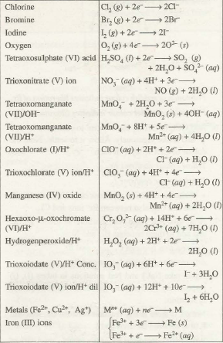](http://www.chemistry-assignment.com/wp-content/uploads/2013/02/1157.png)

**Table 30.3Oxidation Half Reactions of Some Reducing Agents**

[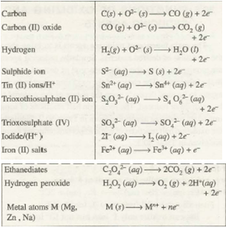](http://www.chemistry-assignment.com/wp-content/uploads/2013/02/1158.png)

 (a). Iron(II) chloride, FeCl2 - the solution of this substance (Fe2+) is green in color. When reacted with a substance suspected to be an oxidizing agent, and its color changes to reddish brown, then the substance is confirmed to be an oxidizing agent. The Fe2+ ion is oxidized to Fe3+ ion.  
(b). When a strip of moist starch – iodide paper is dipped into a substance suspected to be an oxidizing agent, and a blue black color appears, then the substance is confirmed to be an oxidizing agent.  
The oxidizing agent oxidizes the iodide to free iodine. The solution of the free iodine then reacts with the starch to give the blue black color (notice that it is only the solution of the free iodine which gives the blue black color with the starch).  
(c). When hydrogen sulphide (H2S) is reacted with a substance, and some yellow deposits (sulphur) are settled on the bottom of the container, then the substance is an oxidizing agent – H2S is oxidized to sulphur.

TEST FOR REDUCING AGENTS  
(a). Reacting the suspected reducing agent with potassium tetraoxomanganate(VII) solution, KMnO4 (purple color), and the color is observed to become colorless (Mn2+), the substance is confirmed to be a reducing agent. KMnO4 is reduced to Mn2+.  
(b). Also, a solution of potassium heptaoxodichromate(VI), K2Cr2O7 (orange in color) would become greenish (Cr3+) when reacted with a reducing agent.

EVALUATION

### 2

Which of the following process involves the use of an oxidising agent?



Acidified potassium permanganate being used to form ethanoic acid from ethanol



Using carbon monoxide to obtain iron from iron ore in a blast furnace



Lithium aluminium hydride being used to change propanone into propan-2-ol

### 3

Which of the following reactions is an example of a redox process?



Black carbon powder burning in oxygen to form colourless carbon dioxide gas



Ethanol and a butanoic acid reacting together to form an ester



Magnesium metal displacing zinc from a solution of zinc sulfate

### 4

What is the equation for the redox reaction involving the following two ion-electron equations?

















### 5

What is added to complex ion-electron equations to balance the electrical charge?



Water molecules (H2O)



Hydrogen ions (H+)



Electrons (e-)

### 6

Which of the following is the correctly balanced ion-electron equation for the change ?













### 7

Which of the following is the correctly balanced ion-electron equation for the change Br2 (l) giving BrO-(aq)?













### 8

Which of the following is the correctly balanced ion-electron equation for the change ClO3- (aq) giving Cl2 (g)?













### 9

Which of the following is the correctly balanced ion-electron equation for the change XeO3 (s) giving Xe (g)?













### 10

Which of the following is the correctly balanced ion-electron equation for the change CrO42- (aq) giving Cr2O72- (aq)?













**WEEK 5**

**IONIC THEORY**

IONIC THEORY

To account for the phenomena of electrolysis the Ionic Theory was put forward by Arrhenius in 1880. The theory states that electrolytes are made up of ions, which are built up in certain patterns called crystal lattice. When these substances dissolve in water, the structure is destroyed and the ions are set free to move.

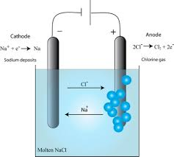

Concentrated mineral acids such as sulphuric acid, hydrochloric acid and nitric acid do not contain ions but they consist of molecules. However, when they are diluted, the molecular structure is destroyed and ions are formed.

THE MECHANISM OF ELECTROLYSIS

The conductivity of ionic compounds is explained by the fact that ions move in a particular direction in an electric field. This can be shown in experiments with coloured salts. For example, copper (II) chromate (VI) (CuCrO4) dissolves in water to give a **green** solution. This solution is placed in a U-tube. A colourless solution of dilute hydrochloric acid (HCl) is then layered on top of the salt solution in each arm. Graphite rods are fitted as shown in figure 13.3. These rods (electrodes) carry the current into and out of the solution.

After passing the current for a short time, the solution around the cathode becomes **blue**. Around the anode, the solution becomes **yellow**. These colours are produced by the movement (migration) of the ions in the salt. The positive copper ions (Cu2+) are blue in solution. They are attracted to the cathode (negative electrode). The negative chromate ions (CrO42-) are yellow in solution. They are attracted to the anode (the positive electrode). The use of coloured ions in solution has shown the direction that positive and negative ions move in an electric field. Always positive ions (cations) move to the cathode and negative ions (anions) move to the anode.

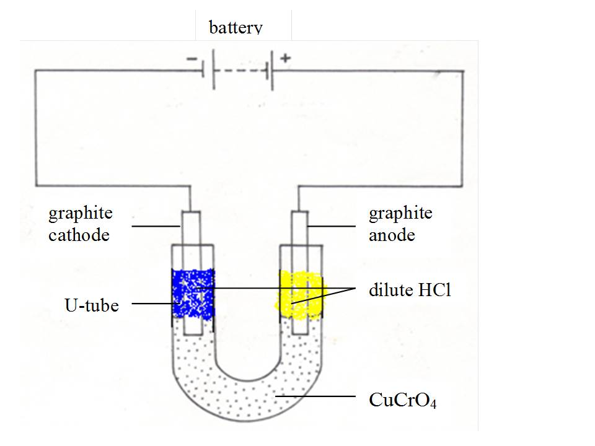

**Figure 6.3:  The movement of ions in solution**



**Electrovalent compounds**

* Electrovalent compounds are formed by complete transfer of electrons in KCI (K. + .CI: — K+ CI–)
* Electrovalent compounds are made up of ions.
* Electrovalent compounds are heard, crystalline solids e.g. NaCI, MgCl2
* Electrovalent compounds are usually soluble in water but insoluble in non-polar solvents like CI4
* Electrovalent compounds generally have high melting and boiling points.
* Electrovalent compounds are good conductors of electricity in the molten state and in aqueous solutions but insulators in the solid state.

Covalent compounds

* Covalent compounds are formed by mutual sharing of electrons as in NH3
* Covalent compounds are made up of molecules.
* Covalent compounds are usually liquids or gases. E.g. CH4, C2 H6, NH3
* Covalent compounds are soluble in non-polar solvents like benzene or carbon tetrachloride and in soluble in polar solvents like water.
* Covalent compounds generally have low melting and boiling points.
* Covalent compounds are bad conductors of electricity.

## Electrovalent Compound

The compounds which contain ionic or electrovalent bonds are known as Electrovalent or Ionic Compounds. Mainly electrovalent compounds are formed due to reaction between highly electropositive and highly electronegative atoms.

## Characteristics of Electrovalent Compounds

#### 1.     Crystal Structure:

In solid state of electrovalent compounds anions and cations are arranged in regular manner called as crystal, In which anions surrounded by definite number of cations and cations surrounded by definite number of anions.

#### 2.     Physical Nature:

Ionic or electrovalent compounds are generally hard and their hardness increases with increasing ionic charge and decreasing distance between ions.

#### 3.     Solubility:

Positive ion of ionic compound attach with negative part of polar solvent and negative ion of ionic compound attach with positive part of polar solvent, so ionic or electrovalent compounds are soluble in polar solvents like water and insoluble in non polar solvents like benzene, ether, alcohol.

#### 4.     Melting Point and Boiling Point:

Electrovalent or ionic compounds have high Melting and boiling points because they need large amount of energy to break strong ionic bonds.

#### 5.     Electrical Conductivity:

                                    In molten and solution forms electrovalent compounds conduct electricity because ions flows in molten and solution forms.

## Characteristics of Covalent Compounds

### 1.     Crystal Structure:

Crystal structure of covalent compounds is formed from atoms or molecules. Crystal of covalent compounds are divided in three parts as –

i.                   These are crystals of covalent compounds whose molecule are very small and these molecules are held together by vander waals forces.

Example: Sulphur, Iodine.

ii.                 These are crystals of covalent compounds whose molecule are very large due to combination of every atom with other atom by covalent bonds.

Example: Diamond, Silica.

iii.              These are crystals of covalent compounds whose have separate layers.

Example: Graphite.

### 2.     Physical Nature:

Due to weaker force of attraction between the molecules of the covalent compounds, maximum covalent compounds are gases or liquids but some covalent compounds exist as solid like Urea, Sugar, Glucose, and Naphthalene.

### 3.     Solubility:

                Covalent compounds are not soluble in polar solvents like water but are soluble in non-polar solvent like alcohol, ether, carbon tetra chloride.

### 4.     Melting Point and Boiling Point ( MP and BP) :

Melting and boiling points of covalent compounds are very low because very less energy is required to overcome the weak force of attraction between the neutral molecules in the covalent compound. But Diamond and Graphite are exception because they have very high melting and boiling points.

### 5.     Conductivity:

Covalent compounds do not have ions so they do not conduct electricity but some polar covalent compounds conduct very less electricity.

### Strong Electrolytes

[Strong electrolytes](http://chemistry.about.com/od/chemistryglossary/g/strong-electrolyte-definition.htm) include the [strong acids](http://chemistry.about.com/od/acidsbase1/a/strong-acids-list.htm), [strong bases](http://chemistry.about.com/od/acidsbase1/a/list-strong-bases.htm), and salts. These chemical completely dissociate into ions in aqueous solution.

**Examples**

* hydrochloric acid - HCl
* hydrobromic acid - HBr
* hydroiodic acid - HI
* sodium hydroxide - NaOH
* strontium hydroxide - Sr(OH)2
* sodium chloride - NaCl

### Weak Electrolytes

[Weak electrolytes](http://chemistry.about.com/od/chemistryglossary/g/weak-electrolyte-definition.htm) only partially break into ions in water. Weak electrolytes include weak acids, weak bases, and a variety of other compounds. Most compounds that contain nitrogen are weak electrolytes.

**Examples**

* HF - hydrofluoric acid
* CH3CO2H - acetic acid
* NH3 - ammonia
* H2O - water (weakly dissociates in itself)

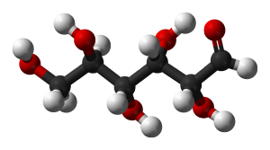

Glucose is a nonelectrolyte.

### Nonelectrolytes

[Nonelectrolytes](http://chemistry.about.com/od/chemistryglossary/a/nelectrolytedef.htm) do not break into ions in water. Common examples include most carbon compounds, such as sugars, fats, and alcohols.

**Examples**

* CH3OH - methyl alcohol
* C2H5OH - ethyl alcohol
* C6H12O6 – glucose

**Conductors and non-conductors (insulators)**

We have seen in the above definitions that there are some substances that can conduct electricity while others cannot. For a solid to conduct electricity, it must have a structure that contains “free” electrons that are able to flow through it. All metals conduct electricity whether in solid or molten states. They are electrical conductors.

The structure of a solid metal has positive ions surrounded by a ’sea’ of electrons.

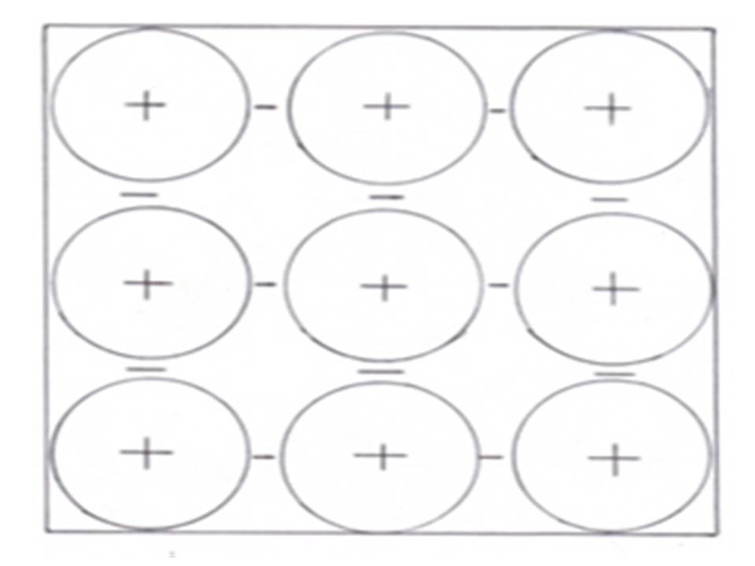

**Figure 6.1: Positive ions surrounded by free electrons**

The electrons between the positive ions are free to move. When a metal is connected to the **+** and **–** of a power supply a current flows. The electrons flow through the metal.

Nearly all non-metals do not conduct electricity. They are electrical insulators. They do not have freely moving electrons to carry the current.

Graphite is the only no-metal that conducts electricity. This solid has unusual structure. The atoms of graphite are joined in layers by covalent bonds, but between the layers, there are weak bonds with electrons that can move freely, allowing electrical current to flow.

When electricity flows through a solid or liquid metal or through solid graphite no chemical reactions takes place. The copper wire is still copper when the current is switched off.

**Electrolytes and non-electrolytes**

Liquids such as ethanol, paraffin, petrol and methylbenzene do not conduct electricity. The bonding in these compounds is covalent. These substances consist of molecules. There are no free electrons or charged particles to flow through them. Solutions of covalent compounds, for example sugar solution, do not conduct electricity. These compounds are **non-electrolytes**. Non-electolytes exist only in the form of molecules and are incapable of ionization. Examples of no-electrolytes include trichloromethane, CH3Cl, cane sugar, (C12H22O11), alcohol (ethanol), (C2H5OH) and urea (carbamide) (CON2H4)

Ionic compounds contain charged particles (ions), but in solid state, the ions are firmly held in place and they are not free to move. An ionic solid does not conduct electricity. However, the ions present can become free to move if the solid is melted or dissolved in water. Then they can conduct electricity. For example, solid sodium chloride cannot conduct electricity but when melted or dissolved in water, the ions, Na+ and Cl- are set free. Then these ions are free to move in solution and hence conduct electricity. These compounds are called **electrolytes**.

**Weak and strong electrolytes**

Weak electrolytes are compounds that are only partially or slightly ionized in aqueous solutions. Some substances, for example, ethanoic acid solution ionize partially.

                    CH3COOH(aq) ⇔ CH3COO-(aq)  + H+(aq)

Most of the electrolytes exist in solution in the form of unionized molecules. For example, in ordinary dilute (2M) ethanoic acid, out of every 1000 molecules present, only 4 are ionized and 996 are unionized.

A solution of ammonia water is also a weak electrolyte, containing a relatively small proportion of ammonium and hydroxyl ions.

                    NH4OH(aq) ⇔ NH4+(aq)  + OH-(aq)

Most of the organic acids are weak electrolytes, e.g. tartaric, citric and carbonic acids.

However, there is no sharp dividing line between weak and strong electrolytes.

Water is also a weak electrolyte. It ionizes only slightly.

                    H2O(l)⇔ H+(aq)  + OH-(aq)

Study shows that for every molecule of water ionized, there are 6 million molecules of water not ionized.

Strong electrolytes are compounds that are completely ionized in aqueous solutions. When sodium chloride is dissolved in adequate water it ionizes completely into Na+ and Cl- ions. There are no NaCl solid particles left unionized. All strong electrolytes (salts, the mineral acids and caustic alkalis) ionize completely in solutions.

**EVALUATION**

**Define the following terms**

**i.electrolytes ii. non-electrolytes iii. weak electrolytes iv. conductors v. covalent compounds vi .electrovalent compounds**

**Differenciate between an electrolyte and a conductor**

**Describe the principle behind the ionic theory.**

**WEEK 6**

Electrolysis



When an electric current is passed through an electrolyte solution, the ions of the electrolyte undergo chemical changes at the respective electrodes. The chemical reaction carried out by passing electricity is called electrolysis.

it is important that we familiarize ourselves with different terms that we are going to use to explain different phenomena. It is crucial that the definitions and meanings of these terms be understood at the outset in order that concepts defined in this chapter are easily and clearly apprehended. These terms are given hereunder:

* **Electrolysis**: decomposition of a compound in solution or molten state by passing electricity through it.
* **Conductor**: a solid substance that allows electricity to pass through it. All metals are included in this class.
* **Non-conductor or insulator**: a solid substance that does not allow electricity to flow through it. All non-metals fall in this class.
* **Electrolyte**: a substance which, when dissolved or molten, conducts electricity and is decomposed by it.
* **Non-electrolyte**: a compound which cannot conduct electricity, be it in molten or solution state.
* **Electrode**: a graphite or metal pole (rod) or plate through which the electric current enters or leaves the electrolyte.
* **Cathode**: a negative electrode which leads electrons into the electrolyte.
* **Anode**: a positive electrode which leads electrons out of the electrolyte.
* **Ion**: a positively or negatively charged atom or radical (group of atoms).
* **Cation**: a positive ion which moves to the cathode during electrolysis.
* **Anion**: a negative ion which moves to the anode during electrolysis.

**The electrolytic cell (voltameter)**

The apparatus in which electrolysis is carried out is called electrolytic cell. A battery supplies the direct current. Graphite electrodes carry the current into and out of the liquid electrolyte. Graphite is chosen because it is quite unreactive (inert). It will not react with the electrolyte or with products of electrolysis. Electrons flow from the negative terminal (cathode) of the battery around the circuit and back to the positive terminal (anode). In the electrolyte it is the ions that move to carry the current.

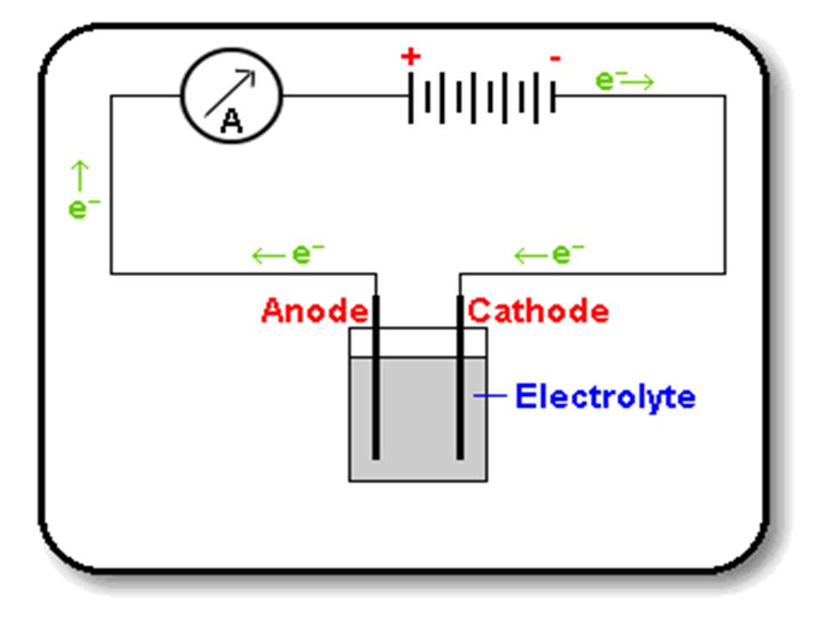

6.2. THE MECHANISM OF ELECTROLYSIS

The conductivity of ionic compounds is explained by the fact that ions move in a particular direction in an electric field. This can be shown in experiments with coloured salts. For example, copper (II) chromate (VI) (CuCrO4) dissolves in water to give a **green** solution. This solution is placed in a U-tube. A colourless solution of dilute hydrochloric acid (HCl) is then layered on top of the salt solution in each arm. Graphite rods are fitted as shown in figure 13.3. These rods (electrodes) carry the current into and out of the solution.

After passing the current for a short time, the solution around the cathode becomes **blue**. Around the anode, the solution becomes **yellow**. These colours are produced by the movement (migration) of the ions in the salt. The positive copper ions (Cu2+) are blue in solution. They are attracted to the cathode (negative electrode). The negative chromate ions (CrO42-) are yellow in solution. They are attracted to the anode (the positive electrode). The use of coloured ions in solution has shown the direction that positive and negative ions move in an electric field. Always positive ions (cations) move to the cathode and negative ions (anions) move to the anode.



**The movement of ions in solution**

PREFERENTIAL (SELECTIVE) DISCHARGE OF IONS

When a salt such as sodium chloride is dissolved in water, its ions are set free to move. So the solution can be electrolysed. Since the salts, alkalis and acids are dissolved in water, most of the solutions are aqueous. There is then a complication in electrolysis of such substances in aqueous form. This is because the water used to dissolve them also do ionize partially (it is a weak electrolyte)

                   H2O⇔ H+ + OH-

Then at each electrode, we get more than one ion for discharge, but only one is supposed to be discharged. Take an example of electrolysis of copper (II) sulphate solution using platinum electrodes. By ionic theory, the solution ionizes thus:

         CuSO4 (aq) → Cu2+ (aq) + SO42-(aq) (strong electrolyte)

         H2O⇔ H+ + OH-     (weak electrolyte)

During electrolysis, Cu2+ and H+ ions move to the cathode while SO42-and OH- ions move to the anode.

|  |  |
| --- | --- |
| Cathode | Anode |
| Cu2+ | SO42- |
| H+ | OH- |

In situations like this, the order of discharge of the ions at the electrode will depend on:

1. the position of the metal ion or radical in the electrochemical series;
2. the concentration or nature of the ions (or electrolyte) to be discharged; and
3. the nature of the electrodes used.

1. **The position of ion or radical in the electrochemical series**

|  |  |  |  |
| --- | --- | --- | --- |
| **Cations** |  | **Anions** |  |
| K+ | ease of discharge  increases | SO42- | ease of discharge increases |
| Ca2+ | NO3- |
| Na+ | Cl- |
| Mg2+ |  | Br- |  |
| Al3+ |  | I- |  |
| Zn2+ |  | OH- |  |
| Fe2+ |  |  |  |
| Pb2+ |  |  |  |
| H+ |  |  |  |
| Cu2+ |  |  |  |
| Ag+ |  |  |  |

The arrangement of ions above is the same as that of the electrochemical series. If all other factors are constant, any ion will be discharged from solution in preference to those above it. For example, in sodium hydroxide solution, containing H+ (from water) and Na+ (from the salt), H+ discharges in preference to Na+.

In copper sulphate solution, containing  OH- (from water) and  SO42- as negative ions,  OH- is discharged in preference to  SO42-.

|  |  |  |
| --- | --- | --- |
| Cathode |  | Anode |
| Cu2+ |  | SO42- |
| H+ |  | OH- |
| Cu2+ + 2e- → Cu(s)  copper is discharged (loses its charge) |  | 4OH-→2H2O(l)+O2(g)+4e-  hydroxyl ion is discharged |

In other words, we can say that the reaction that occurs at the **cathode** is reduction (electron gain) and that which occurs at the **anode** is oxidation (electron loss).

                                 Result

* At cathode, copper is deposited
* At anode, oxygen is given out (liberated)
* The solution at the end of electrolysis is colourless and acidic because in the electrolyte there are left  H+ and  SO42- ions, which remain moving freely in the solution as ionic sulphuric acid.

**2. The concentration or nature of electrolyte**

Take an example of electrolysis of sodium chloride using platinum electrodes when in:

1. aqueous solution;
2. concentrated aqueous solution; or
3. fused or molten state.

1. **aqueous solution**

NaCl → Na+ + Cl-

H2O⇔H+ + OH-

    During electrolysis:

|  |  |
| --- | --- |
| Cathode | Anode |
| Na+ and   H+ | Cl-  and  OH- |
| H+  ions are discharged in preference to  Na+ ions:     2H+ + 2e- → H2(g) | OH- ions are discharged in preference to Cl- ions:  4OH-→2H2O(l) +O2(g)+4e- |

                                 Result

* At cathode, hydrogen is given out
* At anode, oxygen is out
* The concentration of the solution remains constant since all  Na+ and  Cl- ions remain undisturbed in the solution. This means that the  Na+ and  Cl- ions that are left in the solution are equivalent to sodium chloride solution.

**i. Concentrated aqueous solution**

     NaCl → Na+ + Cl-

     H2O⇔H+ + OH-

|  |  |
| --- | --- |
| Cathode | Anode |
| Na+and  H+     H+ ions are discharged in preference to  Na+  ions since  Na+ and  H+ are very far from each other in e. c.s  2H+ + 2e- → H2(g) | Cl- and  OH-    Cl- ions are discharged in preference to  OH- ions since Cl- and  OH- ions are very close to each other in the e. c. s  (and because there are more  Cl- ions in the solution)  2Cl- → Cl2(g) + 2e- |

                              Result

* At cathode  H2(g) is given off
* At anode Cl2(g) is given off
* The solution becomes progressively more alkaline as the electrolysis goes on because  Na+ and  OH-  ions remain in solution as caustic soda (sodium hydroxide) solution. This is the main method used in the manufacture of sodium hydroxide in industry.

                        Na+(aq) + OH-(aq) → NaOH(aq)

1. **Fused or molten sodium chloride**

NaCl → Na++ Cl-

             During electrolysis:

|  |  |
| --- | --- |
| Cathode | Anode |
| Na+ + e- → Na(l) | 2Cl- → Cl2(g) + 2e- |

                        Result

* At cathode sodium is liberated (deposited)
* At anode chlorine is given off

**3. The nature of electrodes (inert vs active electrodes)**

**Example 1**

1. If dilute sulphuric acid  (H2SO4) is electrolysed using platinum electrodes:

                     H2SO4 → 2H+ + SO42-

               H2O⇔H+ + OH-

|  |  |
| --- | --- |
| Cathode | Anode |
| 2H+ + 2e- → H2(g) | SO42- and OH-        4OH-→2H2O(l)+O2(g)+4e- |

                           Result

* At cathode  H2(g) is given out
* At anode  O2(g)   is given out
* The solution becomes acidic at the end of electrolysis because of the acidic ions (SO42-) left in the finala solution.

1. If dilute sulphuric acid is electrolysed using graphite electrodes:

          H2SO4 → 2H+ + SO42-

             H2O⇔H+ + OH-

|  |  |
| --- | --- |
| Cathode | Anode |
| 2H+ + 2e- → H2(g) | SO42- and OH- |
|  | 4OH-→2H2O(l) + O2(g) + 4e- |
|  | http://demo.shuledirect.co.tz/ckfinder/userfiles/images/equ%2850%29.png |
|  | C + O2 → CO2(g) |

                                 Result

* At cathode,  H2(g) is given out
* At anode, a mixture of O2, CO and CO2 gases are formed

**Example 2**

Electrolysis of copper (II) sulphate using:

1. platinum electrodes
2. copper electrodes

1. **With platinum electrodes**

CuSO4 → Cu2+ + SO42-

     H2O⇔H+ + OH-

|  |  |
| --- | --- |
| Cathode | Anode |
| H+ and Cu2+ | SO42- and OH- |
| Cu2+ + 2e- → Cu(s) | 4OH-→2H2O(l) + O2(g) + 4e- |

                  Result

* At cathode copper is deposited
* At anode oxygen is given out
* The solution turns colourless and acidic to litmus due to  SO42- and H-  ions remaining in the solution, both of which are acidic in nature and are equivalent to acqueous sulphuric acid.

                         2H+ + SO42- → H2SO4

1. **With copper electrodes**

CuSO4 → Cu2+ + SO42-

    H2O⇔H+ + OH-

|  |  |
| --- | --- |
| Cathode | Anode |
| H+ and Cu2+ | 1. SO42- |
| Cu2+ + 2e- → Cu(s) | 1. OH- |
|  | 1. Cu → Cu2+ + 2e- |

The  SO42-  and  OH- ions move to the anode and there are possibilities of one of these being discharged. However, these ions are not discharged but remain in solution. Instead, copper atoms of the anode lose electrons and go into solution as copper ions.

                                        Cu → Cu2+ + 2e-

                               Result

* At cathode copper is deposited
* At anode copper dissolves (ionizes)
* The concentration of the solution remains constant since for every one mole of  Cu2+ discharged, there is one mole of  Cu  dissolved or ionized into one mole of Cu2+ ions. This method is applied in the purification of impure copper where the impure copper is made the anode, pure copper the cathode, and copper sulphate solution the electrolyte.

**EVALUATION**

1.Define Electrolysis

Ii Define the following terms

I.anode ii. cathode ii i. anoins iv. cations v.ion vi. electrode

ii State 3 factors that affect the preferential discharge of ions.

**WEEK 7**

**ELECTROLYTIC CELLS AND ELECTROLYSIS OF SPECIFIED ELECTROLYTES**

The passage of electricity through the electrolytes in their molten or dissolved state can cause chemical changes under suitable conditions. For example, the passage of electricity through the acidified water results in the formation of hydrogen and oxygen gases. The process of chemical decomposition of the electrolyte by he passage of electricity through its molten or dissolved state is called electrolysis.

**ELECTROL YTIC CELL**

The device in which the process of electrolysis is carried 1ut is called electrolytic cell. It consists of:

(i) Electrolytic tank, which is made of some nonconducting materials like glass, wood or bakelite.

(ii) Electrolyte in its dissolved state or molten state.

(iii) Source of electricity; an electrochemical cell or battery.

[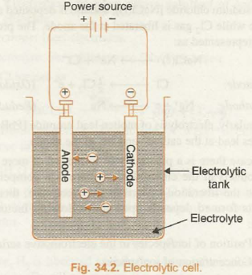](http://www.chemistry-assignment.com/wp-content/uploads/2013/02/1203.png)

(iv) Two metallic rods, suspended in the electrolyte and connected to the battery through conducting wires. These rods are called electrodes. The electrode connected to the negative terminal of battery is called cathode while the other one which is connected to the positive terminal is called anode. The apparatus used to constitute electrolytic cell has been shown in Fig. 34.2.

**Mechanism and Criteria of Product Formation in Electrolytic Cell**

Mechanism and Criteria of Product Formation in Electrolytic Cells

The process of electrolysis can be explained on the basis of the theory of ionisation. When an electrolyte is dissolved in water, it splits up into charged particles called ions. The positively charged ions are called cations while the negatively charged ions are called anions. The ions are free to move about in aqueous solution. When electric current is passed through the solution, the ions respond to the applied potential difference and their movement is directed towards the oppositely charged electrodes. The cations move towards the negatively charged electrode while anions move towards the positively charged electrode. The formation of products at the respective electrodes is due to oxidation (loss of electrons) at the anode and reduction (gain of electrons) at the cathode.

For example, when electricity is passed through the molten sodium chloride [NaCl)], sodium is deposited at the cathode while C~ gas is liberated at the anode. The process can be represented as:

[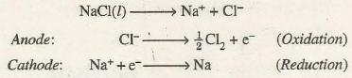](http://www.chemistry-assignment.com/wp-content/uploads/2013/02/1204.png)

Similarly, electrolysis of molten lead bromide [PbBr2(l)] produces lead at the cathode and Br2 at the anode.

In case there is a possibility of formation of more than one products at the electrodes, or there is a competition between the liberation of ions at the electrodes, then the products formed depends upon the following factors in general:

• Position of ion/species in the electromotive series

• Concentration of ion/species

• Nature of electrodes.

One of the dominant factors which control the criterion of product formation at the electrodes is the values of electrode potentials of the species. Let us understand it as follows:

(a) At the Cathode. Cathode involves reduction process at its surface. Therefore, for the different competing reduction processes, the one with higher reduction potential, will preferably take place. For example, during the electrolysis of aqueous solution of sodium chloride there is possibility of following reactions at the cathode:

[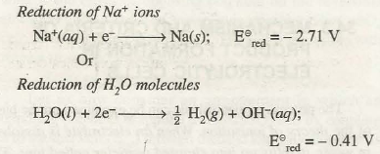](http://www.chemistry-assignment.com/wp-content/uploads/2013/02/1205.png)

The reduction of water will preferably take place at the cathode because E red of water is higher. Hence, the product of electrolysis of aqueous solution of NaCl at the cathode will be H2 gas instead of Na(s).

Similarly, during electrolysis of aqueous solution of Copper (II) tetraoxosulphate (VI) reduction of Cu2+ ions will take place at the cathode in preference to the reduction of 0 molecules because E2 is greater than E2

[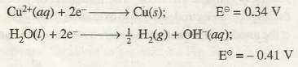](http://www.chemistry-assignment.com/wp-content/uploads/2013/02/1206.png)

**(b) At the Anode**. Anode involves oxidation process at its surface. Therefore, for different competing oxidation processes, the one with higher oxidation potential (or lower reduction potential) will preferably occur. For example, if we carry out electrolysis of aqueous solution of copper(II) tetraoxosulphate(VI), the competing oxidation processes at the anode are as follows:

[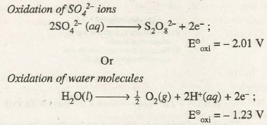](http://www.chemistry-assignment.com/wp-content/uploads/2013/02/1207.png)

As oxidation potential of water is higher, the product formed at the anode will be O2 gas instead of S2O8O 2- ion.

Similarly, if the electrolysis of copper sulphate solution is carried out using copper electrodes, then the process occurring at the anode will be oxidation of copper atoms to copper ions instead of oxidation of water because oxidation potential of Cu is higher.

[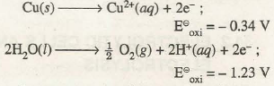](http://www.chemistry-assignment.com/wp-content/uploads/2013/02/1208.png)

Thus, in such a case copper from anode will go on dissolving into solution as Cu2+ ions while Cu2+ ions from solution will go on depositing at the cathode as copper atoms.

The above discussion leads us to a general conclusion that for different competing reactions at the electrodes:

It may be noted that in some cases the unexpected results are obtained due to overvoltage*. For example, let us compare the oxidation potentials of CI- ion and water

**ELECTROLYSIS OF SPECIFIED ELECTROLYTES**

In the light of above discussion let us discuss some examples of electrolytic reactions. Before we take up the actual examples, it is quite important to know about inert electrodes and active electrodes.

Inert electrodes are those electrode which do not gain or lose electrons during the process. Two common examples are carbon (graphite) electrode and platinum electrodes.

Active electrodes are those electrodes which themselves participate in the gain or loss of electrons.

1. Electrolysis of molten lead (IT) bromide

Electrodes: Inert electrodes

Electrolyte: Molten lead (II) bromide Molten lead (II) bromide ionises as

[](http://www.chemistry-assignment.com/wp-content/uploads/2013/02/1210.png)

Reaction at anode (oxidation of Br-)

[](http://www.chemistry-assignment.com/wp-content/uploads/2013/02/1211.png)

**2. Electrolysis of concentration solution sodium chloride (Brine solution)**

Electrodes: Inert electrodes

Electrolyte: Sodium chloride dissolved in water solvent.

NaCl ionises in aqueous solution as

NaCl (l) à Na + + Cl –

Cathode reaction: Reduction of H2O occurs in preference to Na+ ions as Na+ is much higher in electromotive series

2H2O (l) - à H2 (g) + 2OH (aq)

Anode reaction: Oxidation of CI- ions occur in preference to H2O because of higher concentration of CI- ions and overvoltage

2Cl –(aq) à Cl2 (g) + 2e –

Thus, Cl2 gas is produced at anode and H2 gas is liberated at cathode. The pH of solution increases due to increase in the concentration of OH ions in solution.

**3. Electrolysis of very dilute solution of sodium chloride**

Electrode: Inert electrodes.

Electrolyte: Very dilute brine (NaCl) solution.

NaCl ionises as

[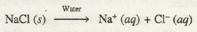](http://www.chemistry-assignment.com/wp-content/uploads/2013/02/1212.png)

Cathode reaction: Reduction of water occurs in preference to Na+ ions

4H2O (l) + 4e – à 2H2 (g) + 4 OH – (aq)

Here, H2 is liberated at cathode whereas O2 is liberated at the anode. The pH of solution does not change due to equal consumption of H+ and OH ions. However, concentration of NaCl gradually increase due to decomposition of water.

**4. Electrolysis of aqueous solution of copper (II) tetraoxosulphate (VI) solution: using platinum electrodes**.

Electrodes: Inert electrodes (Pt).

Electrolyte: CuSO 4 dissolved in water CuSO 4 ionises in aqueous solution as

[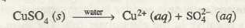](http://www.chemistry-assignment.com/wp-content/uploads/2013/02/1213.png)

Cathode reaction: eu2+ undergoes reduction in preference to H2O because H2O lies above Cu2+ in electrochemical series

Cu2+ (aq) + 2e – à Cu (s)

Thus, copper is deposited at cathode and 0 2 is liberated at anode. The pH of the solution decreases gradually due to increase in concentration of H+ ions. Blue colour of the solution gradually fades due to decrease in concentration of eu2+ ions.

**5. Electrolysis of aqueous solution of copper(II) tetraoxosulphate(VI) solution using copper electrodes**

Electrodes: Active electrodes.

Electrolyte: CuSO4 dissolved in water.

CuSO4 ionises in aqueous solution as:

[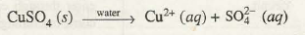](http://www.chemistry-assignment.com/wp-content/uploads/2013/02/1214.png)

Cathode reaction: Cu2+ ions undergo reduction in preference ~0 molecules

eu2+ (aq) + 2e- à7 Cu (s)

Anode reaction: Cu atoms from the copper electrode get oxidised in preference to ~0 because Cu lies below Hp in activity series.

Cu (s) à Cu2+ (aq)

Thus, copper dissolves from anode and get deposited at cathode. Mass of cathode increases and that of anode decreases. Blue colour of the solution does not fade because concentration of Cu2+ ions in solution remains unaltered. The pH of the solution also does not change as the electrolysis proceeds.

**Applications of Electrolysis**

Some of the important industrial applications of electrolysis are as FOLLOWS.

**ELECTROMETALLURGY**

Many of the highly reactive metals such as metal of group 1 or group 2 are extracted from their ores by electrolysis of their molten ores. This is because chemical reduction of their compounds .is either chemically not viable or highly expensive. Metals like sodium and magnesium, are manufactured by the electrolysis of their molten chlorides. Pure aluminium is obtained at Valco Industry from a solution of its oxide in molten cryolite. Details of this extraction and that of some other metals is discussed in later units.

**ELECTROREFINING OF METALS**

Refining of many of the crude metals such as copper, silver; aluminium, etc. is carried out by the process of electrolysis. In this. process, the block of crude metal is made anode while a thin sheet of pure metal is made cathode and the electrolyte is aqueous solution of some salt of the metal. As the electrolysis proceeds metal from anode dissolves whereas it gets deposited in pure form at cathode. The impurities settle down just below anode in the form of anode sludge or anode mud.

**MANUFACTURE OF CHEMICAL SUBSTANCES**

Electrolysis is used in the manufacture of some important substances such as hydrogen, chlorine, sodium hydroxide, sodium oxochlorate (I) and oxygen.

**Electroplating**

It is another important industrial application of electrolysis. Electroplating is an art of coating a layer of costlier metal like gold, silver, etc. over the cheaper metal like iron. The purpose of electroplating is

• protection of cheaper metal like iron from corrosion

• beautification of articles like, earrings, bangles, tings, parts of wrist watches, etc.

• repair of the broken parts of delicate machinary where welding is not possible.

The principle of electroplating is similar to that of purification of metals by electrolysis. The article to be plated, is thoroughly cleaned with aq H2SO 4 and washed with distilled water. It is then made the cathode of the electrolytic cell. The anode is pure sheet of metal to be coated or plated. The electrolyte is a solution of a salt of the metal to be plated. During electrolysis, the metal to be electroplated is transferred from the anode to the cathode.

APPLICATION OF ELECTROLYSIS

Electrolysis has several uses in industry. Its main application has been in the fields of manufacture of chemicals and in the purification of metals for which other purification methods prove either too difficult or highly expensive to apply. Some applications of electrolysis are as discussed below:

1. **Extraction of metals**

Reactive metals exist as compounds, so it is difficult to extract them from their compounds. Extraction of metals such as sodium, potassium, magnesium and calcium necessarily requires an electrolytic process. For example, electrolytic method is used to extract sodium from molten sodium chloride:

2NaCl(l) → 2Na(l) + Cl2(g)

1. **Purification of metals**

Some metals can be purified by means of electrolysis. This process is used in industry to purify copper, which must be very pure 99.9% for electrical wiring. Copper made by roasting the sulphide ore is about 99.5% pure (so it has an impurity level of 0.5%). This level of impurity cuts down electrical conductivity significantly.

This is how the electrolytic purification (refining) process is carried out:

The anode is made of a large block of impure copper. The cathode is a thin sheet of pure copper. The electrolyte is copper (II) sulphate solution.

During the refining process, the copper atoms of the impure block become ions (the anode dissolves).

                Cu → Cu2+ + 2e-

The ions from the solution become atoms.

                Cu2+ + 2e- → Cu(s)

They stick onto the cathode. A layer of pure copper builds up on the cathode. As electrolysis takes place, the cathode gains mass as copper is deposited on it. As a result, the cathode gets smaller while the cathode gets bigger as electrolysis proceeds. Eventually the whole cathode dissolves.

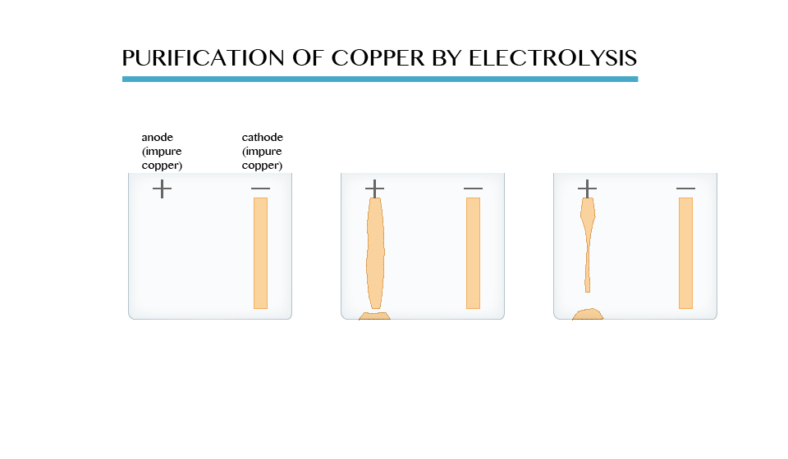

Only pure copper sticks to the cathode. Most impurities fall to the bottom of the electrolytic cell. They form a solid material (**anode sludge** or **slime**) which contains small quantities of precious metals such as silver, gold and platinum. The precious metals recovered from the slime are purified and sold.

1. **Industrial manufacture of chemicals from brine**

The electrolysis of a concentrated sodium chloride solution (brine) is an important industrial process. The electrolysis of brine produces hydrogen, chlorine and sodium hydroxide. The electrolysis is carried out in an apparatus called Down’s cell.

The diagram below shows one of several types of cell that are used. The cell is sometimes referred to as the membrane cell.

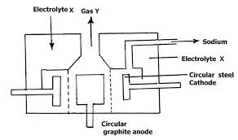

The anode is made of titanium and the cathode of nickel. Anion-exchange up the middle lets sodium ions through but keeps the gases apart. The sodium ions move freely to the cathode.

At the cathode: hydrogen bubbles off:

                    2H+ + 2e- → H2(g)

At the anode: chlorine bubbles off:

                2Cl- → Cl2 + 2e-

Na+ and OH- ions are left behind, which means a solution of sodium hydroxide forms. Some is evaporated to a more concentrated solution, and some evaporated completely to give solid sodium hydroxide.

The products of this electrolysis have a wide range of uses.

Hydrogen is used to make ammonia and in the manufacture of margarine.

Chlorine is used to kill bacteria in swimming pools and domestic water supplies. It is also used to make plastics.

Sodium hydroxide is used to make soap, paper, bleach, and rayon fibres.

The products also have several other uses not mentioned here.

1. **Electroplating**

Electroplating is the coating of a metal with a layer of another metal by means of electrolysis. Electrolysis can be used to coat a thin layer of a less reactive metal onto a more reactive metal. The thin layer of less reactive metal will provide protection from corrosion for the more reactive metal underneath. It may also make the product more attractive.

The object to be coated should be made the cathode and the coating material should be the electrolyte. The most commonly used metals for electroplating are copper, chromium, silver and tin.

Steel can be electroplated with chromium or tin. This prevents the steel from rusting and gives it a shiny, silver finish. This is also the idea behind chromium-plating articles such as car bumpers, kettles, bath taps, etc. Chromium does not corrode, it is a hard metal that resists scratching and wear, and can also be polished to give an attractive finish.

Nickel can be electroplated with silver. This will make nickel more attractive.

The diagram below shows how a steel jug is electroplated with silver. The jug becomes the cathode of an electrolytic cell. The anode is made of silver. The electrolyte is a solution of a silver compound, for example silver nitrate.

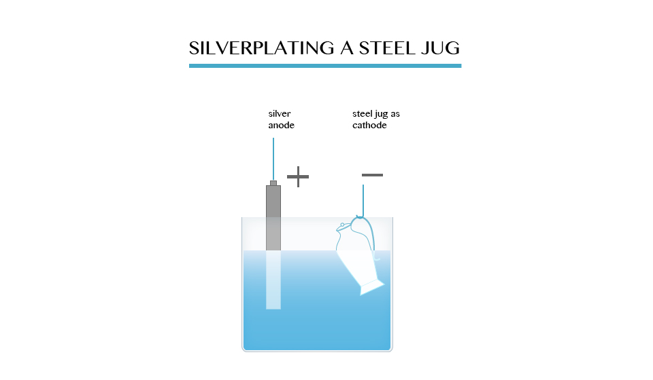

At the anode: The silver dissolves, forming ions in solution:

                                Ag → Ag+ + e-

At the cathode: The silver ions receive electrons, forming a coat of silver on the jug:

                           Ag+ + e- → Ag (s)

When the layer of silver is thick enough, the jug is removed.

In general, to electroplate any object with metal M, the set up is:

Cathode – object to be electroplated

Anode – metal M

Electrolyte – solution of a soluble compound of M

1. **Anodizing aluminium**

Although aluminium is quite reactive, corrosion in air is not a problem. This is because a thin layer of aluminium oxide quickly forms and acts as a barrier to oxygen. The layer can be made thicker, to give a more protection by a process called anodizing.

The aluminium is used as the anode of a cell. Dilute sulphuric acid is the electrolyte. When this acid is electrolysed, as you learned early, oxygen forms at the anode.

             4OH-→2H2O(l) + O2(g) + 4e-

The oxygen liberated at the aluminium anode reacts with aluminium to form a protective layer of the oxide on the metal:

             4Al(s) + 3O2(g) → 2Al2O3(g)

The anodized aluminum absorbs dyes and pigments easily.It is used for a whole range of things including masts for yachts and windsurfing boards, facings for buildings, and window frames.

1. **Producing hydrogen from water**

Hydrogen may become a much more important fuel in the future. It can be produced by the electrolysis of acidified water. Pure water is a very poor conductor of electricity. However, it can be made to decompose if some sulphuric acid is added.

Sulphuric acid, when dissolved in water, forms ions:

                H2SO4(aq) → 2H+(aq) + SO42-(aq)

Water ionizes thus:   H2O⇔H+ + OH-

Therefore, a dilute solution of the acid contains H+ ions from water and acid, OH- ions from the water and SO42- ions from the acid.

|  |  |
| --- | --- |
| At cathode | At anode |
| Ions:          H+ | OH-  and  SO42- |
| Reaction:  2H+ +2e- →H2(g) | 4OH-→2H2O(l)+O2(g)+4e- |
| Product:   Hydrogen is liberated | Oxygen is liberated. |

A Hofmann voltammeter shown below can be used to keep the gases produced separate. The gas collected above the cathode is hydrogen. Oxygen collects at the anode. The ratio of the volume is approximately 2:1. Effectively this is the electrolysis of water.

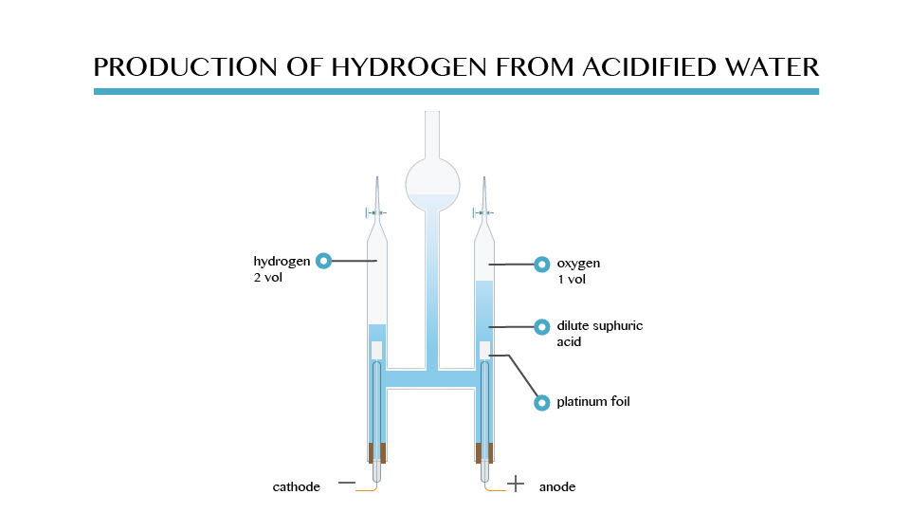

In the future, hydrogen from the electrolysis of water may be piped into homes and used as a fuel for cooking and heating. It will also be used in batteries called fuel cells to power homes and electric cars.

**EVALUATION**

1. With the aid of a well labelled diagram, describe the electrolysis of dilute sodium tetraoxosulphate(vi) using suitable electrodes

2. Name the electrode

**WEEK 8**

**ELECTROCHEMISTRY**

It is a well known fact that energy menifests itself in different forms which are interconvertible into one another. Among different forms of energy, the electrical energy plays a very significant role in our daily life. Many chemical transformations and industrial processes are based on electrical energy and its relationship with chemical energy. There are large number of spontaneous redox reactions which form the basis of production of electrical energy. The device in which such chemical processes are carried out is called electrochemical cell or galvanic cell. For example, Daniell cell is based on the following redox reaction:

Cu2(aq) + Zn(s) à Cu(s) + Zn2+ + Electrical Energy

At the same time many of the non-spontaneous redox reactions can be made to occur by the use of electrical energy. Some examples are:

The branch of chemistry which deals with the study of relationship between electrical energy and chemical energy and interconversion of one form of energy into another is called electrochemistry. Electrochemistry is very vast and interdisciplinary branch of chemistry which finds tremendous applications. Its study is very important as it helps in the development of new technologies which are economical and environment-friendly. In this unit, we shall focus on the study of some aspects of electrochemical cells, batteries and fuel cells, etc.

[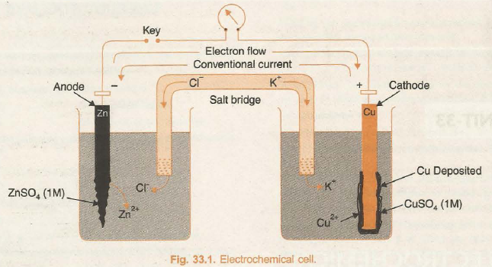](http://www.chemistry-assignment.com/wp-content/uploads/2013/02/1174.png)

**Electrochemical Cells**

Electrochemical Cells

The device in which chemical energy is converted into electrical energy is called galvanic cell or electrochemical cell or voltaic cell. In a galvanic cell, a redox reaction is carried out in an indirect manner and the decrease in free energy during the chemical process appears as electrical energy. An indirect redox reaction is such that reduction and oxidation processes are carried out in separate vessels. In order to understand this phenomenon, let us consider the redox reaction between Zn and CuSO4 solution.

Zn(s) + Cu2+(aq) à Zn2+(aq) + Cu(s)

The overall reaction is split up into two half reactions,

Zn (s) à Zn2+ (aq) and Cu2+ (aq) + 2e - à Cu(s)

**Half Reactions and Redox Couples**

The half reactions are used to form redox couples as described below.

In its simple form, a zinc strip is dipped in the ZnSO4 solution and a copper strip is dipped in the CuSO4 solution taken in separate beakers. An arrangement involving contact between oxidised and reduced form of the substance such as Zn / Zn2+, or Cu/Cu2+ at the interface is called redox couple. The two metallic strips which act as electrodes are connected by the conducting wires through a voltmeter. The two solutions are joined by an inverted U-tube known as salt bridge. The U-tube is filled with the solution of some electrolyte such as KCl, KNO3 or NH4Cl to which gelatin or agar-agar has been added to convert it into semi-solid paste.

A schematic diagram of this cell has been shown in Fig. 33.1.

The deflection in voltmeter indicates that there is a potential difference between the two electrodes. It has been found that the conventional current flows through the outer circuit from copper to zinc strip. It implies that the electrons flow occurs from zinc to copper strip.

Let us now understand the working of the cell.

(i) Zinc undergoes oxidation to form zinc ions

Zn(s) à Zn2+(aq) + 2e – (oxidation)

(ii) The electrons liberated during oxidation are pushed through the connecting wires to copper strip.

(iii) Copper ions move towards copper strip, pick up the electrons, and get reduced to copper atoms which are deposited at the copper strip.

Cu2+(aq) + 2e - à Cu(s) (Reduction)

The overall cell reaction is combination of oxidation half and reduction half reactions.

Zn(s) + Cu2+ (aq) à Cu(s) + Zn2+ (aq)

The electrode at which oxidation occurs is anode and that at which reduction occurs is cathode. In the above cell, zinc strip is anode and the copper strip is cathode. Due to the oxidation process occurring at the anode it becomes a source of electrons and acquires a negative charge in the cell. Similarly, due to reduction process occurring at the cathode it acquires positive charge and becomes a receiver of the electrons. Thus, in the electrochemical cell, anode electrode acts as negative terminal and cathode electrode acts as positive terminal.

**Salt Bridge and functions**

Salt Bridge is a U-shaped tube containing a semi-solid paste of some inert electrolyte like KCl, KNO3, NH4Cl, etc., in agar-agar or gelatine. An inert electrolyte is one which:

(a) does not react chemically with the solution in either of the compartment.

(b) does not interfere with the net cell reaction. Function of Salt Bridge. In the electrochemical cell a salt bridge serves two very important functions :

(i) It allows the flow of current by completing the circuit.

(ii) It maintains electrical neutrality.

The transference of electrons from anode to cathode leads to a net positive charge around the anode due to increase in the concentration of cations and a net negative charge around the cathode due to excess of anions in solution. The positive charge around the anode will prevent electrons to flow out from it and the ·negative charge around the cathode will prevent the inflow of electrons at it. The reaction would thus, stop and no current will flow. The salt bridge comes to aid and restores the electroneutrality of the solutions in the two compartments. It contains a concentrated solution of an inert electrolyte the ions of which are not involved in electrochemical reactions. The anions of the electrolyte in the salt bridge migrate to the anode compartment and cations to the cathode compartment. Thus, the salt bridge prevents the accumulation of charges and maintains the flow of current. In the electrochemical cell, the salt bridge can be replaced by the porous partition which allows the migration of ions but does not allow mixing of the two solutions.

**REPRESENTATION OF REDOX COUPLE AND GALVANIC CELL**

Galvanic cell is a combination of two redox couples, namely; oxidation couple or oxidation half cell and reduction couple or reduction half cell. If M represents the symbol of the element and Mn+ represents its cation (i.e., its oxidised state) in solution, then

Oxidation half cell is represented as M / MD n+(c)

Reduction half cell is represented as MD n+(c)/M.

In both the notations c refers to the molar concentration of the ions in solution. Conventionally, a cell is represented by writing the cathode on the right hand side and anode on the left hand side. The two vertical lines are put between the two half cells which indicate salt bridge. Sometime the formula of the electrolyte used in the salt bridge is also written below the vertical lines.

For example, zinc-copper sulphate cell is represented as follows:

[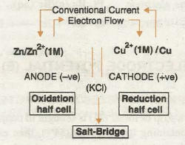](http://www.chemistry-assignment.com/wp-content/uploads/2013/02/1175.png)

**VARIOUS TYPES OF REDOX COUPLES OR ELECTRODES**

Some important types of electrodes which are frequently used in electrochemical cells are described as follows:

**1. Metal-metal Ion Electrode.** Such type of electrodes include a metal rod dipped in the solution of its own ions. Some examples are Zn/Zn2+ Ag/Ag+, .Cu/Cu2+ etc.

**2. Amalgam Electrodes**. These are similar to metal-metal ion electrodes, but here the metal is used in the form of its amalgam with Hg. Amalgam is formed to modify the activity of metal. (Zn-Hg)/Zn2+ is one of the common example of this type.

**3. Gas Electrodes**. Such electrodes involve inert metal such as platinum dipped in the solution containing ions of the gaseous element. The arrangement is made in such a manner that gas and its ions are brought in contact at the surface of the inert metal. Some examples along with their electrode reactions are as follows:

[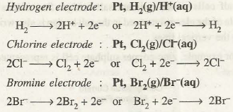](http://www.chemistry-assignment.com/wp-content/uploads/2013/02/1176.png)

**Electrode Potential (E)**

→ **DEVELOPMENT OF ELECTRODE POTENTIAL**

When a strip of metal (M) is brought in contact with the solution containing its own ions (M n+), then either of the following three possible processes can take place:

(i) The metal ion M n+ may collide with the metallic strip and bounce back without any change.

(ii) The metal ion M n+ may collide with the strip, gain n electrons and get converted into metal atom, i.e., the ion is reduced.

M n+ + ne – à M

(iii) The metal atom on the strip may lose n electrons and enter the solution as M n+ ion, i.e., metal is oxidised

M à M n+  +  ne –

The above changes have been shown in Fig. 33.2.

[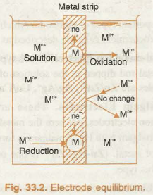](http://www.chemistry-assignment.com/wp-content/uploads/2013/02/1177.png)

Now, if the metal has a relatively high tendency to get oxidised, its atoms would start losing electrons, change into positive ions and pass into the solution. The electrons lost, accumulate in the metal strip and cause it to develop negative charge. The negative charge developed on the strip does not allow metal atoms to continue losing electrons but it would reattract the metal ions from the solution in an attempt to neutralize its charge. Ultimately, a state of equilibrium will be established between the metal and its ions at the interface.

[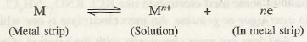](http://www.chemistry-assignment.com/wp-content/uploads/2013/02/1178.png)

Similarly, if the metal ions have relatively greater tendency to get reduced, they will accept electrons at the strip from the metal atoms and consequently, a net positive charge is developed on the metal strip. Ultimately, a similar equilibrium is established between the metal ions and the metal atoms at the interface.

[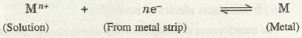](http://www.chemistry-assignment.com/wp-content/uploads/2013/02/1179.png)

The development of positive and negative charges on the metal strip has been shown in Fig. 33.3 and 33.4 respectively.

[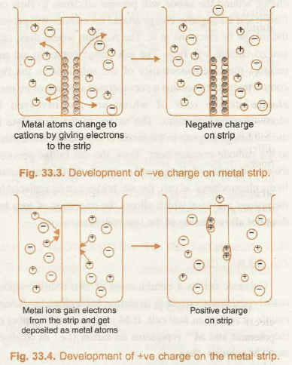](http://www.chemistry-assignment.com/wp-content/uploads/2013/02/1180.png)

Now, different metals have different tendencies to lose/gain electrons, therefore, they may develop different magnitude of negative or positive charge, which, unfortunately cannot be measured by any direct means. However, the separation of charges at the equilibrium state in either case, results in the electrical potential difference between the metal and the solution of its ions and is known as electrode potential.

The exact potential difference at the equilibrium depends on the nature of metal, its ions, the concentration of ions and the temperature.

According to the present IUPAC conventions, the half reactions are always written as reduction half reactions and their potentials are represented by reduction potentials. It may be noted that:

(i) Reduction potential (tendency to gain electrons) and oxidation potential (tendency to lose electrons) of an electrode are numerically equal but have opposite signs.

(ii) Reduction potential increases with the increase in the concentration of ions and decreases with the decrease in the concentration of the ions in solution.

**STANDARD ELECTRODE POTENIAL (E)**

The reduction potential of electrode when the concentration of the ions in solution is 1 mol L-1 and temperature is 298 K is called standard reduction potential (Ed) or simply standard electrode potential (E).

In case of gas electrode, the standard conditions chosen are 1 bar pressure and 298 K along with 1 M concentration of ions in solution.

The absolute value of E cannot be determined because once equilibrium is reached between the electrode and the solution in a half cell, no further displacement of charges can occur unless and until it is connected to another half cell with different electrode potential. This difficulty is overcome by finding the electrode potentials of various electrodes relative to some reference electrode whose electrode potential is arbitrarily fixed. The common reference electrode used forth is purpose is standard hydrogen electrode (SHE) whose electrode potential is arbitrarily taken to be zero.

**Cell Potential or EMF of the Cell**

→ Cell Potential or EMF of the Cell

The electrochemical cell consists of two half cells. The electrodes in these half cells have different electrode potentials. When the circuit is completed the loss of electrons occurs at the electrode having lower reduction potential whereas the gain of electrons occurs at the electrode with higher reduction potential. The difference in the electrode potentials of the two electrodes of the cell is termed as electromotive force (abbreviated as EMF) or cell voltage (E cell). Mathematically, it can be expressed as

EMF = E red (Cathode)- E red (Anode) or simply as

E cell = E cathode – E anode

Since in the representation of a cell, the cathode is written on right hand side and the anode on left hand side, therefore, EMF of a cell is also sometimes written as: ·

EMF = E Right – E Left = ER – E1

EMF of the cell may be defined as the potential difference between the two terminals of the cell when either no current is drawn from it. It is measured with the help of potentiometer or vacuum tube voltmeter.

The EMF of the cell depends on nature of the reactants, concentration of the solutions in the two half cells, and the temperature. The EMF of the cell at the standard state conditions is called standard EMF and can be calculated from the standard electrode potentials of the two half cells.

E cell = E cathode – E code

**Standard Hydrogen Electrode (SHE)**

→ Standard Hydrogen Electrode (SHE)

Standard hydrogen electrode (Fig. 33.5) consists of a platinum wire sealed into a glass tube and carrying a platinum foil at one end. The platinum foil is coated with finely divided platinum. The electrode is placed in beaker containing an aqueous solution of some acid having one molar concentration of H+ ions. Hydrogen gas at 1 bar or 100 kPa pressure is continuously bubbled through the solution at a temperature of 298 K. The oxidation or reduction in the SHE takes place at platinum foil. Hence, it can act as anode as well as cathode and may be represented as:

[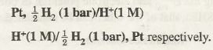](http://www.chemistry-assignment.com/wp-content/uploads/2013/02/1181.png)

[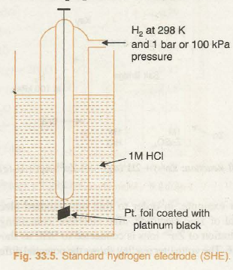](http://www.chemistry-assignment.com/wp-content/uploads/2013/02/1182.png)

If SHE acts as anode then oxidation will take place at it as

[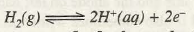](http://www.chemistry-assignment.com/wp-content/uploads/2013/02/1183.png)

If SHE acts as cathode then reduction will take place at it as

[](http://www.chemistry-assignment.com/wp-content/uploads/2013/02/1184.png)

**Measurement of Standard Electrode Potentials**

→ Measurement of Standard Electrode Potentials

In order to determine the standard electrode potential of an electrode, the electrode in standard conditions is connected to standard hydrogen electrode (SHE) to constitute a cell. If the electrode forms the negative terminal of the cell it is allotted negative value of electrode potential and if it forms the positive terminal of the cell, it is allotted a positive value of electrode potential. The potential difference between the electrodes is determined with the help of potentiometer or vacuum tube voltmeter. At the same time, the direction of flow of conventional current in the external circuit is also noticed with the help of galvanometer. This helps us to know the positive and negative terminals of the cell because conventional current in the external circuit flows from +ve terminal to -ve terminal. Now, the direction of the flow of electrons is opposite to that of conventional current. Since electron flow in external circuit occurs from anode to cathode it helps us to mark anode and cathode electrodes of the cell.

[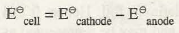](http://www.chemistry-assignment.com/wp-content/uploads/2013/02/1185.png)

Knowing the E cell and electrode potential of one of the electrodes (SHE), that of the other can be calculated

[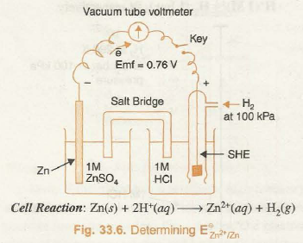](http://www.chemistry-assignment.com/wp-content/uploads/2013/02/1186.png)

For example, in order to find out standard electrode potential of zinc electrode, zinc electrode containing 1 M concentration of Zn2+ ions is connected to SHE as shown in Fig. 33.6. The voltmeter reading shows the potential difference of 0.76 volts. The electron flow is found to be from zinc electrode to SHE. From this it follows that Zn acts as anode while SHE acts as cathode. The net cell reaction is

[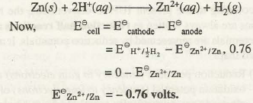](http://www.chemistry-assignment.com/wp-content/uploads/2013/02/1187.png)

Similarly, when standard copper electrode is coupled with SHE the voltmeter reading shows a potential difference (E cell) of 0.34 volts. The electron flow is found to occur from SHE towards copper electrode as shown in Fig. 33.7. Therefore, SHE in this cell acts as anode and copper electrode acts as cathode. The cell reaction is

[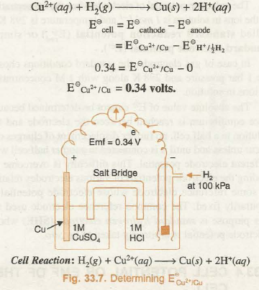](http://www.chemistry-assignment.com/wp-content/uploads/2013/02/1188.png)

**Electrochemical Series**

We have seen that different metal/metal ion combinations have different values of standard electrode potentials. The various elements can be arranged in order of increasing or decreasing values of their standard reduction potentials. The arrangement of various elements in the order of increasing values of standard reduction potentials is called electrochemical series. The  electrochemical series, also called activity series consisting of some electrodes along with their respective reduction reactions has been given in Table 33.1.

**Table 33.1. Standard Electrode Potentials**

[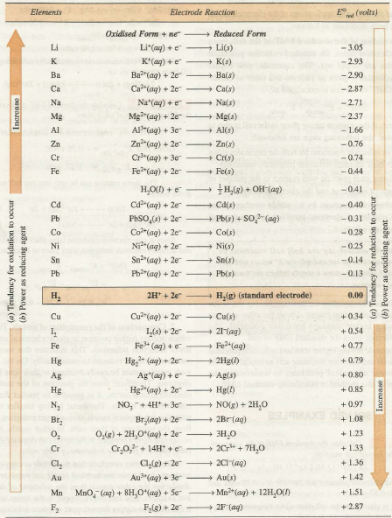](http://www.chemistry-assignment.com/wp-content/uploads/2013/02/1189.png)

**EVALUATION**

W hat is the voltage of the cell represented as Zn(s)/Zn2+(aq)//Cu2+(aq)/Cu(s)?

Given that Cu2+(aq)/Cu(s) E0=+0.337V

Zn(s)/Zn2+(aq) E0=0.763V

WEEK 9

**APPLICATIONS OF ELECTROCHEMICAL CELLS**

The importance of electrochemical cells or galvanic cells lies in their ability to provide us with a portable source of electrical energy. We have already studied that indirect redox reaction is, primarily, the basis of all the electrochemical cells Quite often, we use the term battery to represent the arrangement of two or more galvanic cells connected in series.

However, in practice the redox reaction used should give the arrangement which fulfills the following requirements:

• It should be light and compact;

• Its voltage should not vary appreciably during its use;

• It should provide power for a longer period; and

• It should be rechargeable.

**APPLICATIONS OF THE ELECTROCHEMICAL SERIES**

Some of the important applications of the electrochemical series have been discussed as follows:

1. Calculation of the standard EMF of the cell. From the electrochemical series, the standard reduction potentials of electrodes are found out. The electrode with higher reduction potential is taken as cathode and other as anode. From this EMF0 of the cell is calculated as:

EMF o = E o cathode – E o anode

However, if the reaction taking place in the cell is also to be determined, the following steps are followed:

(a) Write reduction equations for both the electrodes along with their standard reduction potentials, separately.

(b) Balance each reaction with respect to the number of atoms of each kind and the electrical charges.

(c) Multiply the reactions by a suitable number so that the number of electrons involved in both the half reactions are equal.

(d) Subtract the equation for reaction having the lower standard reduction potential from the other reaction having higher standard reduction potential. The difference gives the standard EMF of cell.

The electrode having higher standard reduction potential acts as cathode and the other electrode acts as anode. Now let us solve some numerical problems to understand the applications of this method in calculating standard EMF.

**2. Comparison of the reactivities of metals.** The metals which occupy higher position in electrochemical series have lower reduction potentials. This indicates that ions of such metals will not be reduced to metals easily. On the contrary, such metals would be easily oxidized to their ions by losing electrons. Therefore, from the position of the metal in the electrochemical series, it is possible to predict the relative reactivities of metals. The metal having smaller reduction potential can displace metals having larger reduction potential from the solutions of their salts. In other words, the metal occupying higher position in the series can displace the metals lying below it from the solutions of their salts.

Thus, we may conclude that the metals occupying higher positions in the electrochemical series are more reactive in displacing the other metals from the solutions of their salts. For example, zinc lies above copper in the series and hence, it can displace copper from copper sulphate solution. Copper cannot displace zinc from zinc sulphate solution because it lies below zinc in the series and hence, it is less reactive.

**3. Predicting the feasibility of a redox reaction**. With the help of electromotive series we can predict whether a given redox reaction will take place or not. From the given equation, the substances undergoing oxidation and reduction are identified. The substance undergoing oxidation will act as anode and the substance undergoing reduction will act as a cathode. The EMF of this hypothetical cell is calculated as under :

EMF o = E o cathode – E o anode

If EMF o comes out to be positive the given redox reaction will take place and if EMF0 comes out to be negative the given redox reaction will not take place.

4. To predict the reaction of a metal with dilute acids to liberate hydrogen gas. Some metals like Fe, Zn react with dil. acids like HCl, H2SO4 to liberate H2 gas while some metals like Cu, Ag do not liberate H2 gas with dil. HCl, dil. H2SO4. A prediction about ability of a given metal to produce H2 gas by its reaction with dilute acids can be easily made from the knowledge of electromotive series. Chemical reaction between metal and acid can be represented, in general as

[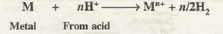](http://www.chemistry-assignment.com/wp-content/uploads/2013/02/1190.png)

For the above reaction to occur, the E o red of metal (M n+ M) must be lower than that of hydrogen. Hence, it can be concluded that metals which lie above hydrogen in the electromotive series can reduce H+ ions to hydrogen and hence, liberate hydrogen gas on reaction with dil acids. In other words, metals having negative reduction potentials can displace hydrogen from acids. For example, zinc (E o zn+2 / z n = -0.76 volt) lies above hydrogen in the series and hence, it can displace hydrogen from dilute acids, whereas copper (E0 eu•2teu = +0.34 volts) which is lying below hydrogen in the series cannot displace hydrogen from acids.

5. Relative Oxidising and Reducing Powers of Various Substances. Substance with higher value of standard reduction potential have greater tendency to undergo reduction. For example F 2 has highest reduction potential which means it is most easily reduced to p– ions. In other words, F2 is best oxidising agent. Li+ ion, on the other hand, had lowest reduction potential. Hence Li+ is weakest reducing agent or conversely Li metal is best reducing agent. Thus, it can be concluded that substances with higher reduction potentials are strong oxidising agents while substances with lower reduction potentials are strong reducing agents.

**Fuel Cells**

→ Fuel Cells

In recent years, the scientists have designed the cells which convert chemical energy of a fuel directly into electrical energy. Such cells are called fuel cells. These are the voltaic cells in which, the fuels such as H2, CO, CH4, C3H8, etc., are used to generate electrical energy without the intervention of thermal devices like boiler, turbines, etc.

The conventional method of conversion of chemical energy of a fuel into electrical energy involves combustion of a fuel to liberate heat. The heat energy so produced is used to generate steam for spinning the turbines which are coupled to electrical generators. This process is approximately 40% efficient.

Fuel cells are designed in such a way that the materials to be oxidised and reduced at the electrodes are stored outside the cell and are constantly supplied to the electrodes. In fact, fuel cell is a flow battery that continues to operate as long as the reactants from outside are fed into it. One of the most successful fuel cells uses the reaction of hydrogen and oxygen to form water and is known as H2O2 fuel cell. The H2-O2 fuel cell is also called Bacon cell after the name of its inventor and it had been used to power the Apollo space Missions. The water vapours produced during the reaction were condensed and added to drinking water supply for the astronauts. The experimental arrangement is shown in Fig. 33.13.

[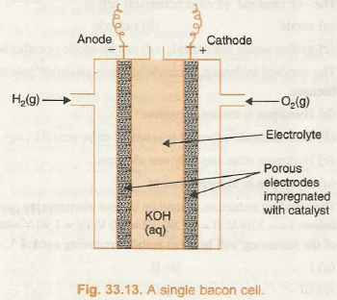](http://www.chemistry-assignment.com/wp-content/uploads/2013/02/1199.png)

The cell consists of porous carbon electrodes which are impregnated with catalyst (Pt, Ag or CoO). Hydrogen and oxygen are bubbled through the electrodes into electrolyte which is an aqueous solution of NaOH or KOH. The electrode reactions are:

[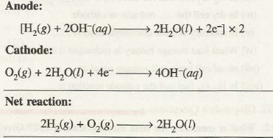](http://www.chemistry-assignment.com/wp-content/uploads/2013/02/1200.png)

The cell runs continuously as long as the gases hydrogen and oxygen are supplied at the temperature 525 K and 50 atm. pressure.

**ADVANTAGES OF FUEL CELLS**

Some prominent advantages of fuel cells are being described as follows:

(i) Pollution Free Working. There is no harmful or objectionable product formed in fuel cells. Hence, they do not cause pollution problems.

(ii) High Efficiency. The efficiency of fuel cells is approximately 70-75%, which is much higher than the conventional cells.

(iii) Continuous Source of Energy. Unlike conventional batteries, energy can be obtained from the fuel cell continuously so long as the supply of fuel is maintained.

The H2/O2 cell has been used for generating electrical power in the Apollo space programmes.

**Comparison Between Electrochemical Cell and Electrolytic Cell**

Comparison Between Electrochemical Cell and Electrolytic Cell

We have learnt that there are two types of cells namely electrochemical cells and electrolytic cells. Electrochemical cell is a device which converts chemical energy into electrical energy. On the other hand, electrolytic cell is a device which converts electrical energy into chemical energy. The two cells also differ significantly with respect to the charges on the electrodes. For example, in electrochemical cell anode is negative whereas in electrolytic cell, the anode is positive. Similarly, cathode is positive in electrochemical cell whereas it is negative in the electrolytic cell. The main points of difference have been summed up as follows in Table 34.1.

**1. Differences between Galvanic Cell and Electrolytic Cell**

|  |  |
| --- | --- |
| Galvanic Cell    1. In galvanic cell, electrical energy is produced.    2. In galvanic cell, reaction taking place is spontaneous.    3. The two half cells are set up in different containers and are connected through salt  bridge or porous partition.    4. In galvanic cell, anode is negative and cathode is positive.    5. The electrons move from anode to cathode in external circuit. | Electrolytic Cell    1. In electrolytic cell, electrical energy is consumed.    2. In electrolytic cell, reaction taking place is nonspontaneous.    3. Both the electrodes are placed in the solution or molten electrolyte in the same container.    4. In electrolytic cell, the anode is positive and cathode is negative.    5. The electrons are supplied by the external source. They enter through cathode and come out through anode. |

[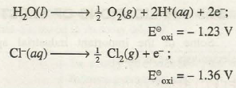](http://www.chemistry-assignment.com/wp-content/uploads/2013/02/1209.png)

Although oxidation potential of H2O is more than that of CI- ions, yet during the electrolysis of concentrated solution of sodium chloride, the chloride ions oxidise in preference to H2O molecules at the anode giving Cl2 gas as the product.

The galvanic cells can be broadly classified into two categories, namely; primary cells and secondary cells.

**PRIMARY CELLS**

This type of cells become dead over a period of time and the chemical reaction stops. They cannot be recharged or used again. Some common examples are dry cell, mercury cell, etc.

(a) Dry Cell. It is a compact form of Leclanche cell known after its inventor, a French chemist, G Leclanche. In this cell, anode consists of zinc container while cathode is a graphite rod surrounded by powdered :MnO2 and carbon. The space between the electrodes is filled with the paste of NH4Cl and ZnCl2. The arrangement is shown in Fig. 33.9.

[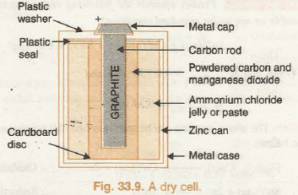](http://www.chemistry-assignment.com/wp-content/uploads/2013/02/1191.png)

The reactions taking place at the electrodes are given in their simplified form as follows:

**Cathode:**

MnO2 + NH4+ e- à MnO(OH) + NH3

**Anode:**

Zn à Zn2+ + 2e-

The zinc ions (Zn2+) so produced combine with ammonia liberated in cathodic reaction to form diammine zinc (II) cation.

Zn2+ + 2NH3 à [Zn(NH3) 2]2+

Dry cells do not have long life as NH4Cl which is acidic, corrodes the zinc container even if the cell is not in use. The cell potential of dry cells lies in the range J. 25 V to 1. 5 V.

(**b) Mercury Cell**. It is miniature cell which finds a frequent use these days to supply energy for watches, video cameras, hearing aids and other compact devices. In mercury cell the anode is zinc-mercury amalgam and the cathode is a paste of mercury( II) oxide and carbon. Electrolyte is a moist paste of KOH-ZnO. The arrangement in its simple form is shown in Fig. 33.10.

[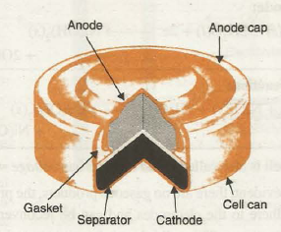](http://www.chemistry-assignment.com/wp-content/uploads/2013/02/1192.png)

**Fig. 33.10. Commonly used mercury cell. The reducing agent is zinc and the  oxidising agent s mercury (‘I) oxide**   
The operating voltage for mercury cell is = 1.35 V and the cell reactions are as follows:

[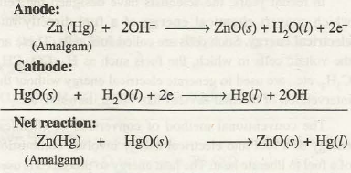](http://www.chemistry-assignment.com/wp-content/uploads/2013/02/1193.png)Such a cell has constant potential throughout its life

**SECONDARY CELLS**

This type of cells can be recharged by passing direct current through them and can be used again and again. Some examples are lead-storage battery, nickel-cadmium storage cell, etc. Let us study the working of lead storage cell.

**(a) Lead-storage Battery**. It is the most frequently used battery in automobiles. It consists of six voltaic cells connected in series. In each cell anode is made of spongy lead and cathode ‘is a grid of lead packed with lead dioxide (PbO2). The electrolyte is the aqueous solution of H2SO 4 which is 38% by mass. The reactions taking place in this type of cell can be represented as:

[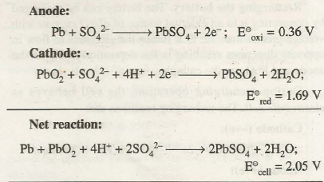](http://www.chemistry-assignment.com/wp-content/uploads/2013/02/1194.png)

During the working of the cell, the concentration of H2SO4 decreases as sulphate ions are consumed to form PbS04. The PbSO4 precipitates and partially gets coated on both the electrodes and water formed dilutes the sulphuric acid. With the decrease in the concentration of H2SO4 the density of the solution also decreases. The condition of the battery can be easily checked by measuring the density of the solution .

To enhance the output of the cell, the anode and cathode plates are arranged in alternating manner and they are separated by sheets of insulating material. The anode and cathode plates are separately connected to each other so as to increase the electrode area in contact with electrolyte solution. This increases current delivering capacity of the cell. The groups of electrodes constitute one cell are shown in Fig. 33.11. The cells are further connected in series so as to increase the voltage of the battery. In 6 volts battery there are 3 cells and in 12 volts battery there are 6 cells.

[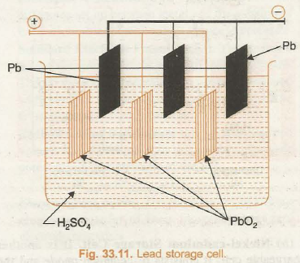](http://www.chemistry-assignment.com/wp-content/uploads/2013/02/1195.png)

Recharging the battery. The battery can be recharged by connecting it to an external source of direct current with voltage greater than 12 V. It forces the electrons to flow in opposite directions resulting in the deposition of Pb on the anode and Pb02 on the cathode.

During recharging operation, the cell behaves as electrolytic cell. The recharging reactions are:

[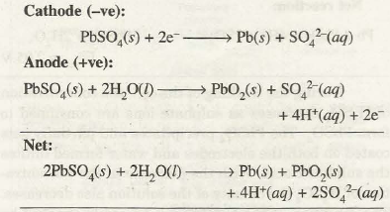](http://www.chemistry-assignment.com/wp-content/uploads/2013/02/1196.png)

Such an operation becomes possible because PbSO4 formed during discharge operation is solid and sticks to the electrodes. Therefore, it is in a position to lose or gain electrons during electrolysis.

The discharging and recharging of lead storage battery has been shown in Figs. 33.12 (a) and 33.12 (b) respectively.

In an automobile, the battery is discharged when the engine is started. While running, the engine powers the alternator which produces electrical energy sufficient enough to recharge the battery. Thus, battery is constantly recharged as long as the automobile is being driven.

[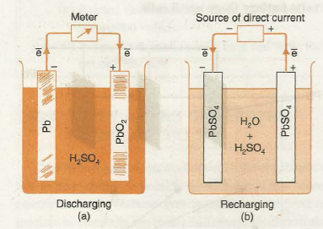](http://www.chemistry-assignment.com/wp-content/uploads/2013/02/1197.png)

**Fig. 33.12. Discharging and recharging of lead storage cell**

**(b) Nickel-cadmium Storage Cell.** It is another rechargeable cell. It consists of cadmium anode and the cathode is made of a metal grid containing nickel (IV) oxide.

These are immersed in KOH solution. The reactions occurring are:

[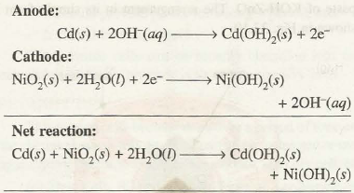](http://www.chemistry-assignment.com/wp-content/uploads/2013/02/1198.png)

The cell is also called nicad cell and has voltage =1.4 V. As is evident, there are no gaseous products, the products formed adhere to the electrodes and can be reconverted by recharging process. This cell is becoming more popular these days and finds use in electronic watches and calculators.

**EVALUATION**

1.What are the applications of electrochemical cells.

2.Describe the structure of i.the Daniel cell ii.the Leclanche’ cell and give the chemical reactions taking place in them respectively**.**

**WEEK 10**

**FARADAY’S LAWS OF ELECTROLYSIS AND CALCULATIONS.**

**Charge flow during electrolysis**

The coulomb is the electrolytic unit of charge. A current of one ampere is the rate of flow of charge equal to one coulomb per second.

The charge is calculated from the knowledge of the number of seconds for which a steady current is passed.

|  |  |  |
| --- | --- | --- |
| **Current in circuit** | **Time taken** | **Total charge** |
| 1 ampere | 1 second | 1 coulomb |
| 1 ampere | 10 seconds | 10 coulombs |
| 20 amperes | 10 seconds | 200 coulombs |
| A amperes | t seconds | At coulombs |

Therefore charge = quantity of electricity (Q) = I × t

                                                                     Q = I × t

**Flow of charge required to liberate 1 mole of element during electrolysis**

Electrolysis always produces chemical reactions. Consider a reaction (at cathode) in which one mole of silver Ag+ ions is discharged and deposited.

   Ag+ + e- → Ag(s)

In this case, 1 mole of electrons (e-) is required to discharge 1 mole of Ag+ ions to produce 1 mole of silver atoms (Ag(s)). 1 mole of electrons is a large charge and experiments show that it is equal to 96500 coulombs.

Therefore 1 mole of electrons = 96500 coulombs. This is called the faraday.

The number of faradays (moles of electrons) required to liberate 1 mole of an element during electrolysis is deduced from the equation for the electrode reaction.

**Examples**

|  |  |  |
| --- | --- | --- |
| Element | Electrode reaction | Faradays |
| 1. Sodium | Na+ + e- → Na(s) | 1 |
| 1. Copper | Cu2+ + 2e- → Cu(s) | 2 |
| 1. Aluminium | Al3+ + 3e- → Al(s) | 3 |
| 1. Chlorine | 2Cl- → Cl2(g) + 2e- | 2 |

That is, 1 faraday is needed to deposit 1 mole of sodium atoms (23g), 3 faradays to deposit 1 mole of aluminium atoms (27g) and 2 faradays to liberate 1 mole of chlorine gas (71g).

* The mass of an element liberated by 1 coulomb of electricity during electrolysis is called electrochemical equivalent of that element.
* The mass of an element deposited or liberated by 1 faraday during electrolysis is called chemical equivalent of that element.

FARADAY’S LAWS OF ELECTROLYSIS

The laws expressing the quantitative results of electrolysis were first stated by a British chemist called Michael Faraday. The laws assert that the amount (expressed in moles) of an element liberated during electrolysis depends on:

1. the time of passing the steady current;
2. the magnitude of the steady current passed; and
3. the charge on the ion of the element.

**The First Law**

The fact that the amount of a substance liberated during electrolysis depends upon these factors can be proved by conducting experiments. The product of time (measured in seconds) and the current passed (measured in amperes) gives a measure of electricity known as the quantity of electricity.

**Quantity of electricity (Q) = current (I) × time (t)**

**(coulombs)                    (amperes)    (seconds)**

**Q = I × t**

Because of this relationship, factors (1) and (2) may be included in the same experiment. The experiment to determine the effect of time on the amount of element deposited or liberated is carried out by passing a steady current through a solution of the compound of that element for different lengths of time.

The following table summarises the specimen results obtained by passing a steady current (0.21 amps) through a solution of copper (II) sulphate for 15, 30, 45 and 60 minutes. The last column shows the mass of copper deposited.

**Table 61.1 Specimen results for electrolysis of copper (II) sulphate**

|  |  |  |  |
| --- | --- | --- | --- |
| Current (amps) | Time  (s) | Quantity of electricity  (coulombs) | Mass of copper deposited  (grams) |
| 0.21 | 15 × 60=900 | 900 × 0.21=189 | 0.063 |
| 0.21 | 30 × 60=1800 | 1800 × 0.21=378 | 0.129 |
| 0.21 | 45 × 60=2700 | 2700 × 0.21=576 | 0.187 |
| 0.21 | 60 × 60=3600 | 3600 ×  0.21=756 | 0.250 |

The relationship between the amount of copper deposited and the quantity of electricity passed can be assessed by considering the values in the last two columns in the table. This data may be represented in a graph illustrated in figure 6.4. The shape of the graph shows a straight line passing through the origin. From this fact, it is clear that the mass of copper deposited is directly proportional to the quantity of electricity passed. This is in accordance to what Faraday formulated in his First Law.

Faraday’s First Law of Electrolysis states that the mass of a substance liberated at (or dissolved from) an electrode during electrolysis is directly proportional to the quantity of electricity passing through the electrolyte.

The quantity of electricity is measured in coulombs where a coulomb is the passage of an electric current of one ampere for one second. Let

m be the mass of the substance liberated;

I  be the current passed in amperes; and

t be the time in seconds.

We can therefore represent the first law mathematically as:

m α I × t or m = Z × I × t where Z is the proportionality constant referred to as electrochemical equivalent of the substance liberated. Electrochemical equivalent is the mass of a substance (element) liberated by 1 coulomb of electricity during electrolysis.

**The Second Law**

The third (3) factor mentioned previously as affecting the amount of substance liberated during electrolysis may also be investigated experimentally. Because our interest is the effect of the charge on the ions present in solution, we need to keep the quantity of electricity fixed whilst varying the types of the ions in solution. This may be achieved by passing the same quantity of electricity through two cells, with ions of different charges in each cell.

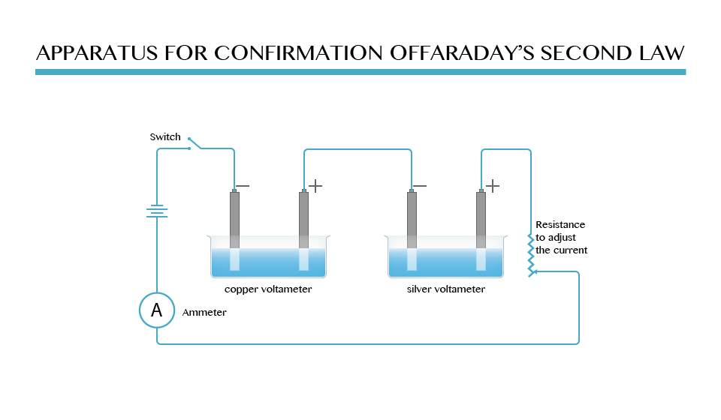

The experiment is conducted using two voltameters. The two voltameters are connected in series as shown. The first one is a copper voltameter and the second is a silver voltameter.

The copper voltameter has **copper electrodes** in a solution of **copper (II) sulphate**. Hence, in this voltameter, copper ions are discharged and deposited at the cathode.

The silver voltammeter has **silver electrodes** in a solution of **silver nitrate**. The discharged silver ions are deposited at the cathode.

Before the experiment is started, each cathode electrode in the voltameters is cleaned, dried and weighed. The electrodes are then connected to the circuit, after which a suitable current is passed for a measured period of time.

After this, the cathode are removed from the voltameters, cleaned, dried and reweighed. The increase in mass of the two cathode electrodes represents the respective amounts of copper and silver deposited at the cathodes. The quantity of electricity required to deposit one mole of each element is calculated using Faraday’s Second Law of Electrolysis.

**Specimen results**

|  |  |  |
| --- | --- | --- |
| Current flowing | = | 0.45A |
| Duration of current flow | = | 25 minutes |
| Mass of copper deposited | = | 0.221g |
| Mass of silver deposited | = | 0.755g |
|  |  |  |

The results show that the masses of silver and copper deposited are different. A comparison of the amounts of each of the elements deposited can be made simple by calculating the number of moles of atoms of each of the element deposited.

Thus:Amount of copper deposited = 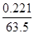mole = 0.0035 mole

Amount of silver deposited = 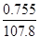mole = 0.0070 mole

It is seen that twice as many atoms of silver are deposited as atoms of copper. The difference in amount of each element deposited arises from the difference in charges on ions of the element concerned.

The change on the copper ion (Cu2+) is twice that on the silver ion  (Ag+) and therefore twice the quantity of electricity will be required to liberate one mole of copper as for the liberation of one mole of silver.

This relationship is in accordance to Faraday’s Second Law of Electrolysis, which describes the relationship between the amount of element deposited and the charge on the ions of that element.

Faraday’s Second Law of Electrolysis states that when the same quantity of electricity is passed through solutions of different electrolytes the relative numbers of moles of the elements deposited are inversely proportional to the charges on the ions of each of the elements respectively.

In order to discharge one mole of monovalent ions such as H+, Na+, Ag+ and Cl-, 96500 C of electricity are required. This quantity of electricity has been experimentally determined and is known as the Faraday constant.

It represents one mole of electrons, which is the same as the quantity of electrons required to discharge one mole of Ag+ ions to give one mole of silver atom. The validity of Faraday’s Second Law of Electrolysis is evident from the following observations:

1. One faraday (IF) discharges one mole of H+,  Na+,  Ag+, Cl- and  OH-  ions.
2. Two Faradays (2F) discharges one mole of Cu2+, Pb2+, Mg2+, Ca2+, Fe2+, etc ions.
3. Three Faradays (3F) discharge one mole of  Al3+,  Fe3+, etc. ions.

**Summarizing the two Laws of Electrolysis**

-Chemical equivalent of element = 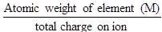

-Electrochemical equivalent of an element, Z = 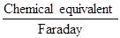

Therefore, electrochemical equivalent, Z = 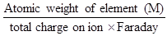

-Mass of substance liberated (m) = ZQ

                                                 m = Z × I × t

Since Z =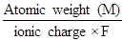, then m = 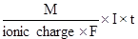

But F = 96500 C

Therefore m = 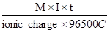

                m = 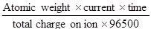

The relation summarizes the two Laws of Electrolysis.

**Calculations in electrolysis**

1. A steady current of 4 amperes is passed through aqueous copper (II) sulphate solution for 1800 seconds using platinum electrodes. Calculate:
2. mass of copper deposited
3. mass of oxygen liberated

**Given**: Atomic weight of copper = 63.5

            Atomic weight of oxygen = 16

            1 Faraday = 96500 C

**Clue**: Copper is deposited at the cathode and oxygen is liberated at the anode.

**Solution**

1. Cathode reaction: Cu2+ + 2e- → Cu(s)

In this case, 2 Faradays of electricity are required to deposit one mole of copper atom 63.5g.

This means 2 × 96500 C liberates 63.5g of copper.

* Quantity of electricity passed = I×t = 4×1800C. So, if 2×96500 C liberates 63.5g, then 4×1800C  will liberate 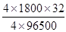= 2.4g of copper.

Therefore, mass of copper deposited = 2.4g

1. Anode reaction: 4OH-→2H2O(l) + O2(g) + 4e-

**Solution**

The reaction shows that 4 moles of electrons (=4 Faradays) are lost during the reaction process.

Therefore, 4 × 96500 C are needed to liberate one mole (32g) of oxygen.

I.e.  4 × 96500 32g of oxygen gas

* Quantity of electricity flowing = 4 × 1800 C

            So if  4 × 96500 C = 32g, then

                 4 × 1800 C =   = 0.6g

            Therefore, mass of oxygen liberated = 0.6g

1. A current of 3.2 amperes was passed through fused aluminium oxide for 10 minutes. The volume of oxygen given out at the anode was 112cm3 measured at s.t.p. Calculate:
2. the mass of aluminium deposited
3. the charge of one mole of electrons (The Faraday)

       (O=16, Al = 27, molar volume = 22.4 dm3 at s.t.p.)

**Note:**

1 mole (32g) of oxygen at s.t.p. occupies 22400cm3

**Solution**

(i) If 32 of oxygen occupies = 22400 cm3, then the weight of oxygen that would occupy 112cm3 = 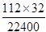= 0.16g

Let the weight of oxygen liberated be M1 and that of aluminium be M2 and their chemical equivalents be E1 and E2 respectively.

Then, by applying Faraday’s Second Law of Electrolysis, we have the relation

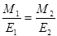

But chemical equivalent = 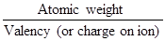

Therefore, E1 = 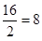

      E2 = 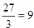

**Data**

M1 = 016         E1 = 8

M2 = ?             E2 = 9

            Substituting the relation in the formula

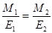, we have

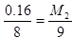

            M2 = 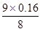

                   = 0.18g

**\**The mass of aluminium deposited = 0.18g

(ii) In this case, we can either use the mass of aluminium deposited or oxygen liberated to find the charge of one mole of electrons (the Faraday):

- The mass of oxygen liberated = 0.16g

- The mass of aluminium deposited = 0.18g

- The charge flow = amperes × seconds = (3.21 × 10 × 60)C

Alternative 1: using the mass of aluminium deposited.

3 moles of electrons are required to deposit 1 mole (27 g) of aluminium atoms

          Al3+ + 3e- → Al

If 3 moles of electrons deposit 27g, then 1 mole would deposit 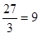g

But, what is the charge of this 1 mole of electrons?

**Solution**

If 0.18g of Al are deposited by (3.21 × 10 × 60)C, then 9g would require 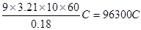

Alternative 2:  using the mass of oxygen liberated

2 moles of electrons are required to deposit one mole (16g) of oxygen atoms

                         O2- → 2e- + O

If 2 moles of electrons deposit 16g of oxygen atoms, 1 mole deposits 8g.

**Solution**

If 0.16g requires (3.21 × 10 × 60)C, then 8g would need 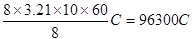

Therefore, you can see that both cases give a similar answer (96300C). However, remember that it is difficult to get the exact Faraday constant 996500C) under ordinary practical conditions.

**EVALUATION**

1.0.222g of a divalent metal is deposited when a current of 0.45A is passed through a solution of its salt for 25minutes.Calculate the relative atomic mass of the metal.

2. Calculate the mass of aluminium deposited when a current of 3.0 amperes is passed through an aluminium electrolyte for 2 hours.(Al=27,1 Faraday=96500c).